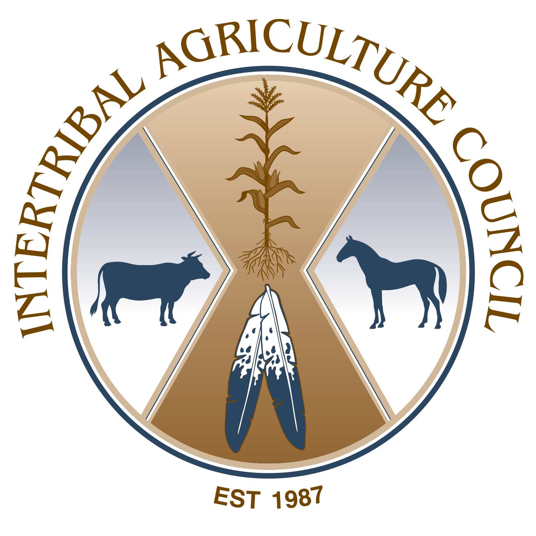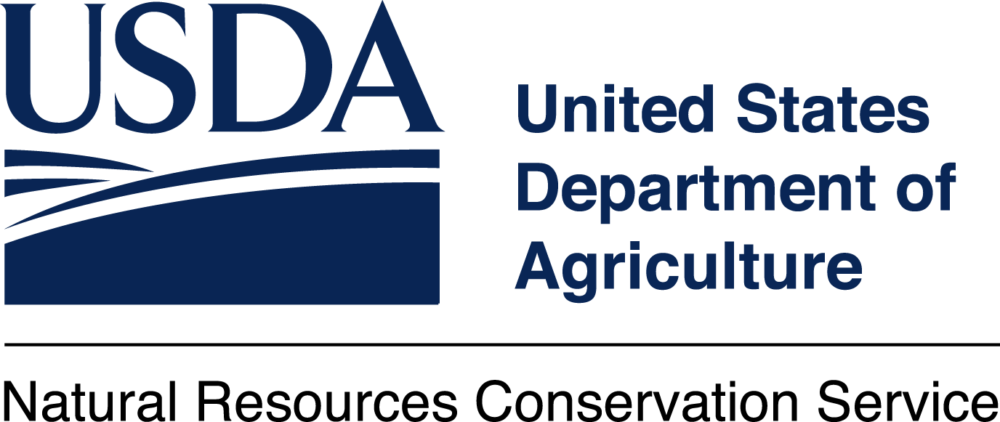

September 17, 2026 Tribal Conservation Planning Session
NRCS Plant Materials Center Lockeford
21001 N. Elliot Rd Lockeford, CA 95237
Scope: The Natural Resources Conservation Service (NRCS), and Intertribal Agriculture Council
(IAC), are hosting a ‘Conservation Planning Session, a session focused on the topics of
USDA-NRCS programming opportunities that Tribes and Individual Tribal members can
utilize for land stewardship, conservation agriculture, and food systems-related projects
at the Lockeford Plant Materials Center (PMC). The PMC tour will highlight a Cultural Burn Site at the
PMC with pre and post-fire conditions, Soil Health, and Plants of Cultural Significance in Hedgerows.
Agenda
8:30 am Check-In/Refreshments
9:00 am Welcome/Invocation
9:15-9:25 am (10 min) NRCS Leadership
9:30-9:45 Introductions (NRCS Staff/Guest Speakers/Participants)
9:45-10:00 am Break/Organize for field
10:00-11:00 Cultural Burn Site- Cultural Burn Discussion
11:00-11:30 pm (30 min) Soil Health
11:30-12:00 Plants of Cultural Significance_NRCS Hedgerow Practice
12:00-1:00 Conservation Planning Overview and Follow-Up Discussion
1:00 pm Closing

