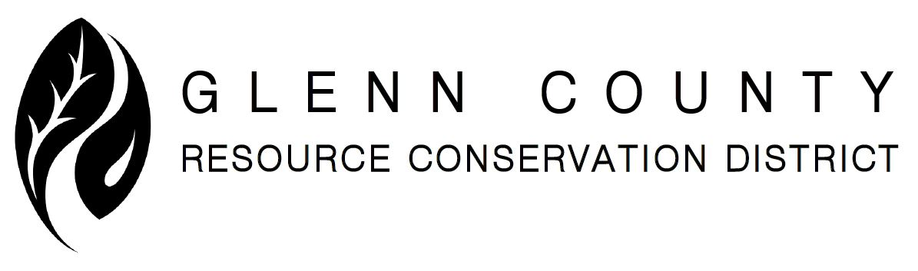

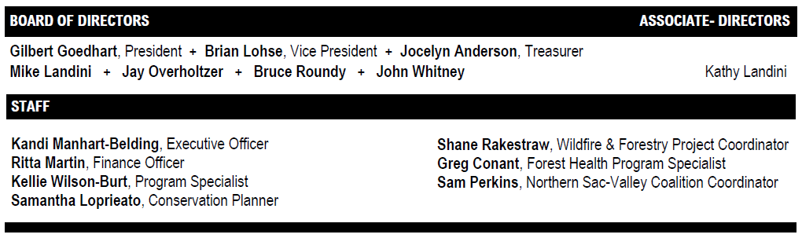

DRAFT MEETING NOTICE & AGENDA DRAFT

Date: Monday, July 20, 2026
Time: 1:00 PM to 3:00 PM – Local Working Group Meeting at 2:30 PM
Location: USDA Willows Service Center / Glenn County RCD
132 N. Enright Avenue, Suite C
Willows, CA 95988

1:00 | - CALL TO ORDER | Goedhart
1:00 | II. PLEDGE OF ALLEGIANCE | Goedhart
1:00 | III. WELCOME, INTRODUCTIONS & OFFICIAL ROLL CALL | Goedhart
1:05 | IV. PUBLIC COMMENT (limit 5 minutes):  Any person wishing to address the Board on items not on the agenda may do so at this time. The Board will not make decisions or determinations on items brought up during Public Comment. | Goedhart
1:10  *ACTION | V. CONSENT CALENDAR  - *Approve RCD Meeting Minutes for June 15, 2026 | Goedhart
1:15 | VI. PARTNER REPORTS (limit 5 minutes each, unless previously scheduled) | Goedhart
1:30 | VII. RCD REPORTS  - Directors and Associate-Directors  - Executive Officer  1. California Association of RCDs 80th Annual Conference,  November 17-19, 2026 in Sacramento, CA | Goedhart
1:45  *ACTION  *ACTION  *ACTION | VIII. FINANCIAL/BUDGET REPORT  A. *Discussion and possible action to accept the following reports:  1. Bank Statements and Reconciliations  2. Balance Sheet  B. *Discussion and possible action to approve RCD Cash Disbursement  Journal (Check Detail Register since previous RCD Meeting)  C. **Discussion and possible action to adopt Budget for FY July 1, 2026 to  June 30, 2027 | Anderson/  Martin
2:00 | IX. RCD PROJECTS & PROGRAMS UPDATE  - Conservation Planning  - Groundwater Recharge Development Plan (and Pilot)  - CAFF - Groundwater Community Engagement  - Healthy Soils Program (HSP)  - State Water Efficiency and Enhancement Program (SWEEP)  - Fuels Reduction and Fire Prevention Program  Update only – Request for Qualifications and Proposal, Seeking  Consultant to provide Reforestation and Tree Planting Services, Office  Issue: June 4, 2026 available on www.glenncountyrcd.org  - *Discussion and possible action to update agreement with Dudek for Northern Sacramento Valley Coalition (NSVC) StoryMap/Experience, Amendment 1  - Invasive Species Program: Upper Stony Creek Arundo Project  - Colusa Glenn Subwatershed Program – Helping growers meet the  Irrigated Lands Regulatory Program  - Sacramento Valley Region of RCDs (Secretary/Treasurer)  Future  Discussion on potential projects and programs | Manhart-Belding/  Staff
2:30 | ANNUAL LOCAL WORKING GROUP MEETING  By Kandi Manhart-Belding and Kristin Guy  RCD & USDA-NRCS SEEKS PARTICIPATION  - identify where the best investments can be made to address natural resource problems,  - share the work that has already been done in the county, and  - share your vision for what the county will look like when these natural resource concerns have been addressed.  Please complete the survey online at:  Click here | Manhart-Belding & Guy
3:00 | X. ADJOURNMENT | Goedhart

Please note times are approximate.

CORRESPONDENCE: Mail is distributed for review.

DATE OF NEXT MEETING: Monday, AUGUST 17, 2026, at USDA Willows Service Center / Glenn County RCD, 132 N. Enright Avenue, Suite C, Willows, CA 95988.

NOTIFICATION & AGENDA TOPIC REQUESTS: If you would like to be notified of future meetings and events or request a specific agenda topic, please call Kandi Manhart-Belding, Executive Officer at (530) 934-4601 x5 or
email kandi@glenncountyrcd.org.

Visit www.glenncountyrcd.org for Agendas, approved Minutes, and Meeting Schedule.

In compliance with the Americans with Disabilities Act, if you need special assistance or accommodations to participate in this meeting, please contact Kandi Manhart-Belding, Executive Officer at (530) 934-4601 x5. Notification at least 48 hours prior to the meeting will enable the RCD to make reasonable arrangements to ensure accessibility to this meeting. This is to include agendas in alternative formats.

(28 CFR 35.101-35.164 ADA Title II.)

