ALE APPLICATION CHECKLIST
This checklist provides a summary of materials necessary to support an ALE easement application.

Use the numbered items in the Table of Contents as a checklist.☐
Table of Contents
A. Submitting Applications 2
B. The NRCS Easement Application Review Process 2
C. Most frequent problems encountered during application reviews 2
D. Checklist - Landowners 3
☐1. CCC‐902 Farm Operating Plan 4
☐2. CCC‐941, Average Adjusted Gross Income (AGI) Certification and Consent to Disclosure of Tax Information 4
☐3. AD‐1026, Highly Erodible Land Conservation and Wetland Conservation 4
☐4. Power of Attorney 4
☐5. Articles of Organization 4
E. Checklist – Land Eligibility 5
☐6. NRCS CPA‐41A: “Parcel Application for an Agricultural Land Easement (ALE) Agreement” 5
☐7. Written pending offer 5
☐8. Copies of all deeds 5
☐9. ACEP-ALE Eligibility Worksheet 5
☐10. Current HEL plan (if any land included is classified as HEL) 5
☐11. Forest Management Plan (if applicable) 5
☐12. Impervious Surface waiver request (if applicable) 5
F. Checklist - Mapping 5
☐13. Map – Location 6
☐14. Map - Easement and Parcel Boundary (Offer) 6
☐15. Map-Deed and tax parcel 6
☐16. Map – Impervious Surface 6
☐17. Map – Soils 6
☐18. Map – Land use 6
☐19. Map -GIS Shape file of easement boundary 6
☐20. Map- GIS Shape file of Access Points and Access Routes 7
☐21. Map- Farm Infrastructure 7
☐22. Narrative Statements 7
G. Checklist – Entity WITH a Program Agreement 7
☐23. Update any changes to signature authority 7
☐24. Update any changes to SAMS 7
H. Checklist – Entity WITHOUT a Program Agreement 7
☐25. NRCS CPA‐41: “Entity Application for an Agricultural Land Easement (ALE) Agreement” 7
☐26. Entity’s authority to purchase and hold agricultural conservation easements 7
☐27. Documentation of entity’s commitment to conservation of agricultural lands 7
☐28. Documentation of the entity’s capability and record 7
☐29. Documentation of the entity’s staff capacity 7
☐30. Copies of current entity or trust establishment documents 8
☐31. Identify the individual(s) with signature authority. 8
☐32. Screen‐print from SAM.gov showing active, current registration 8
☐33. Direct deposit form (AD‐1199) for entity 8
I. File Naming Suggestions 9

Submitting Applications

  - Use of Box (a secure cloud content management tool supporting e‐signatures)
    - Entities needing to access Box should contact Brian Loadholt; brian.loadholt@usda.gov
  - Electronic copies sent to: RA.NRCS.NCRAL.EasementMonitoring@usda.gov
    - Scanned applications as one file are discouraged.
  - Paper copies mailed to:
    - NRCS – Attn. Programs, 4407 Bland Rd Suite 117, Raleigh, NC 27609

The NRCS Easement Application Review Process

The NRCS reviews of easement applications spans three levels. Note at any time during the easement application process one of these reviews could require additional information from the entity or landowner.
- North Carolina State Office,
  - The state office assures all submitted documents are consistent with NRCS easement acquisition polices.
  - Enters information in NRCS business tools (Protracts, Conservation Desktop, National Easement Staging Tool)
  - Ranks easements
  - Conducts field reviews.
- Easement Acquisition Branch (EAB)
  - EAB reviews all submitted documents and works with the state office to assure all documents conform to federal and NRCS contracting laws and policies.
  - Initiates contracting processes.
- National-level Internal Controls (IC).
  - Provides final review of easement applications.

Most frequent problems encountered during application reviews
Below we address the most common problems in processing easement applications found among the three levels of review.
- Landowner eligibility
  - Problems include:

    - not all the landowners have records established at the local Farm Service Agency
    - Landowners who are entities (e.g. LLC, corporations) have members who have not established at the local Farm Service Agency
- Inconsistent easement acres on application documents.
  - Inconsistencies in denoting the area (acres) of easements among the various forms and maps submitted as part of an application package. All acreage must be consistent. For example, if an application (CPA-41A) is for 202.1 acres, all maps and forms stating an easement size must equal 202.1 acres.
- Ownership as entered on the CPA-41A application is not the same as the landowner on the deed(s).
- Entities who are landowners or entities as the holder of the easement do not have Signature Authority identified.

Checklist - Landowners
Owners MUST establish eligibility with the Farm Service Agency
Ownership includes:
- all grantees listed on the deed(s)
- entities as grantees on the deed
  - member of entities on the deed
- ownership acquired through wills and trusts
All owners must have records established with USDA Farm Service Agency (FSA), which demonstrate compliance with:
- Adjusted Gross Income (AGI)
- Highly Erodible Land Conservation/Wetland Conservation (HELC/WC)
- Possess a CCC‐902 Farm Operating Plan
- We highly recommend that the landowner present FSA with the “FSA Eligibility Letter” and have them sign it stating that all eligibility forms have been received and are being processed.

VERY IMPORTANT - Eligible entities must work with landowners to assure landowners meet qualifying criteria
Under ACEP‐ALE, the landowners of record for the offered easement are considered the beneficiaries of payment. Therefore, landowners of record must meet the payment eligibility criteria required to participate in USDA programs for the land trust or other eligible entity to submit an ALE application on their behalf. All individual landowners of record must be United States citizens or resident aliens with a valid social security number (exceptions may apply – contact NRCS immediately).
All landowners, as listed on the current property deed(s) or equivalent evidence of ownership must be established in the Farm Service Agency’s (FSA) Service Center Information Management System (SCIMS) and have a copy of the current property deed or other evidence of ownership (e.g., will) including a breakdown of ownership shares, if applicable, when a landowner is an entity.

CCC‐902 Farm Operating Plan
There are FSA Forms: 1) CCC‐902I (Individual) or 2) CCC‐902E (Entity). A Members Information form (CCC‐901) may need to be completed for entities. Persons and legal entities applying for and participating in NRCS programs must complete a CCC‐902, “Farm Operating Plan”.

CCC‐941, Average Adjusted Gross Income (AGI) Certification and Consent to Disclosure of Tax Information
For each landowner of record (including all members of landowner entities) for the fiscal year in which the ALE application will be submitted (no exceptions).

AD‐1026, Highly Erodible Land Conservation and Wetland Conservation
for each landowner of record, unless all the following are true:
- An AD‐1026 is currently on file that accurately reflects the current status of the operation;
- The landowner has not acquired any more land (owned or operating);
- There have not been any changes to the land or operation; and
- A new determination has not been requested.

Power of Attorney
- FSA‐211, form, only if someone other than the landowner of record will be signing documents. Should cover NRCS programs for the period of the ALE contract, or
- Other legally drafted POA by an attorney

Articles of Organization

Required for landowners that are entities. Articles should include appropriate documentation to include member names, member percent ownership/membership and signature authority.

Checklist – Land Eligibility

NRCS CPA‐41A: “Parcel Application for an Agricultural Land Easement (ALE) Agreement”
  - Be sure to check “Program Agreement” in Section 2 ‐ Agreement Type.
  - Only the most current version of the form will be accepted (02/2020)

Written pending offer
  - The written pending offer may be extended by the eligible entity to the landowner to acquire the conservation easement or may be from the landowner to the eligible entity to sell the conservation easement.

Copies of all deeds
  - If the easement covers parcels with more than one deed, submit each deed/PLAT separately as an individual file. Deed files can be numbered.
  - Ownership must be proven; a title commitment could be useful when there is ambiguity in ownership.
  - Deeds must contain a description of the boundaries (e.g. metes and bounds)
  - If any land is listed as “excepted” on the deed, provide additional deeds/PLATs of the excepted land.

ACEP-ALE Eligibility Worksheet

Current HEL plan (if any land included is classified as HEL)

Forest Management Plan (if applicable)

Impervious Surface waiver request (if applicable)

Checklist - Mapping
Maps are an essential component of the application. The NRCS Easement Acquisition Branch (EAB) utilizes the State supplied conservation maps as Exhibits to EAB’s contracting documents, Due Diligence Contracts, and submittal of support documentation for Internal Controls. It is important the maps are consistent, clear, and professional to provide quality service.

The map elements listed¹ are things to consider for mapping.
- Assess Route showing the entire route from the public road to the easement boundary and any inholdings/excluded areas of the parcel.
- Indicate Point of Access from the public road on the map
- Map symbol legend, clearly labeled with easement program boundary
- Scale of the map
- Information needed to locate the planning area (e.g. geographic coordinates, public land survey coordinates, address, etc.)
- North arrow
- Appropriate map symbols as needed
- Map symbol legend on the map or as an attachment include appropriate interpretations, such as roads, streams, boundary, or recorded access.

All maps that state a value for size (acres) should have that value exactly match the value listed on the CPA-41A form (Section C, Item 4)

¹ These elements are consistent with policy criteria (Section 600.31) located in Title 180 – National Planning Procedures Handbook (180-VI-NPPH, Amend. 8, Nov. 2020).

Map – Location
  - Map depicting location at a scale that anyone driving can find the site.
  - Map should show named roads and location of nearest community.
  - It is required to have latitude and longitude of the easement location.

Map - Easement and Parcel Boundary (Offer)
  - Map must depict:
    - the easement boundary and size (acres)
    - planned and/or existing farmstead or homestead
    - Road names or Secondary Road (SR) numbers must be provided.
    - Ingress/egress to the easement and any inholdings/excluded areas must be shown. This can be shown with a symbol - include symbol in the legend.
    - Any excluded areas within the easement boundary and area (acres).
    - Lat/Long coordinates required

Map-Deed and tax parcel
This is a map which will identify which deed is associated with a tax parcel which is part of the 3-part NRCS easement application review process.
  - Map must show the easement boundary and tax parcels.
  - Tax parcel and associated deeds must be identified on the map or using a table.
  - See example – page 9.

Map – Impervious Surface
  - Map should include: 1) location of the impervious surfaces, and 2) proportion (%) of the impervious surfaces to the area of the easement

Map – Soils
  - The soils map and associated text of the Farmland Classification report in Web Soil Survey (WSS) is preferred. You can use the shape file of the easement in WSS.

Map – Land use
  - Map depicting cropland, rangeland, grassland, pastureland, forestland and proportions (percentages).

Map -GIS Shape file of easement boundary
Upload zipped shapefile containing all subfiles to Box or email to: RA.NRCS.NCRAL.EasementMonitoring@usda.gov

Map- GIS Shape file of Access Points and Access Routes
Upload zipped shapefile containing all subfiles to Box or email to: RA.NRCS.NCRAL.EasementMonitoring@usda.gov☐

Map- Farm Infrastructure

Include locations of major infrastructure utilizing appropriate map symbols. Examples include: powerlines, wells, septic tanks, above/below ground storage tanks, chemical storage areas, machinery repair areas, etc.

Narrative Statements
  - A statement that describes the parcel’s accessibility to agricultural markets, access to existing agricultural infrastructure and other support systems, and the treat of conversion or fragmentation or development.
  - If the “Land Eligibility Category for Parcel” (Section C-5 on the CPA-41A) is checked for either 1) Contains historical or archaeological resources, 2) Furthers a State or
local policy with the purposes of ACEP, then a narrative statement must be provided supporting how the easement meets either of these choices. The State or local policy must be cited if this option was selected.

Checklist – Entity WITH a Program Agreement

VERY IMPORTANT - Eligible entities must work with landowners to assure landowners meet qualifying criteria

Update any changes to signature authority

Update any changes to SAMS

Checklist – Entity WITHOUT a Program Agreement

NRCS CPA‐41: “Entity Application for an Agricultural Land Easement (ALE) Agreement”

Entity’s authority to purchase and hold agricultural conservation easements
  - Cite the appropriate state statue providing this authority.

Documentation of entity’s commitment to conservation of agricultural lands
  - using voluntary conservation easements that protect farm or ranch lands from conversion to nonagricultural uses

Documentation of the entity’s capability and record
  - Document history of acquiring, holding, managing, and enforcing conservation easements.

Documentation of the entity’s staff capacity
  - Document how easement monitoring and enforcement are addressed.

Copies of current entity or trust establishment documents
  - Examples: Articles of Incorporation on file with the NC Secretary of State, bylaws governing the entity. Ensure each entity is legal, valid, and in “good standing” with the North Carolina Secretary of State.

Identify the individual(s) with signature authority.

Screen‐print from SAM.gov showing active, current registration
  - NOTE that Registration in SAM (DUNS) must be maintained for the duration of the agreement and through easement closing.

Direct deposit form (AD‐1199) for entity

File Naming Suggestions
- Keep names as short and informative as possible.
- Abbreviate Entity names, e.g. Loadholt and Kroeger Land Trust as LKLT
- Use the number on the checklist as a prefix to the file name.
- Example:
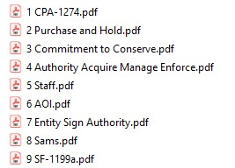

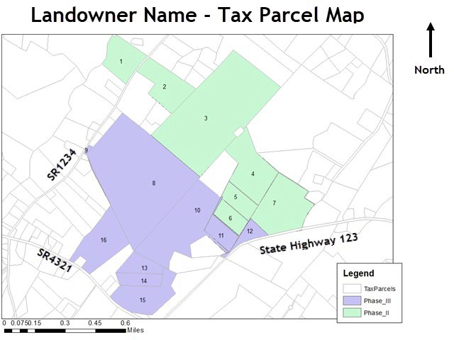
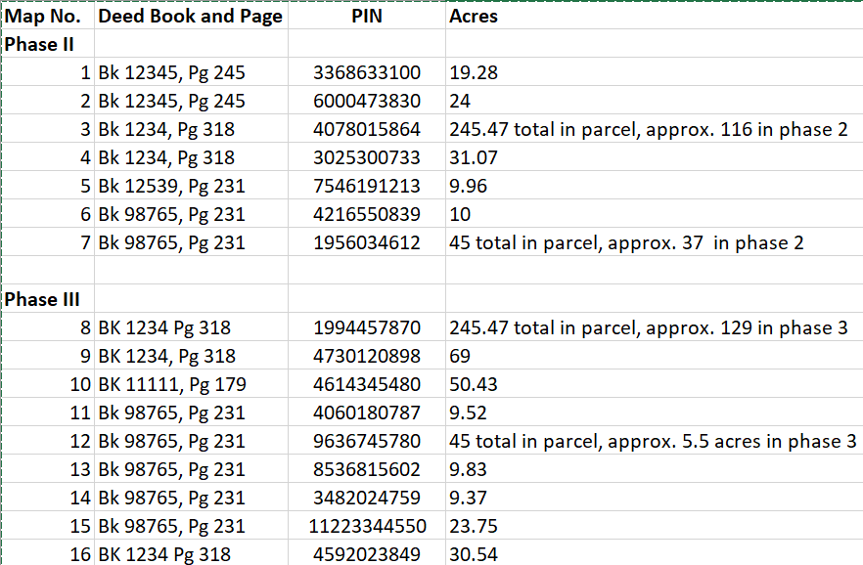

Example of map and table depicting tax parcels and associated deeds.

Simpler easements/maps can include parcel IDs on the map.

