Cheatgrass Challenge Team

FY25 Funding Cycle

Application Instructions

GENERAL INFORMATION

Grant Funds Requested—Fill in the amount, rounded to the nearest dollar, do not include cents. The total project cost is the sum of the match plus the requested grant funding from the proposed project budget (page 6 of the application).

Name of Project—Provide a name, five words or fewer, that can be used for the project on all related correspondence and agreements. Give the project a name that helps to define it, i.e., “Owyhee County Wildfire Rehabilitation,” or “Bear Creek Annual Grass Treatment.” Do not include the word project as they are all projects.

Part I. CONTACT INFORMATION
Information in this section must be complete.

Applicant—Applicant may be a soil and water conservation district, tribe, watershed council, individual, nonprofit organization, university, federal agency, state agency, or local agency. All applicants must be legal entities and supply a Tax Identification Number. Other entities may act on behalf of private landowners, not-for-profit institutions, schools, community colleges, state institutions of higher education, independent not-for-profit institutions of higher education, local agencies, state agencies, or federal agencies if an individual or entity so chooses. Enter all contact information including the contact person. If an entity is acting on behalf of any of the above individuals or groups, they must show consent through signature of the represented individual or group that is being represented.

Fiscal contact—All applicants must be legal entities and supply a Tax Identification Number. Identify which of these entities will be responsible for tracking project income and expenses and for complying with the grant agreement terms. Enter all contact information. If the fiscal agent is also the applicant, you may write in “Same as Applicant” and leave the contact information blank.

Other contacts:

Landowner—
- Private Land: Provide the name of the landowner(s) on whose property the project will be implemented. Enter all contact information. If there is more than one landowner, a cooperative landowner agreement is recommended. However, if a cooperative landowner agreement is not used, attach a separate sheet with contact information for each additional landowner, along with their signatures to attest to the conditions of the application. ALL landowners must sign the application. A copy of the landowner agreement must be submitted with the application. If the application is recommended for funding ALL landowners must sign the Grant Agreement.
- Federal Land, State Land or Tribal Land: If the project is on federal or state land the federal permittee or state lessee must sign an agreement acknowledging and accepting the conditions of the application. The project must have approval through the supervisor of that national

forest, BLM district, or Idaho Department of Lands District that has jurisdiction for the area in which the project is located. If the project is on tribal land it must have approval through the tribal council that oversees the tribal land on which the project will be implemented. This approval will be through a signature by the appropriate state/federal/tribal individual on page 8 of the application and/or a support letter.

Project Manager for the Grantee—Identify the person who will shepherd the project from start to finish. This person will serve as the main point of contact for the project, and in particular, will be responsible for securing signatures on the grant agreement, seeing that all signatories have copies, and making sure that all required attachments accompany the application and the invoices requesting payment. This person will ensure reports are completed and sent to the Cheatgrass Challenge Team.

Part II. PROJECT INFORMATION

Project Location—
- Identify the county or counties the project is located in.
- Identify the land ownership(s) in which the project will occur; public, state, private, and tribal and the acres of each ownership. List each federal agency and its acreage if applicable.
- Include a shapefile or location pin of each project element with your application. If the project is on private land, have the landowner’s signature verifying consent for location information.
- IDL GIS Program, Idaho Maps and Land Records - Department of Lands is an online tool for acquiring the county, township, range and section (TRS), latitude and longitude coordinates, and land ownership.
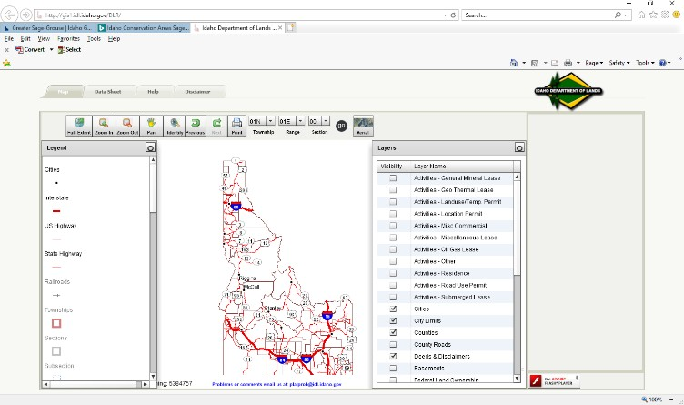

For guidance on the Cheatgrass Challenge “Protect the Core” map, contact Lacey Clarke at Lacey.clarke@usda.gov

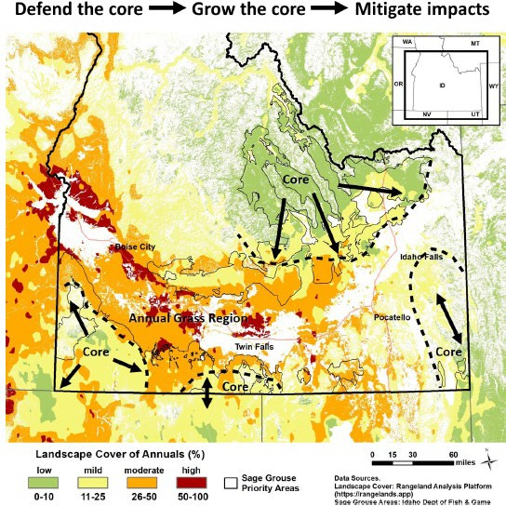

  - Narrative—Describe where your project is situated on the landscape and how it fits in with the larger landscape. Describe what plans or other actions occurring with other partners your project helps complement (i.e. associated with a current or upcoming NRCS application, associated with a larger BLM or USFS restoration project). Explain the current conditions on the site and describe the baseline before the project (i.e. range condition, plant species present).

  - Issue. Describe how the Issue meets criteria for Cheatgrass Challenge—Describe the threat(s) to tis perennial rangelands and what will be done to address them. Primary threats include wildfire, disturbance and invasive species. Secondary threats include but are not limited to climatic variation, undesirable species (i.e. lacking native species and/or sagebrush), and improper livestock grazing. Discuss if the threats you are addressing are primary or secondary or other threats to perennial rangelands. Provide detail on any known wildlife threats or habitat issues in your project area (e.g., degraded riparian/mesic area condition, degraded upland plant condition, livestock impacts, etc.). Talk with local IDFG biologist about what limiting factors may be in your areas and if you have further questions about threats. Consult cheatgrass_booklet_032020.pdf (usda.gov) to include pertinent criteria in your proposal.
  - Solution. Describe the solution(s) you are proposing that will address the threat(s)—attach a site map, color photos, and (if applicable) project drawings or designs —Describe the proposed solutions or practices (e.g., perennial grass seeding, chemical grass/weed spraying, fuel break installation, etc.) in sufficient detail to communicate to the project reviewers what you are planning to do and how the practices will address the threats/problems identified.
    - The emphasis should be on how implementation of this project will benefit perennial rangelands and sage-steppe habitat. Where applicable, include the number and type of units to be treated by the project and the methods that will be used to accomplish the project. For example, for a herbicide project include information on the type chemical, the timing of application, the method of application, and the post-application management. The objectives should be measurable in order to detect change of the pre and post treatment conditions.
    - If you plan on having a component for burning (broadcast, pile, jackpot, etc.) in your project, state how you will deal with noxious weeds and invasive species in the years after the burning has been implemented.
    - Technical Guidance Source—The project should use the approved technical guidance source listed in this question. If the NRCS Field Office Technical Guide is not used, state the technical guidance source used to design and implement the project. Information on the NRCS approved technical guidance sources for NRCS Idaho is found on at the link below or through your local NRCS office:
The NRCS Idaho Field Office Technical Guide (FOTG).
Section 4 of the FOTG is for NRCS Conservation Practice standards and specifications.

    - Attach a map of the project site with sufficient detail to show the location of the work to be performed. Provide maps on 8½” x 11” pages and include a legend.
For mapping assistance, you may contact your local IDFG Biologist, USFWS Biologist, Soil and Water Conservation District, or local NRCS staff.
Attach color photographs of the site showing current conditions. If doing construction or other engineered work, attach copies of preliminary project drawings or designs.

  - What is the anticipated timeline and schedule for the project? Indicate when the project is expected to start, when permits, if needed, will be attained, when monitoring points will be established, when materials will be acquired, when construction will start, and when project will be finished. Project funds awarded must be utilized by December 1, 2027 unless otherwise stated.

  - Have the required permits been obtained for the project? Indicate whether required permits for the project have been obtained, or if permits are not needed. List the permits that have either been issued (attach copies) or need to be obtained. If permits are needed, copies of the

issued permits must be provided to the Cheatgrass Challenge Team prior to the release of funds. It is the responsibility of the applicant and project manager to acquire the needed permits. Examples of permits include, but are not limited to, waters rights, rights of way, removal/fill, etc.
  - Is NEPA needed for this project? Check whether NEPA has been completed or is not required. If the project is planned on federally managed lands or funded in part with federal dollars, having NEPA complete is mandatory for the project to be considered in the ranking for grant funding.
  - Maintenance and Post-Implementation Monitoring—Long-term maintenance is the responsibility of the landowner. However, in the short term, the grantee may have an arrangement with the landowner to maintain and monitor the project that should be listed in this section. Refer to the sample below to help you complete the section in the application.
    - What aspects of the project will be maintained? Maintenance is the general upkeep and repair of a project. Examples include, but are not limited to, treating weeds with herbicide or cultural methods, reseeding areas with poor germination, resting treatment area from livestock utilization, fixing fence or watering systems to maintain the proper grazing management system, etc.
  - What aspects of the project, will be monitored Post-Implementation? Post-project monitoring (photo points and visual inspection) is required of all Cheatgrass Challenge Team grants and must include photo points and visual inspection. Show in the application what you will be monitoring for (invasive species or noxious species establishing/returning, vegetative characteristics for bunch grasses or mesic meadows, seeding establishment/survival, etc.).
- The applicant must submit yearly annual reports updating the Cheatgrass Challenge Team about project progress. Annual reports will be due to the respective funding agency by January 31st of each year through project completion.
- Note here what, if any, additional aspects of the project will be monitored post implementation. See the links to the Technical Guide and Field Guide to Photo Point Monitoring:
- If you plan to ask for funds that will be used for monitoring you must show how the monitoring is linked to project objectives, what the type of monitoring you will be conducting and why it is appropriate for this project, what monitoring protocols will be used, and the frequency and duration of the monitoring that you are asking for funding.
Photo Monitoring Technical Guide and Photo Monitoring Field Guide
  - Who will be responsible for writing the Status Reports? A template for a final report and a yearly status report will be provided to you by the Cheatgrass Challenge Team if your grant is approved for funding.
    - Provide the name and contact information of the individual who will take responsibility for documenting the condition of the project two years after actual project completion date. (This date may be found in the CCT agreement with the applicant.) The individual should generally be either the Project Manager for the Grantee or the Technical

Contact. The budget allows this person to be compensated for the report, however it must be built into the budget as a separate line item.
  - Technical Assistance: Who will provide technical assistance to the project? Provide the name and contact information for those individuals that are providing the technical assistance to the project. On Question #4 –Solution: state what their responsibilities are; designer, planner, etc. If the project is being designed include the experience that demonstrates your designer has the experience and qualifications needed to design the project. Also, include how the design takes into consideration extreme events (i.e. 100 year floods) as well as alternatives that were looked at.
  - Project Partners—Identify all anticipated funding sources—groups, volunteers, or agencies participating in the project, what they will do and if they are providing in-kind match or dollars to the project. List any agencies, volunteers, or groups who will assist with the design or implementation of the project and describe briefly what they will do and the estimated value. For example, indicate that the landowner will purchase sagebrush seedlings and Idaho Fish and Game will donate the use of their planting equipment; an NRCS employee will design the project, or student volunteers will plant the seedlings in areas where the equipment cannot reach.
  - Project Budget Estimate—The budget template is available in Word format. Fill in the information requested in ALL columns. Refer to the sample budget on page 6. List the items, amounts, and sources of funding for expenses associated with the project. Include the dollar value of donated services and supplies in this table under the “Cost Share/In-Kind” column. List all items requesting Cheatgrass Challenge Team funds under the “Cheatgrass Challenge Actions Team Funds” column. Fill in the amounts, rounded to the nearest dollar, do not include cents. Include a justification on where prices were gathered. Acquiring estimates from contractors to help the review committee understand if the budgeted dollars are sufficient to complete the project and address the threats is recommended. Other ways to estimate price may come from local NRCS or Soil and Water Conservation District offices.

    - Cost Share/In-Kind/Cash (Match)—The Cheatgrass Challenge Team gives higher ranking scores for greater amounts of match. Match funding sources may come from other non- Cheatgrass Challenge Team grants, cash donations, donated labor or services, and donated supplies or materials. Other Cheatgrass Challenge Team grants may not be used to satisfy the match requirement. Match should be shown in a letter from the partner providing the match, with signatures and dollar amount expected as match. This letter is recommended to be submitted with the project application. IMPORTANT: Match claimed for one grant may not be claimed for any other grant.

Match Definitions
      - Cash Match: Actual cash paid by the applicant for a service or product. This includes any cash funds that were donated to the applicant to offset the costs of a specific item.
      - In-Kind Match: Services or goods that are donated to the project by the applicant or a third party.

Eligible Match
      - Cash or in-kind resources that are for work/dollars spent during the same timeframe as the proposed project, the matching work or cash cannot be completed/spent before the approved grant agreement is signed.
      - Cash or in-kind resources that are implementing a similar practice/action as the proposed project and done in concert with the proposed project.
      - Cash and in-kind resources that are integral to the successful completion of the project and align with the proposed ecological objectives.
      - Cash or in-kind contributions are defined as resources that further the grant objectives and are necessary to achieve the proposed outcomes.

Ineligible Match
      - Mitigation funds
- Cash and in-kind resources that are not necessary to the successful completion of the project and do not complement the proposed ecological objectives.

  - Maps – See included instructions on the application.

Part III. PROJECT BUDGET

  - Description of Budget Line Item Expense Categories—Complete only the line items that apply to your project. Indicate the Number of Units and the Unit Cost wherever appropriate. Be sure to include information requested in the Description column.
  - Contracted Services—Includes all acceptable costs (i.e. labor, materials/supplies, and travel) associated with hiring consultants, construction firms, or other outside firms. Landowners performing work for the grant are to be paid from this category. Contract costs should be broken out and should match the scope of work described in the application.
  - Materials and Supplies— List all the supplies and materials purchased by, or invoiced to the applicant for the project, such as fencing, pipes, seed, plants, herbicide etc., that are typically “used up” in the course of the project. Indicate the Number of Units and the Unit Cost wherever appropriate. The Cheatgrass Challenge Team has discretion in deciding appropriate costs for supplies and materials. However, supplies and materials must be directly related to the on-the-ground work; Team Funds will not provide funding for film, education and outreach materials, first aid kits, or interpretive signage.
    - Other—Refers to items that do not fit in the other budget categories (i.e. Land Use signature costs). These items may be incurred prior to start date of grant.
  - Project Totals—Add up the “Cheatgrass Challenge Team Funds” column and enter the amount. Add up the “Cost Share/In-Kind” column and enter the amount. The total of the “Cost Share/In- Kind” column is recommended to be at least 25% of the total “Cheatgrass Challenge Team Funds” column.

Signatures—The applicant, landowner, and fiscal agent must sign the application. If more than one landowner is involved, add signature lines to the application and have each landowner involved sign and date. On a separate page, spell out what each landowner plans to contribute to the project. NOTE: ALL landowners must sign the subsequent Grant Agreement if the grant is funded.

Project Checklist—Include attachments as appropriate/required. Check the corresponding box once you have attached the item to the application.

