Texas NRCS EHE Parcel Application Questionnaire
Parcel applications for the ACEP-ALE and RCPP EHE will be developed in accordance with the following format and guidance that adheres to applicable NRCS program application policy. A properly completed and executed parcel application is one that is submitted on the appropriate forms, accompanied by all required supporting documentation, including this questionnaire, and signed by all required applicants and other required parties. Only complete and executed application packages will be considered for approval. The complete and executed application package must be submitted to:

HARD COPY:
EHE Program Manager
USDA NRCS
Texas State Office
101 S. Main Street
Temple, TX 76501
EMAIL:
Texas NRCS Easements
FPAC.NRCS.TX.Easements@usda.gov
***PREFERRED***

Applications are accepted on a continuous basis.
Complete applications must be received by 5:00 P.M. CST on the advertised Funding Opportunity Date(s) to be considered for funding in a specific fiscal year (FY).
Note: There may be multiple cut-off dates in the same FY.
The following is a questionnaire meant to gather adequate documentation for consideration of funding in NRCS entity-held easement programs such as the ACEP-ALE or RCPP-EHE. You must answer all questions contained within and provide all supporting documentation requested for the application package to be considered complete. The supporting documentation may be inserted under the applicable question or provided as an exhibit or attachment to the questionnaire. It is strongly suggested that the order and format of this questionnaire is followed to ensure consistency and fairness among all applicants. The appendices to this questionnaire should not be included in the submission. Basic eligibility and ranking outcome will rely solely on information submitted in the application package. Eligible entities should refer to the most recent Texas applicable program ranking criteria when providing supporting evidence with a parcel application.
Eligible and complete applications received by advertised cut-off dates are considered for funding through a competitive process. It is the responsibility of the applying eligible entity to ensure the application package is complete and accurate. If an identified issue can be corrected, the package may be considered for a future signup. Identification of basic eligibility within the Questionnaire is only to be used as a guide. NRCS makes the final determination at its discretion upon review of a complete and accurate application package. Additional NRCS on-site and environmental investigations are used to verify land eligibility requirements. If a question is answered that indicates parcel is ineligible, contact NRCS before continuing with the application. If the issue cannot be rectified, the package may not be further considered. NOTE: Requirements contained within subject to change upon publication of the ACEP policy updates.
If the entity has a current Program Agreement (PA), only a parcel application needs to be submitted. If there is no existing PA, the entity application package must be submitted at or prior to submission of a parcel application package.
For more information or assistance in completing an application, please contact the Texas Easements inbox, by email at FPAC.NRCS.TX.Easements@usda.gov .
Helpful entity held easement information may also be found on the Texas webpage or American Farmland Trust ALE Toolkit.

PART I – PARCEL APPLICATION CHECKLIST
All listed items are required for EACH parcel application submitted unless noted. Omission of applicable items may deem the application INELIGIBLE. Insert or append supporting documentation where applicable.

REQUIREMENTS FOR ALL APPLICATIONS:
☐ALE Parcel Application Questionnaire and all applicable supporting documentation requested
☐Completed NRCS-CPA-41A, Parcel Sheet for ACEP-ALE with required attachments, OR
☐Completed NRCS-CPA-1275, Parcel Sheet for RCPP-EHE with required attachments
☐Evidence of landowner records in Farm Service Agency’s (FSA) Service Center Information Management System (SCIMS)
☐Evidence of landowner current fiscal year FSA Farm Operating Plan
☐Land Use and Cover Type Table
☐Evidence of active eligible entity and coholder UEI number and SAM registrations (if registration will expire before 9/30 of the year of application, ensure it is updated appropriately)
☐Current ownership Recorded vesting deed(s) covering the entire offered area in the landowners name that matches all landowners listed on the parcel sheet and FSA Farm records, OR
☐Evidence the land is in the process of being purchased such as copy of an executed purchase agreement for the ACEP-ALE parcel
☐Title commitment, preliminary title report, or other form of preliminary title evidence (<1yo) & exception documents If issues are present, how does the landowner and entity plan to address the issues?
☐Written pending offer for the ALE or equivalent
☐Precise GIS shapefiles or Google Earth KML files of proposed boundary
☐Provide summary information on the ownership of any subsurface mineral rights indicating whether the rights are held by a third party and any required water rights for the parcel
☐When the land offered is not in active agricultural use, provide evidence of enrollment in the Texas current use assessment program or consistency with use the definition of a farm set forth in the Texas agricultural use tax assessment program.
Maps (aerial/topographic) with an accurate and appropriate scale, North arrow, and heading, applicable labels and all showing the proposed easement boundaries and acreage:
☐Location map of the parcel that clearly identifies where the land is located and how to navigate there
☐Provide evidence and map of Legal/physical access points and route to all parts of the easement, public roads location and names, and notation where third-party lands are crossed
☐Boundaries and total acreage of the parcel, including the acreage of each noncontiguous parcel and each subdivision, when applicable
☐Parcel land use map with applicable acreages that matches CPA-41A
☐Showing the proposed parcel boundary within the larger property boundaries, when applicable
☐ Demonstrating the threat of conversion or fragmentation due to non-ag development pressure or conversion of grassland to nongrassland uses (approx. 1:24,000)
☐Showing the parcel’s accessibility to other Viable agricultural operations, including on-farm and off-farm infrastructure, and other support systems
☐Showing the parcel’s accessibility to agricultural markets
☐Location and proximity to other Protected lands
☐ Soils map that includes the location and acres of the prime, unique, or statewide and locally important soil in each parcel
☐ Location and acres of lands where grazing uses and related conservation values would be protected
☐ Location and acres of grassland of special environmental significance, when applicable
☐ Location, number, and acreage of historical/archaeological sites proposed to be protected, when applicable
☐Proposed building envelopes showing existing or proposed access to each
☐The offered easement area proximity to range of a Federally and/or state listed threatened, endangered, proposed, or candidate species, when applicable
☐Irrigated land footprint, location of source

ADDITIONAL REQUIREMENTS, WHEN APPLICABLE:
☐Entity application package (if no applicable Program Agreement)
☐Legal access easements over private or Federal land to the offered easement area
☐Waiver request letter(s)
☐Attach to CPA-41A (1) evidence of matching funds or (2) evidence of entity ability to steward and monitor the parcel if entity match is <10% of FMV
☐Excerpts from state/local policies highlighting supporting passages (for state/local policy land eligibility category OR if using in any way to support application) – DO NOT submit entire document.
☐ Map of the offered easement area location in one of TCEQ/TSWSCB defined Source Water Protection Area watersheds as identified on the map in Appendix 3

ADDITIONAL RCPP18 REQUIREMENTS:
☐An appraisal that conforms with NRCS specifications and review requirements, OR
☐An estimated fair market value of the proposed RCPP-EHE parcel, including a description of the methodology used and supporting documentation for value.
NOTE: The value of the appraisal must be based upon an NRCS approved draft conservation easement deed. The effective date of the appraisal must be no earlier than 6 months prior to NRCS parcel obligation.
PROVIDE IF AVAILABLE AT APPLICATION:
☐Legal boundary survey
☐Phase-I environmental assessment
☐Minerals assessment
☐Appraisal report for ACEP-ALE

PART II – PARCEL QUESTIONNAIRE
All questions in Part II must be answered and details or other documentation provided as required. If any questions are unanswered or not answered effectively, the eligibility or ranking outcome may be affected. You may need to refer to some materials provided in the Entity Application section (e.g., Minimum Deed Terms) to effectively answer the questions.
TABLE OF CONTENTS
LANDOWNER APPLICANT INFORMATION 2
Farm Service Agency (FSA) Payment Eligibility 2
PARCEL INFORMATION 4
Ownership and Parcel Accuracy 4
Description of the Agricultural Operation 5
LAND ELIGIBILITY 5
Land Eligibility Categories 5
Land Uses 7
Access 9
At-Risk Species 9
Subsurface/Mineral Rights 10
Title and On- or Off-site Conditions 10
Impervious Surface 11
Building Envelopes 11
Agricultural Viability 11
OTHER REQUIREMENTS 12
Minimum Deed Terms (MDT) 12
Conservation Reserve Program (CRP) and Conservation Reserve Enhancement Program (CREP) 13
Plans 13
Resource Concerns, Multifunctional Benefits, and Conservation Values 14
Mapping (Other) 14
Waivers 14
Entity Cash Contribution 14
Application Checklist 15
Funding 15
GRASSLANDS OF SPECIAL SIGNIFICANCE (GSS) 16
Definition of GSS 16
Enrollment in GSS 16
GSS Criteria 16
CERTIFICATION STATEMENT 17
APPENDIX 1: DEFINITIONS i
APPENDIX 2: WEB SOIL SURVEY INSTRUCTIONS vii
APPENDIX 3: NONPOINT SOURCE WATER POLLUTION WATERSHED OF PROTECTION xi
APPENDIX 4: COST SHARE MATCH REQUIREMENTS FOR 2018 FARM BILL ENROLLMENTS xii
APPENDIX 5: American Farmland Trust (AFT) ACEP-ALE Landowner Eligibility Checklist
APPENDIX 6: American Farmland Trust (AFT) ACEP-ALE Land Eligibility Checklist

INSTRUCTIONS for updating the table of contents: Upon completion of your application and removal of all Appendices (DO NOT submit Appendices with your application package! They are for your reference only): (1) Click anywhere on the table, (2) Click the “Update Table” button that appears on the top left of the table, (3) Select one of the update options and click OK.

LANDOWNER APPLICANT INFORMATION
Basic Information:

    - ALL Landowner Name(s) (must match the entity provided deed, corresponding title work, FSA records, and the CPA-41A): Click or tap here to enter text.

- Ranch Name or Property Common Name (if applicable): Click or tap here to enter text.

- County: Click or tap here to enter text.

- If Limited-Resource, Beginning, Socially Disadvantaged, or Veteran Farmer or Rancher (see also, Appendix 1: Definitions) was selected in Section B #9 on the CPA-41A, does this designation apply to all landowners of record?
☐ YES ☐ NO, it only applies to: Click or tap here to enter text. ☐ N/A

- Do all eligible entity applicants and all prospective co-holders have an active DUNS/SAM registration?
☐ YES ☐ NO – INELIGIBLE

- The main eligible entity applicant, Click or tap here to enter text., meets one of the following:
☐ Has an active, executed Program Agreement covering the program selected on this CPA-41A.
☐ Has a current Fiscal Year (10/1 - 9/30) entity application package already on file with NRCS.
☐ Will submit an entity application package with this parcel application.
☐ Does not meet any of the above – INELIGIBLE.

Farm Service Agency (FSA) Payment Eligibility

This part of the application process should be completed as soon as possible at the beginning of the Fiscal Year (FY) (October 1) in which the parcel application will be submitted in order to meet state established landowner eligibility deadline. Refer to the American Farmland Trust (AFT) ACEP-ALE Landowner Eligibility Checklist to help the landowner provide required information to FSA. All landowners of record, including but not limited to life estates, must meet all required payment eligibility criteria to be considered for funding. Work directly with the local FSA or NRCS office to complete the appropriate paperwork and tasks properly. Landowners who have previously worked with USDA must still check in with FSA and NRCS to ensure all requirements are met for all landowners of record and for the land covering the offered easement area for the current FY for ACEP-ALE. The questions in this section are prompts to consider specifics about certain requirements and are not reflective of all payment eligibility requirements. See also: Landowner Eligibility Matrix

- Does the landowner(s) (appearing on the vesting deeds and title commitment) have Farm & Tract Eligibility (FTE) for the offered easement area?

NOTE: Farm and Tract Eligibility means that the Farm(s) and Tract(s) provided by you below generally cover the offered easement area and all landowners of record are associated with these Farms and Tracts in the FSA farm record. Landowners must provide FSA up to date vesting deeds if the farm records do not already exist or are incorrect. This also applies to buy-protect-sell parcels.
☐ YES, all current landowners are associated with the following Farm and Tract Number(s):
Click or tap here to enter text. and all generally cover the offered easement area.
☐ NO – INELIGIBLE, all current landowners must obtain Farm and Tract Eligibility

- Has every landowner of record (appearing on the vesting deeds and title commitment) and all members and beneficiaries of an entity, trust, or estate landowner filed with FSA a CCC-941 Average Adjusted Gross Income (AGI) form using the exact name, address, and tax ID on file with the IRS?

NOTE: Landowners may have to ensure FSA knows that they are applying for NRCS easement programs and an AGI determination from IRS is required for participation. Eligible entities assisting landowners with associated paperwork may include “FOR NRCS PROGRAMS” written on the top of the CCC-941 AGI form to help ensure local FSA offices are aware of this IRS requirement.
☐  YES ☐ NO – INELIGIBLE ☐ N/A – this is a buy-protect-sell transaction

- Has every landowner of record (appearing on the vesting deeds and title commitment) and all members and beneficiaries of an entity, trust, or estate landowner filed with FSA or appropriately updated an existing AD-1026 High Erodible Land (HEL) Conservation and Wetland Conservation Certification form, considering all land that is owned or operated in the United States?

NOTE: If a member or beneficiary of an entity or trust has less than 20% share, consult FSA to see if the member or beneficiary is exempt from filling out this form. If the person or entity has previously filed an AD-1026 and no changes have occurred related to the form, another AD-1026 may not be required; consult with the local office if this applies.
☐ YES ☐ NO – INELIGIBLE ☐ N/A – this is a buy-protect-sell transaction

- The eligible entity and the landowner(s) understand that FSA and NRCS together will determine the status of highly erodible land (HEL) on the Farm and Tracts associated with the offered easement area and the necessity of a HEL conservation plan as a condition of funding.
☐ YES ☐ NO

- Has every landowner (including individuals) have a CCC-902-E or CCC-902-I (and a CCC-901, as required by the 902) on file with FSA establishing current entity membership and with enough information for FSA to provide a determination AND ensured any existing FSA Farm Operating Plans have been rolled over to the current fiscal year?

NOTE: If CCC-902s already on file with FSA do not have the sections completed to participate in ACEP-ALE, the landowner is required to update the applicable form with FSA. Landowners should also update CCC-902s that are older than five years. All landowners of record must have a fully complete CCC-902. Individual landowners of record who are also members of an entity landowner of record are not covered by the entity landowner’s CCC-902-E and must each file their own CCC-902-Is (this does not apply to individuals that are only members of an entity landowner).

☐ YES ☐ NO - INELIGIBLE ☐ N/A – no entity or trust landowners or this is a buy-protect-sell transaction

NOTE: The landowner may need to provide FSA with entity or trust documents for documentation.


If any of answers under “Farm Service Agency (FSA) Eligibility” section are “NO – INELIGIBLE,” if NRCS finds upon review of the application that the answers should have been “NO – INELIGIBLE,” OR if any other required FSA payment eligibility criteria for any landowner has not been met, this parcel will be considered INELIGIBLE, and the application will not be further considered for funding. You should not continue with submission of the application until all FSA payment eligibility criteria for all landowners has been met. Pay special attention to the definition of “landowner” in “Appendix 1: Definitions” and contact the Easements Program Manager ahead of application submission for a preliminary consultation or if you are unsure who and what land should establish eligibility with FSA.

PARCEL INFORMATION

Ownership and Parcel Accuracy

- Do the landowners of record AND offered acres match on the CPA-41A, the provided vesting deeds, county tax records, title commitment, written pending offer, and all other supporting documentation?

NOTE: Landowners of record and acreage must match across all documentation unless there is a special circumstance that can be explained.
☐ YES ☐ NO – Explanation: Click or tap here to enter text.

- Did an authorized signatory for at least one landowner of record sign the CPA-41A and written pending offer? (Obtaining all landowner signatures is preferred.)
☐ YES ☐ NO ☐ N/A – this is a buy-protect-sell transaction

- Does the legal description of the offered easement area and the physical description on the CPA-41A Section C #1 and #2 match?
☐ YES ☐ NO

- Is the legal description that you verified above accurately reflected in the title commitment and other documentation provided?
☐ YES ☐ NO

- Does the legal description, physical address of the offered easement area, and the title commitment match the Farm and Tract number listed on the CPA-41A in Section C #1?
☐ YES ☐ NO
If yes, confirm the FSA Farm and Tract Number(s): Click or tap here to enter text.

Description of the Agricultural Operation

- Describe the agricultural operation and active agricultural uses on the property, including livestock, crops, products, wildlife management, marketing, labor, water, proximity to protected and agricultural land, and other important details of the operation (NOTE: Property may not be eligible if not in active agricultural use): Click or tap here to enter text.

- Does the landowner currently work with or have they previously worked with the local NRCS Field Office on the land that is offered for enrollment in ACEP-ALE?
☐ YES ☐ NO

IF YES, DESCRIBE THE TECHINCAL AND/OR FINANCIAL ASSISTANCE THAT HAS BEEN PROVIDED, INLCUDING WHICH NRCS PROGRAMS THEY ARE ACTIVELY PARTICIPATING IN ON THE EASEMENT AREA, OR WRITE “N/A”: Click or tap here to enter text.

LAND ELIGIBILITY

Throughout the course of application evaluation, NRCS may determine at any time that the offered easement area does not meet land eligibility and may determine an application ineligible to proceed. Any indication of eligibility within this section is a guide; the final determination is made by NRCS based on the contents of the application package. Land eligibility determinations include a site visit conducted by NRCS after initial application evaluation but before tentative selections for funding can be made.

Land Eligibility Categories
Use this section to aid in selection of the appropriate land eligibility category. All questions in this section must be completed, but you can only select ONE of the following land eligibility categories per parcel application even if the parcel qualifies for multiple categories. The ONE selection must be checked on the CPA-41A and reflect the best scenario for the landowner and entity. If the parcel does not qualify for any category, the parcel is INELIGIBLE and a parcel application package should not be submitted without consultation with NRCS.

- Has Prime, Unique, or Other Productive Soils
Are 50% or more of the soils classified as prime, “prime if,” unique, Statewide or locally important soils on the Web Soil Survey Farmland Classification report (see Appendix 2 for instructions)?
☐ YES – Eligible ☐ NO –Ineligible, select a different category

If YES and this category is selected on the CPA-41A, provide the following required documentation to be considered eligible:
☐ Web Soil Survey print out of Farmland Classification map AND report showing acres and percent prime farmland.
☐ Percent of prime soils written in the space provided on the CPA-41A.
☐ If “Prime, if irrigated” or “Prime, if drained” soils present, proof is provided that these soils are actively irrigated as demonstrated in the “Water Availability” section and demonstrated on a map, OR
☐ N/A, no “Prime, if irrigated” or “Prime, if drained” soils present.

NOTE: The determination of whether the land contains prime, unique, Statewide or locally important soils is based on the NRCS designations made using the criteria and procedures in the most current version of National Soil Survey Handbook. See “Appendix 1: Definitions” for more information.

- Contains Historical or Archaeological Resources
This parcel meets one or more of the following (select all that apply):
☐ Currently listed or formally determined eligible for listing in the National Register of Historic Places – Eligible
☐ Formally listed in a State or Tribal register of historic places – Eligible
☐ Included in the State historic preservation officer (SHPO) or Tribal historic preservation officer (THPO)’s inventory with written justification as to why it is eligible for the National Register of Historic Places – Eligible
☐ None of the above - Ineligible, select a different category
If one of the eligible answers above applies and this category is selected on the CPA-41A, provide the following required documentation to be considered eligible:
☐ Evidence that supports the selection(s) above.
☐ A brief description of the site’s significance: Click or tap here to enter text.
☐ A brief description of how the easement deed will address the protection of these resources: Click or tap here to enter text.
☐ A location map of the site(s)
☐ Identify at least one grantee or third party that will have designated monitoring responsibilities that has experience in managing, monitoring, and enforcing historical or archaeological resources in the deed: Click or tap here to enter text.

- Protects Grazing Uses and Related Conservation Values
      - Does this parcel contain at least 90% (or 95% for GSS) of the following qualifying land uses as identified in Section C #6 of the CPA-41A AND are those land uses considered the “highest and best use” as defined by the landowner: (i) Grassland, (ii) Rangeland, (iii) Pastureland, (iv) Land that contains forbs, (v) Shrubland for which grazing is the predominant use, and/or (vi) Located in an area historically dominated by grassland, forbs, or shrubs and could provide habitat for animal or plant populations of significant ecological value?

NOTE: The 90% (or 95% for GSS) requirement must be met unless a waiver to this requirement is obtained. The ALE Minimum Deed Terms prohibit >10% crop cultivation on the enrolled area. “Highest and best use” in this case is defined as the land use the landowner considers to be the most critical to the success of the agricultural operation. This land eligibility category must be selected for all GSS applications.
☐ YES – Eligible
☐ NO – Ineligible, select a different category or submit a request for a waiver to NRCS upon application

      - All parcels enrolled under the “Protects grazing uses” land eligibility category are considered grassland enrollments for the purposes of the NRCS Minimum Deed Terms, even those enrolled in General ALE (“non-GSS grassland enrollments”). Are the eligible entity and all landowners familiar with and prepared to accept the restrictions and limitations of a grassland enrollment as shown in the most current version of the NRCS Minimum Deed Terms?
☐ YES – Eligible  ☐ NO – Ineligible, select a different category

If YES to (a) AND (b) above and this category is selected on the CPA-41A, provide the following required documentation to be considered eligible:
☐ The “Land Use and Cover Type Table” from the ALE Parcel Application and an
associated map showing that at least 90% (or 95% for GSS) of the offered easement area is classified as a qualifying land use (addressing grasslands or related conservation value). If a waiver will be requested to the 90% (or 95% for GSS) requirement, the table based on actual land use must still be provided.
☐ Description of how the conservation easement deed will address the protection of the grazing uses and/or grassland values (including for grassland bird whose populations are in significant decline, “at-risk species”) and incorporate any specific requirements in the current version of the Minimum Deed Terms: Click or tap here to enter text.
☐ Description of how the current and planned activities of the agricultural operation further the protection of and do not harm the grazing uses and/or grassland values (including for grassland bird whose populations are in significant decline, “at-risk species”): Click or tap here to enter text.

- Furthers a State or Local Government Policy Consistent with the Purposes of ACEP
Is there a State or local government policy applicable to this parcel that aligns with the purposes of ACEP-ALE, which is to protect the agricultural viability and related conservation values of eligible land by limiting nonagricultural uses of that land and/or protect grazing uses and related conservation values by restoring and conserving eligible land?
☐ YES – Eligible ☐ NO – Ineligible, select a different category
If YES and this category is selected on the CPA-41A, provide the following required documentation to be considered eligible:
☐ A copy of the applicable pages of the State and/or local policy or policies, highlighting the specific passage(s) that apply. DO NOT submit entire publications.
☐ Write in all policy citation(s) in the space provided on the CPA-41A. If there is not enough room provided, continue the citations here: Click or tap here to enter text.
☐ A written description explaining how (1) each policy is consistent with the purposes of ACEP-ALE, (2) the preservation of the parcel is consistent with and furthering the identified policies, AND (3) the conservation easement deed will address these matters: Click or tap here to enter text.

- Which category will you select on the CPA-41A of the four categories described above for which the parcel is considered eligible? NOTE: Only one may be selected even if the parcel is eligible for multiple. Category cannot be switched after funding is provided. All subdivisions requested must meet the category selected independently or they will not be permitted.
☐ Has Prime, Unique, or Other Productive Soils
☐ Contains Historical or Archaeological Resources
☐ Protects Grazing Uses and Related Conservation Values (MUST be selected for parcels seeking GSS funding)
☐ Furthers a State or Local Government Policy Consistent with the Purposes of ACEP

Land Uses
- Have you provided a “Land Use and Cover Type Table” table for the parcel and accompanying labeled map(s) for the entire offered easement area AND do the land uses as selected on the table correspond with the selections in Section C #6 on the CPA-41A?
☐ YES ☐ NO

- If “nonindustrial private forestland” was selected as a land use type, describe how that land contributes to the economic viability of the offered easement area or serves as a buffer to protect such land from development. If it does not, the land will be considered ineligible. If “nonindustrial private forestland” exceeds two-thirds of contiguous portions of the offered easement area or any proposed subdivision, the parcel will be considered ineligible without a waiver, a request for which must be submitted with the application. See “Appendix 1: Definitions” for more information.

DESCRIBE OR WRITE “N/A:” Click or tap here to enter text.

- Is any of the offered easement area identified as “Located in an area historically dominated by grassland, forbs, or shrubs and could provide habitat for animal or plant populations of significant ecological value” in Section C #6 of the CPA-41A?
☐ YES – Answer (a) through (c) below.
☐ NO – SKIP to next question.

      - Is the land compatible with grazing uses and related conservation values?
☐ YES – Eligible ☐ NO – Ineligible, select a different land use

IF “YES,” DESCRIBE: Click or tap here to enter text.

      - Have the grassland, forb, or shrubland vegetative communities historically found on the site been restored OR will the eligible entity have a valid, funded plan for the restoration of such vegetative communities in place prior to closing?
☐ YES – Eligible ☐ NO – Ineligible, select a different land use
IF “YES,” IDENTIFY WHICH AND DESCRIBE: Click or tap here to enter text.

      - Does one of the following apply: (1) The land could or does provide habitat for animal or plant populations of significant ecological value if the land is retained in grazing uses and related conservation values OR (2) Would address State, regional, or national conservation priorities?
☐ YES – Eligible ☐ NO – Ineligible, select a different land use

IF “YES,” IDENTIFY WHICH AND DESCRIBE: Click or tap here to enter text.

- May any part of the offered easement area can be classified as nonindustrial private forest land that contributes to the economic viability of an offered parcel or serves as a buffer to protect such land from development.
☐ YES ☐ NO

IF “YES”, Identify Percent and describe contribution to the agricultural operation of the parcel: Click or tap here to enter text.

- Is the land already subject to an easement or other deed restriction that prevents its conversion to non-agricultural uses?
☐ YES ☐ NO

IF “YES,” DESCRIBE THE DEED RESTRICTION AND PROVIDE A COPY OF THE RESTRICTION DOCUMENT: Click or tap here to enter text.

Access
- Is there legal and physical access to all parts of the offered easement area? (Select the access route for all that apply)
☐ YES, directly from public roadway: Click or tap here to enter text.
☐ YES, over and across private lands as described in Reception or Book/Page Number:
Click or tap here to enter text.; a copy of the document is provided in this package
☐ NO, but it is accessible a Forest Service or Bureau of Land Management road and this application package demonstrates that use of these roads in perpetuity has been or will be obtained before closing. NOTE: If this cannot be demonstrated, the last answer must be selected and the parcel may be INELIGIBLE.
☐ NO, all or part of the offered easement area is not legally and physically accessible, but both will be obtained prior to closing, as: Click or tap here to enter text.
☐ NO, all or part of the offered easement area is not legally and physically accessible and access cannot or will not be obtained prior to closing – INELIGIBLE

- Have you provided a map that clearly shows the current or projected legal and physical access route to all areas of the offered easement area, including clearly labeled access points, travel ways, clear identification of public roadways, and reference to applicable recorded documents?
☐ YES ☐ NO
DESCRIBE IN DETAIL THE PHYSICAL AND LEGAL ACCESS TO THE PROPERTY THIS CORRESPONDS TO THE ACCESS MAP PROVIDED: Click or tap here to enter text.

At-Risk Species
To receive points for at-risk species or be considered in a category related to at-risk species, the operations of an agricultural operation may not have a negative effect on the species as determined by NRCS. If the conservation easement and planned activities will not directly benefit the species or if current or planned activities negatively affect the species, ranking points will not be granted for applicable questions and the parcel will not qualify for at-risk species ranking points. NRCS may complete related Wildlife Habitat Evaluation Guides (WHEGs), Threat Checklists, or other documentation during an onsite visit to verify supporting evidence provided and determine the parcels qualifications.

- Is the offered easement area within range of a Federally listed threatened, endangered, proposed, or candidate species and will the conservation easement and the activities of the agricultural operation directly support the species?
☐ YES ☐ NO

IF “YES,” LIST THE APPLICABLE SPECIES AND THEIR LISTING STATUS, PROVIDING SUPPORTING DOCUMENTATION (E.G., MAPS) OF THEIR PRESENCE/RANGE ON THE OFFERED EASEMENT AREA, DESCRIBE HOW THE EASEMENT AND THE ACTIVITIES OF THE AGRICULTURAL OPERATION WILL DIRECTLY SUPPORT EACH SPECIES, AND DESCRIBE HOW THE ACTIVITIES OF THE OPERATION WILL NOT OR WILL BE MODIFIED BEFORE CLOSING TO NOT HARM THE SPECIES: Click or tap here to enter text.

- Is the offered easement area within range of a State-listed threatened or endangered species or species of concern and will the conservation easement and the activities of the agricultural operation directly support the species?
☐ YES ☐ NO
IF “YES,” LIST THE APPLICABLE SPECIES AND THEIR LISTING STATUS, PROVIDING SUPPORTING DOCUMENTATION (E.G., MAPS) OF THEIR PRESENCE/RANGE ON THE OFFERED EASEMENT AREA, DESCRIBE HOW THE EASEMENT AND THE ACTIVITIES OF THE AGRICULTURAL OPERATION WILL DIRECTLY SUPPORT EACH SPECIES, AND DESCRIBE HOW THE ACTIVITIES OF THE OPERATION WILL NOT OR WILL BE MODIFIED BEFORE CLOSING TO NOT HARM THE SPECIES: Click or tap here to enter text.

Subsurface/Mineral Rights
Severed minerals as reflected on the title commitment or other form of preliminary title, with underlying documents, may require NRCS to complete their own minerals assessment at the time of application or at any time before closing for funded parcels. If determined necessary, onsite visit may be required and closing will not be permitted until the assessment is completed and minerals concerns resolved.

- Does the landowner own the entire the subsurface/mineral estate?
☐ YES ☐ NO

- Will the landowner’s discretion with respect to third-party rights to minerals be limited as specified in the current version of the NRCS Minimum Deed Terms?
☐ YES, all minerals development will be prohibited.
☐ YES, minerals development will be permitted with limitations using one of the options in the NRCS Minimum Deed Terms.
☐ YES, other: Click or tap here to enter text.
☐ NO, minerals development will not be limited or prohibited.

- Are any subsurface/mineral rights subject to recorded or unrecorded outstanding lease(s) or surface use agreements?
☐ YES, the leases are: Click or tap here to enter text. ☐ NO

- Has a mineral remoteness assessment or equivalent been developed and provided to NRCS to support the entity answer to QUESTIONS #38-41 and QUESTION #9 in Section C of the application?
☐ YES ☐ NO

- Describe in more detail the circumstances of the mineral estate, any past or current activity, and any potential risk to the offered easement area from exploration and development activities under the subsurface estate: Click or tap here to enter text.

Title and On- or Off-site Conditions
- Has the eligible entity or their attorney reviewed the current title to address Question 9 in Section C of the application?
☐ YES ☐ NO

- Has the eligible entity or their attorney identified any exceptions to title coverage that are concerning?
☐ YES ☐ NO
IF “YES,” DESCRIBE: Click or tap here to enter text.

- Is the entity aware of any unrecorded exceptions to title coverage, leases, or other unrecorded use of the offered parcel, including but not limited to written and verbal leases?
☐ YES ☐ NO
IF “YES,” DESCRIBE: Click or tap here to enter text.

- Is the eligible entity aware of any hazardous materials present or used on or near the offered parcel?
☐ YES ☐ NO
IF “YES,” DESCRIBE: Click or tap here to enter text.

- Are there any existing or permitted rights-of-way for utilities or other infrastructure development on the offered parcel?
☐ YES ☐ NO
IF “YES,” DESCRIBE: Click or tap here to enter text.

- Does the eligible entity plan to complete a limited or full phase-I environmental assessment before closing for the offered easement area?
☐ YES ☐ NO

NOTE: This is not required unless there are specific concerns and you are notified by NRCS. If a phase-II assessment would be required, the parcel will be ineligible unless remediated. NRCS completes a limited phase-I in the land eligibility determination phase and will be onsite to verify evidence provided in the application package.

Impervious Surface
- The current total impervious surface is an estimated Click or tap here to enter text. % of the total offered easement area.
NOTE: Impervious surface includes surfaces that are paved, covered by concrete, or occupied by buildings, with or without floors. These estimates can be obtained through measuring the surface area based on an aerial photo or by other acceptable means. Conservation practices listed in the NRCS Field Office Technical Guide are exempt from the definition for ACEP purposes.

- How much impervious surface is present on the offered easement area?
☐ 2% or less of the total acres – ELIGIBLE
☐ Greater than 2% of the total acres – INELIGIBLE WITHOUT A WAIVER

Building Envelopes
- Will the landowner reserve any building rights and does the landowner understand that any changes to building envelopes after obligation of funds are subject to NRCS approval?
☐ YES ☐ NO

- Have you provided a map that depicts the planned building envelope(s) AND does this map also show and differentiate between the existing and potential future access to the building envelope(s)?
☐ YES ☐ NO ☐ N/A – no building envelopes planned

Agricultural Viability
- Does this parcel have long-term viability for agricultural use?
☐ YES ☐ NO
IF “YES,” DESCRIBE: Click or tap here to enter text.

- What is the average farm size in the county (most recent Census of Agriculture) of the offered parcel?
Click or tap here to enter text.

- Have you provided an aerial or 7.5’ USGS topographic map that depicts the location of the offered parcel in relation to other protected lands that are at least equal in size to the county’s average farm size, including lands owned by federal, state, or local governments, or by an entity whose purpose is to protect agricultural use and related conservation values, or land that is already subject to an easement or deed restriction that limits the conversion of the land to nonagricultural use?
☐ YES ☐ NO

- Have you provided an aerial or 7.5’ USGS topographic map that depicts the location of the offered parcel in relation to other viable agricultural operations, also identifying operations that are at least equal to the average farm size in the county (most recent Census of Agriculture) and which are considered agriculturally viable for the foreseeable future?
☐ YES ☐ NO

- Does this parcel face development pressure from non-agricultural use (General ALE) or conversion to non-grassland uses (GSS)?
☐ YES ☐ NO
IF “YES,” DESCRIBE THE DEVELOPMENT PRESSURE AND/OR CONVERSION THREATS AFFECTING THE PROPERTY AND THE REGION: Click or tap here to enter text.

- Has one or more aerial maps been provided that depict development and “development pressures” within thirty (30) miles of the parcel’s boundaries? NOTE: Urban infrastructure (water/sewer extensions), municipal boundaries, urban growth boundaries, rural subdivisions, 35-acre subdivisions, non-ag zoning, energy infrastructure development, etc., should all be illustrated.
☐ YES ☐ NO

- Have you provided a basic soils map, legend, and table AND a Farmland Classification map, legend, and table from Web Soil Survey (see Appendix 2 for instructions) or from the local NRCS Field Office?
☐ YES
☐ NO
☐ NO, soils data is unavailable from all sources for the offered easement area

OTHER REQUIREMENTS

Minimum Deed Terms (MDT)
- Does the eligible entity and all landowners accept all current MDT applicable to the parcel and all applicable agreement language as written, including language for grassland enrollments?

NOTE: Acceptance of the terms is required as a condition of participation in ACEP-ALE. Grasslands enrollments include all GSS and all General “protects grazing uses” land eligibility category enrollments.

☐ YES ☐ NO

- How will the eligible entity be addressing NRCS MDT for this parcel?

NOTE: Ranking points may be granted for the answer to this question. The selection below will become a part of the contract if the parcel is selected for funding.

☐ The applicable version of the MDT will be appended to the easement deed.
☐ The applicable version of the MDT will be incorporated verbatim into to the easement deed.
☐ The eligible entity will use its own NRCS-approved template easement deed that incorporates required version of the MDT.
☐ The eligible entity will use another eligible entity’s NRCS-approved template easement deed
that incorporates the required version of the MDT.
☐ The eligible entity is a certified entity with NRCS and will meet regulatory deed requirements.

Conservation Reserve Program (CRP) and Conservation Reserve Enhancement Program (CREP)
- Is any part of the offered easement area currently enrolled in CRP or CREP?
☐ YES – CRP ☐ YES – CREP ☐ NO

- If yes to the above, is the CRP and/or CREP contract set to expire within a year of the date of this application?
☐ YES ☐ NO ☐ N/A

- If yes to the above, describe how the easement will assist in the protection of condition of the land coming out of CRP/CREP enrollment: Click or tap here to enter text.

Plans
- Succession planning, along with a conservation easement, can further address agricultural viability for future generations. For the purposes of this application, a formal succession plan or similar plan is considered an executed overarching document or set of legal documents, written agreements, and/or financial statements. The document or set of documents should clearly demonstrate meeting the indicators of farm succession planning as outlined in American Farmland Trust’s (AFT) presentation (Part 5). It should be completed by an industry professional (e.g., any organization or group who does farm succession planning, such as Cooperative Extension). An informal succession plan would be a compilation of similar documents, but that were not developed by an industry professional. Plans and ideas not documented in writing are not considered succession plans.

Based on the information above, does the farm or ranch have an established succession plan or similar plan that addresses farm viability for future generations?
☐ YES, a formal succession plan
☐ YES, an informal succession plan
☐ NO, there is no written succession plan

IF EITHER “YES” IS ANSWERED ABOVE, DESCRIBE HOW THE DOCUMENTED PLAN MEETS EACH OF THE FOLLOWING “GUIDEPOSTS” FROM THE AFT PRESENTATION:
-CLEAR SET OF RESPONSIBILITIES FOR NEXT GENERATION OPERATOR: Click or tap here to enter text.
-FINANCIAL TRANSPARENCY AND INFORMATION SHARING: Click or tap here to enter text.
-OPERATIONAL ACCOUNTABILITY: Click or tap here to enter text.
-TRANSFER OF OPERATING ASSETS: Click or tap here to enter text.
-PLAN TO TRANSFER ASSETS: Click or tap here to enter text.
-VALUATION OF ASSETS: Click or tap here to enter text.
-ANALYSIS OF FARM’S CAPACITY TO SUPPORT MULTIPLE GENERATIONS: Click or tap here to enter text.
-ASSETS TO COVER SENIOR GENERATION’S RETIREMENT: Click or tap here to enter text.
-PLAN TO ADDRESS NONFARM HEIRS OR SIBLINGS: Click or tap here to enter text.

- If “NO” to the question above, will a formal succession plan or similar plan that addresses farm viability for future generations be executed by or at closing, considering all the “guideposts” as referenced in the box above?

NOTE: Ranking points may be granted for the answer to this question, so the answer must reflect what can reasonably be obtained by or at closing of the easement.
☐ YES ☐ NO ☐ N/A – a formal succession plan or similar plan already exists
- An ALE Plan is not required to participate in ALE. RCPP management plans are dependent on the MDTs selected at application. The landowner and eligible entity may elect to complete an optional easement management plan if they agree it will benefit the present and future landowners and the offered easement area. Exception: 1. A HEL component plan is always required in cases where an offered easement area contains HEL. This will be determined by NRCS after application submission. 2. This does not apply to RCPP management plans required by MDT selection at the time of application.

Based on this information, the landowner and eligible entity have elected to complete the following plans (select all that apply):
☐ A comprehensive (“basic”) easement management plan
☐ A grasslands management plan
☐ A forest management plan
☐ No elective plan will be developed

NOTE: Ranking points may be granted for the answer to the above question. The selection will become a part of the contract if the parcel is selected for funding. The appropriate plan language must be included in the easement deed identifying that such plans will be prepared and updated.

- Is the parcel in a geographical region where enrollment achieves landscape, regional, or other agricultural or conservation goals and objectives identified in State Plans?
☐ YES ☐ NO

IF “YES,” DESCRIBE THE EACH OF GOALS AND OBJECTIVES BEING MET AND PROVIDE THE APPLICABLE CITATIONS (IF A COPY OF THE REFERENCE IS PROVIDED, PROVIDE THE CITED PAGE ONLY; DO NOT PROVIDE THE ENTIRE DOCUMENT): Click or tap here to enter text.

Resource Concerns, Multifunctional Benefits, and Conservation Values
- Is the parcel located within one of TCEQ/TSWSCB defined Source Water Protection Area watersheds as identified on the map in Appendix 3?
☐ YES, in Click or tap here to enter text. watershed. ☐ NO

Mapping (Other)
These mapping requirements are in addition to any other mapping requirements noted throughout the questionnaire and parcel application checklist.

- Have you included accurate offered easement area boundary ESRI shapefiles or Google Earth KML files?
☐ YES ☐ NO

Waivers
- Have or will you submit for a waiver to any requirements of ALE? (Document even if noted somewhere else in this questionnaire.)
☐ YES ☐ NO

IF “YES,” DESCRIBE ALL WAIVERS BEING REQUESTED AND INCLUDE ANY SUPPORTING DOCUMENTATION SPECIFIC TO THE REQUEST: Click or tap here to enter text.

Entity Cash Contribution
- What percent of the fair market value is the eligible entity's own cash resources for payment of easement compensation to the landowner AND comes from sources other than the landowner?
NOTE: Cannot include contributions to acquisition and stewardship costs. Can include other funding sources that are “in-hand” or “committed;” must provide proof of these funding sources.

% Click or tap here to enter text.

- Is the above-mentioned entity cash contribution less than 10% of the estimated fair market value of the easement as reflected on the CPA-41A?
☐ YES, and I have attached evidence of entity ability to steward and monitor the parcel. (REQUIRED)
☐ NO

- Is the landowner donating any acres as a part of the transaction separate from the acreage offered under this application?
☐ YES, Click or tap here to enter text. acres ☐ NO

- Does the CPA-41A properly demonstrate the procured and/or stewardship costs that will be used to meet the non-Federal share amount? NOTE: If procured/stewardship costs are not needed to meet the Federal share and that section on the CPA-41A was not completed, answer YES.
☐ YES ☐ NO

- Do the entity applicants, co-holders and holders of third-party rights together have the ability to satisfy the non-Federal share requirements for each parcel proposed for funding?
☐ YES ☐ NO

NOTE: Entity cash must be in-hand or committed by another funder and supported by evidence. Funds not in-hand or formally committed must not be reported on the CPA-41A as available entity cash. Ranking points are granted for entity cash contributions. Therefore, any funds that are reported as available entity cash on the CPA-41A will be the responsibility of the entity to fulfill as a condition of funding and cannot be later assigned as a landowner donation. If the parcel is funded and the original entity cash becomes unavailable for closing, the parcel will be reevaluated, and the entity may need to find other sources of funding to follow through with closing.

Application Checklist
- Has a copy of the Parcel Application Checklist at the beginning of this document been completed and has all the documentation on the checklist been provided in addition to all documentation requested within this questionnaire?
 YES  NO

Funding
- If the entity applicant(s) has an existing Program Agreement, is the direct deposit for those entities as reflected on the last version of the SF-1199A, Direct Deposit, still accurate? NOTE: NRCS must attach any obligated funds to new or existing direct deposit information through an electronic vendor record.
☐ YES
☐ NO, a new SF-1199A(s) has been submitted with this application package

GRASSLANDS OF SPECIAL SIGNIFICANCE (GSS)

*** THIS SECTION MUST BE COMPLETED IF GSS WAS SELECTED IN FUNDING SECTION OF THE APPLICATION OR THE APPLICATION MAY BE DETERMINATION INELIGIBLE FOR GSS RANKING POOLS. IF GSS FUNDING IS NOT SOUGHT, THIS SECTION MAY BE SKIPPED.***

Parcels that qualify for GSS are eligible to receive up to 75% Federal share. Parcels offered for enrollment under GSS must select the GSS designation on the CPA-41A and meet all criteria in the definition provided below. Selection of this category requires specific deed restrictions in the NRCS Minimum Deed Terms related to GSS grasslands enrollments to ensure the GSS attributes are protected. Please review these deed restrictions carefully before selection. To be considered under GSS, the operations of an agricultural operation may not have a negative effect on any of the attributes described in the GSS definition as determined by NRCS. If the conservation easement and planned activities will not directly benefit GSS or if current or planned activities negatively affect the attributes of GSS, the parcel will not qualify for GSS ranking pools. NRCS may complete related Wildlife Habitat Evaluation Guides (WHEGs), Threat Checklists, or other documentation during an onsite visit to determine the parcels qualifications.

Definition of GSS
Grasslands that contain little or no noxious or invasive species (less than 5%), are subject to the threat of conversion to non-grassland uses or fragmentation; AND the land is ALL the following (1-3) —
1. Rangeland, pastureland, shrubland, or wet meadows on which the vegetation is dominated by native grasses, grass-like plants, shrubs, or forbs, or is improved, naturalized pastureland, rangeland, or wet meadows;
2. The land provides, or could provide at least one of the following (a-c):
a. Habitat for threatened or endangered species or at-risk species (including for grassland bird whose populations are in significant decline);
b. Protects sensitive or declining native prairie or grassland types or grasslands buffering wetlands; or
c. Provides protection of highly sensitive natural resources as identified by NRCS, in consultation with the State Technical Committee.
3. 100% of the enrollment must qualify for GSS using the definition above unless a waiver to this requirement is obtained or otherwise approved by NRCS (e.g., in the case of inclusion of incidental lands). NOTE: ALE Minimum Deed Terms prohibit any crop cultivation.

Enrollment in GSS
- Based on the definition above, does this offered easement area qualify for GSS?
☐ YES, all criteria above are met and the parcel may be enrolled in a GSS ranking pool
☐ YES, all criteria above are met but the parcel will not be enrolled in any GSS ranking pool for the following reasons and the remainder of the questions in this section will be skipped: Click or tap here to enter text.
☐ NO – Skip remainder of questions in GSS section

GSS Criteria
- Describe how the enrollment meets each of the specific criteria identified in the GSS definition above, including describing how the current and planned agricultural operations will not harm the GSS attributes from the definition. Provide supporting documentation as needed to effectively demonstrate qualifications (e.g., map, photos).

THIS PARCEL MEETS DEFINITION CRITERIA #1 BY: Click or tap here to enter text.
THIS PARCEL MEETS DEFINITION CRITERIA #2A, #2B, AND/OR #2C BY: Click or tap here to enter text.
THIS PARCEL MEETS DEFINITION CRITERIA #3 BY: Click or tap here to enter text.

- Does the eligible entity and all landowners agree to incorporate and perform/allow management and enforcement of all ALE-GSS Grassland Enrollments deed restrictions to ensure protection of all GSS attributes?
☐ YES ☐ NO – INELIGIBLE FOR GSS, SELECT GENERAL ALE

- Will tillage of the land occur on the offered easement area?
☐ YES, for crop cultivation – INELIGIBLE FOR GSS, SELECT GENERAL ALE
☐ YES, on a limited basis to improve the condition of existing native, naturalized, or improved rangeland, pastureland, shrubland, wet meadows, or other perennial land use eligible for grasslands enrollments
☐ NO, tillage will not occur for any reason

- The following questions relate to new roads and buildings on the offered easement area:
- If a building envelope(s) will be permitted, is there existing access directly to the building envelope via paved, gravel, or two-track road?
☐ YES ☐ NO

- Is the existing access to the building envelope(s) sufficient to provide access for future development and use within the building envelope?
☐ YES ☐ NO

- Will any new roads need to be created on the offered easement area in the future, whether within or outside of any building envelope?
☐ YES ☐ NO

CERTIFICATION STATEMENT

I, Click or tap here to enter text., certify that the information provided in this Questionnaire for this parcel offered for enrollment is true, correct, and complete. I understand that incomplete applications will not be considered by the NRCS for program funding. I understand that NRCS is the decisionmaker in the determination of landowner and land eligibility for the parcel and must follow all statute, regulations, and policies governing easement programs in that determination. I also understand that the Natural Resources Conservation Service (NRCS) will need to perform a site visit and interact with the landowner(s) to make a land eligibility determination before making funding decisions.

______________________________________________________ ______________________
Eligible Entity Signature (electronic signatures not accepted) Date

Click or tap here to enter text., Click or tap here to enter text.
Signatory Name and Title

Click or tap here to enter text.
Eligible Entity Name

PART III – APPENDIX
*** DO NOT INLCUDE THIS PART IN THE SUBMISSION. IT IS FOR APPLICANT INFORMATION ONLY.***

APPENDIX 1: DEFINITIONS

Access: Legal and physical ingress and egress to the entire easement area over adjacent or contiguous lands for the exercise of any of the rights or interests under the easement for the duration of its term for the purposes of the program. Access for easement enrollments must be described in the easement deed.
AD-1026, Highly Erodible Land and Wetland Conservation Certification: A form administered by the USDA Farm Service Agency (FSA) that NRCS uses to in part determine eligibility for ACEP-ALE and other programs. All landowners, including any members of landowner entities, must be in compliance with the highly erodible land and wetland conservation provisions—on all land persons have an interest in, anywhere in the United States—in order to be eligible to receive USDA payments (including ACEP-ALE). If the form has been submitted before and there has been no change in ownership or land use, the form does not need to be resubmitted. If a person is determined to be out of compliance—on any land in any state—all USDA payments are in jeopardy for that crop year and all subsequent crop years the person remains out of compliance. Submit a copy of this form with your application package.
Agricultural land: Real property is considered to be agricultural land or land in agricultural use, including land on a farm or ranch, if it is consistent with the State’s program to purchase agricultural conservation easements. If there is no State program, the definitions of a farm, ranch, or agricultural use in the State’s agricultural use tax assessment program will be used to define agricultural land. The definition must not be so broad as to lead to the degradation of the soils.
Agricultural land easement (ACEP-ALE): An easement or other interest in eligible land that is conveyed under ACEP-ALE for the purposes of protecting natural resources and the agricultural nature of the land, and of promoting agricultural viability for future generations, and permits the landowner the right to continue agricultural production and related uses subject as applicable, to an agricultural land easement plan.
Agricultural land easement plan (ALE plan): A document developed by the eligible entity that describes the activities which promote the long-term viability of the land to meet the purposes for which the easement was acquired. An agricultural land easement plan includes a description of the farm or ranch management system and the natural resource concerns on the land, describes the conservation measures and practices that may be implemented to address applicable resource concerns for which the easement was enrolled, and incorporates by reference any component plans such as a grasslands management plan, forest management plan, or HEL conservation plan as defined in this part.
Agricultural uses: Those activities defined by a State’s farm or ranch land protection program, or, where no program exists, by the State agricultural use tax assessment program.
Associated agriculture lands: An official NRCS land use from the National Planning Procedures Handbook. It is land associated with farms and ranches that are not purposefully managed for food, forage, or fiber and are typically associated with nearby production or conservation lands. This could include incidental areas, such as idle center pivot corners, odd areas, ditches and watercourses, riparian areas, field edges, seasonal and permanent wetlands, and other similar areas.
At-risk species: Any plant or animal species listed as threatened or endangered; proposed or candidate for listing under the Endangered Species Act; a species listed as threatened or endangered under State law or Tribal law on Tribal land; State or Tribal land species of conservation concern; or other plant or animal species or community, as determined by the State conservationist, with advice from the State technical committee or Tribal conservation advisory council, that has undergone, or is likely to undergo, population decline and may become imperiled without direct intervention.
Beginner farmer or rancher: A person, Indian Tribe, Tribal corporation, or legal entity who—
(i) Has not operated a farm or ranch or nonindustrial private forest land (NIPF), or who has operated a farm or ranch or NIPF for not more than 10-consecutive years. This requirement applies to all members of an entity who will materially and substantially participate in the operation of the farm or ranch or NIPF.
(ii) In the case of an individual, individually or with the immediate family, material and substantial participation requires that the individual provide substantial day-to-day labor and management of the farm or ranch consistent with the practices in the county or State where the farm is located.
(iii) In the case of a legal entity or joint operation, all members must materially and substantially participate in the operation of the farm or ranch. Material and substantial participation requires that each of the members provide some amount of the management or labor and management necessary for day-to-day activities, such that if each of the members did not provide these inputs, operation of the farm or ranch would be seriously impaired.
Building envelope: An area within which the structures on the farm or ranch are located and within which building may occur on an ACEP-ALE easement.
Buy-Protect-Sell transaction: A legal arrangement between an eligible entity and NRCS relating to land owned or being purchased by an eligible entity on a transitional basis during which an agricultural land easement will be secured on eligible private or Tribal land, and ownership of the land transferred to a qualified farmer or rancher following conditions specified by NRCS.
CCC-941, Average Adjusted Gross Income form: A form administered by the USDA Farm Service Agency (FSA) that NRCS uses to in part determine eligibility for ACEP-ALE and other programs. Landowner(s) must certify to having an average annual adjusted gross income (AGI) equal to or less than $900,000.00 for the previous three tax years for both on-farm and off-farm income. Landowners should address this immediately to avoid delays in processing this application. If the landowner is an entity, additional forms may be needed by FSA to verify AGI status at the individual level—e.g., “CCC-901” or “CCC-902E.” Check with FSA. Submit a copy of these form(s) with your application package.
Conservation Reserve Program (CRP): The program administered by the Commodity Credit Corporation by and through the Farm Service Agency (FSA) as required by 16 U.S.C. Sections 3831–3836.
Cropland: An official NRCS land use from the National Planning Procedures Handbook. It is land used primarily for the production and harvest of annual or perennial field, forage, food, fiber, horticultural, orchard, vineyard, or energy crops.
Developed land: An official NRCS land use from the National Planning Procedures Handbook. It is land occupied by buildings and related facilities used for residences, commercial sites, public highways, airports, and open space associated with towns and cities.
Eligible entity: An Indian Tribe, State Government, local government, or a nongovernmental organization that has a farmland or grassland protection program that purchases agricultural land easements for the purpose of protecting agricultural and/or grazing uses and related conservation values.
Farm or Ranch Land of State and Local Importance: As identified on Web Soil Survey or in the Field Office Technical Guide. Land in addition to prime or unique farmland, that is of statewide or local importance for the production of food, feed, fiber, forage, biofuels, or oilseed crops. The appropriate State or local government agency determines statewide or locally important farmland with concurrence from the State conservationist. Generally, these farmlands are nearly prime farmland that economically produce high yields of crops when treated and managed in accordance with acceptable farming methods. Some may produce as high a yield as prime farmland. In some States and localities, farmlands of statewide and local importance may include tracts of land that have been designated for agriculture by State law or local ordinance in accordance with 7 CFR Part 657.
Farm or ranch succession plan: A general plan to address the continuation of some type of agricultural business on the enrolled land. The farm or ranch succession plan may include specific intrafamily succession agreements or business asset transfer strategies to create opportunities for new or beginning farmers or ranchers, veteran farmers or ranchers, or other historically underserved landowners.
Farmstead: An official NRCS land use from the National Planning Procedures Handbook. It is land used for facilities and supporting infrastructure where farming, forestry, animal husbandry, and ranching activities are often initiated. This may include dwellings, equipment storage, plus farm input and output storage and handling facilities. Also includes land dedicated to the facilitation and production of high-intensity animal agriculture in a containment facility where daily nutritional requirements are obtained from other lands or feed sources.
Forest land, or non-industrial private forest land: Land on which the historic and/or introduced vegetation is predominantly tree cover managed for the production of wood products or non-timber forest products. Specifically, non-industrial private forest land is rural land, as determined by the NRCS, that has existing tree cover or is suitable for growing trees; and is owned by any nonindustrial private individual, group, association, corporation, Indian Tribe, or other private legal entity that has definitive decision-making authority over the land. Even more specifically for the purposes of ACEP-ALE, non-industrial private forest land is land that contributes to the economic viability of an offered parcel or serves as a buffer to protect such land from development and does not consist of more than two-thirds of contiguous portions of the offered area (unless a waiver is granted). If using this land cover or use category, the land is considered at least 10-percent stocked by single-stemmed woody species of any size that will be at least 13-feet tall at maturity and/or there is land-bearing evidence of natural regeneration of tree cover (cutover forest or abandoned farmland) that is not currently developed for non-forest use. 10-percent stocked, when viewed from a vertical direction, equates to an aerial canopy cover of leaves and branches of 25 percent or greater. The minimum area for classification as forest land is 1 acre, and the area must be at least 100 feet wide. It should be noted that ACEP-ALE considers land covered by trees as cropland when the trees are not native species (orange groves, fruit and nut tree orchards) or native species that are cultivated (planted in rows, fertilized, and cultivated).
Forest management plan: Site-specific plan that describes management practices that conserve, protect, and enhance the viability of the forest land. Forest management plans may include a forest stewardship plan, as specified in section 5 of the Cooperative Forestry Assistance Act of 1978 (16 U.S.C. Section 2103a) or other plan approved by the State forester.
“Furthers a State or local policy” land eligibility category: The protection of the land offered for enrollment must be consistent with a State of local policy that is consistent with the purposes of ACEP-ALE and the protection of such land must further the State of local policy.
Future viability: The legal, physical, and financial conditions under which the land itself will remain capable and available for continued sustained productive agricultural or grassland uses while protecting related conservation values such as management of the agricultural land easement area consistent with an agricultural land easement plan.
Grassland: Land on which the vegetation is dominated by grasses, grass-like plants, shrubs, or forbs, including shrubland, land that contains forbs, pastureland, and rangeland, and improved pastureland and rangeland.
Grasslands of special environmental significance (GSS): Grasslands that contain little or no noxious or invasive species, as designated or defined by State or Federal law; are subject to the threat of conversion to non-grassland uses or fragmentation; and the land meet both of the following —
• Is rangeland, pastureland, shrubland, or wet meadows on which the vegetation is dominated by native grasses, grass-like plants, shrubs, or forbs, or is improved, naturalized pastureland, rangeland, or wet meadows.
• Provides, or could provide, habitat for threatened or endangered species or at-risk species, protects sensitive or declining native prairie or grassland types or grasslands buffering wetlands, or provides protection of highly sensitive natural resources as identified by the State conservationist, in consultation with the State technical committee.
Grasslands management plan: The site-specific plan that describes the grassland resources, the management system and practices that conserve, protect, or enhance the viability of the grassland, and as applicable, the habitat, species, or sensitive natural resources.
Historical and archaeological resources: Resources that meet any of the following criteria:
(i) Listed in the National Register of Historic Places (established under the National Historic Preservation Act (NHPA), 54 U.S.C. Section 300101 et seq.).
(ii) Formally determined eligible for listing in the National Register of Historic Places (by the State historic preservation officer (SHPO) or Tribal historic preservation officer (THPO) and the Keeper of the National Register in accordance with section 106 of the NHPA.
(iii) Formally listed in the State or Tribal register of historic places of the SHPO (designated under section 101(b)(1)(B) of the NHPA) or the THPO (designated under section 101(d)(1)(C) of the NHPA).
(iv) Included in the SHPO or THPO inventory with written justification as to why it meets National Register of Historic Places criteria.
HEL Conservation Plan: The document that applies to highly erodible cropland as designated by the Farm Service Agency (FSA) and describes the conservation system applicable to the highly erodible cropland and describes the decisions of the person with respect to location, land use, tillage systems, and conservation treatment measures and schedules and, where appropriate, may include conversion of highly erodible cropland to less-intensive uses. The plan can only be developed by the NRCS.
Historically underserved landowner: A beginning, limited-resource, or socially disadvantaged farmer or rancher, or veteran farmer or rancher.
Invasive species: An alien species whose introduction does or is likely to cause economic or environmental harm or harm to human health.
Land Eligibility Determination: A determination made by NRCS after review of the application package, an onsite review, and interview with the landowner(s), concluding whether the offered easement area and its attributes meet the established land eligibly criteria applicable to the application. Determinations are made after application submission but before funding selection. Review includes an Environmental Database Records Search paid for by NRCS, which may also occur post-obligation for funded parcels.
Landowner: A person, legal entity, or Indian Tribe having legal ownership of eligible land and those who may be buying eligible land under a purchase agreement. The term landowner may include all forms of collective ownership including joint tenants and tenants-in-common, and includes heirs, successors, assigns, and anyone claiming under them. The term landowner also includes both the owners of a life estate interest in land and the owners of a remainder interest in land that is subject to a life estate, and includes both the purchasers and sellers under an active contract for deed, contract for sale, land contract or other similar “lease to own” land purchase financing arrangement. State governments and local governments are not eligible as landowners. For ACEP-ALE, nongovernmental organizations and Indian tribes that qualify as eligible entities are not eligible as landowners unless otherwise determined by NRCS following an approved buy-protect-sell transaction.
Legal entity: Means an entity created under Federal or State law that meets either of the following criteria:
(i) Owns land or an agricultural commodity, product, or livestock
(ii) Produces an agricultural commodity, product, or livestock
Limited-resource farmer or rancher: Means either of the following –
(i) A person who meets both of the following criteria:
• With direct or indirect gross farm sales not more than the current indexed value in each of the previous 2 fiscal years (adjusted for inflation using Prices Paid by Farmer Index as compiled by National Agricultural Statistical Service)
• Has a total household income at or below the national poverty level for a family of four, or less than 50 percent of county median household income in each of the previous 2 years (to be determined annually using the U.S. Department of Commerce Data)
(ii) A legal entity or joint operation if all individual members independently qualify under paragraph (i) above.
Noxious weed: Any plant or plant product that can directly or indirectly injure or cause damage to crops (including nursery stock or plant products), livestock, poultry, or other interests of agriculture, irrigation, navigation, the natural resources of the United States, the public health, or the environment. Noxious weeds will generally possess one or more of the characteristics of being aggressive and difficult to manage, parasitic, a carrier or host of deleterious insects or disease, and being non-native, new to, or not common to the United States or parts thereof.
Other productive soils: Includes prime farmland soils, unique farmland, or farm and ranch land of State and local importance as defined in this section.
Parcel: The defined area of land and may be a portion or all of the area of land that is owned by the landowner.
Pastureland: Land composed of introduced or domesticated native forage species that is used primarily for the production of livestock. Pastures receive periodic renovation and cultural treatments, such as tillage, fertilization, mowing, weed control, and may be irrigated. Pastures are not in rotation with crops.
Pending offer: A pending offer is a written bid, contract, or option to convey a conservation easement for any of the four land eligibility categories allowable under ACEP-ALE. A written pending offer may take the form of a signed option-to-purchase agreement or other type of purchasing agreement, a letter of intent to sell the easement, an offer letter from the landowner to the eligible entity, or other similar documentation. A pending offer may document a landowner’s intent to sell the easement without a commitment to a purchase price as many offers are made before the appraisals are completed. The offer must be for the acquisition of an agricultural conservation easement in perpetuity, or for the maximum duration allowed under State law. The written pending offer may be extended by the eligible entity to the landowner to acquire the conservation easement or may be from the landowner to the eligible entity to sell the conservation easement.
Prime farmland: As identified on Web Soil Survey or in the Field Office Technical Guide. Land that has the best combination of physical and chemical characteristics for producing food, feed, fiber, forage, oilseed, and other agricultural crops with minimum inputs of fuel, fertilizer, pesticides, and labor, without intolerable soil erosion, as determined by NRCS. Soils that are prime if irrigated or prime if drained may be considered to meet this eligibility criterion if they are currently in the condition required to be prime and the management and maintenance of the necessary irrigation or drainage rights and capabilities are addressed in the conservation easement deed, baseline documentation report, and as applicable, the agricultural land easement plan.
“Protects grazing uses” land eligibility category: Land that is one of the following –
(i) Grassland, rangeland, pastureland, land that contains forbs, or shrubland for which grazing is the predominant use.
(ii) Located in an area historically dominated by grassland, forbs, or shrubland, and the State conservationist, with advice from the State technical committee, determines to be compatible with grazing uses and related conservation values, and the grassland, forb, or shrubland vegetative communities historically found on the site have been restored or the eligible entity has a valid, funded plan for the restoration of such vegetative communities in place prior to closing, and either of the following apply to the enrollment of such land:
• Could or does provide habitat for animal or plant populations of significant ecological value if the land is retained in grazing uses and related conservation values
• Would address State, regional, or national conservation priorities
Purchase price: The appraised fair market value of the agricultural land easement minus the landowner donation.
Rangeland: An official NRCS land use from the National Planning Procedures Handbook. It is land on which the historic and/or introduced vegetation is predominantly grasses, grass-like plants, forbs or shrubs managed as natural ecosystem. Range land may include natural grasslands, savannas, shrublands, tundra, alpine communities, marshes and meadows.
Unique Farmland: As identified on Web Soil Survey or in the Field Office Technical Guide. Land other than prime farmland that is used for the production of specific high-value food and fiber crops, as determined by NRCS. It has a special combination of soil quality, location, growing season, and moisture supply needed to economically produce sustained high quality or high yields of specific crops when treated and managed in accordance with acceptable farming methods. Examples of such crops include citrus, tree nuts, olives, cranberries, fruits, and vegetables. Additional information on the definition of prime, unique, or other productive soil can be found in 7 CFR Parts 657 and 658.
Shrubland: Land predominantly composed of shrubs and for which grazing is the predominant use.
Socially disadvantaged farmer or rancher: A producer who is a member of a group whose members have been subjected to racial or ethnic prejudices without regard to its members’ individual qualities. For a legal entity, at least 50-percent ownership in the legal entity must be held by socially disadvantaged individuals.
Veteran farmer or rancher: A producer who meets the definition in section 2501(a) of the Food, Agriculture, Conservation, and Trade Act of 1990, as amended (7 U.S.C. Section 2279(a)).
Water: An official NRCS land use from the National Planning Procedures Handbook. It is a geographic area whose dominant characteristic is open water or permanent ice or snow. May include intermingled land, including tidal-influenced coastal marsh lands.

APPENDIX 2: WEB SOIL SURVEY INSTRUCTIONS
Purpose
This document provides instructions for accessing Web Soil Survey (WSS) to obtain proper documentation for ACEP-ALE applications. Included are instructions for general access to the website, creation of a custom soil resource report for basic soils information, and creation of a farmland classification (prime soils) map and table.
General Access Instructions
- Visit http://websoilsurvey.nrcs.usda.gov/app/HomePage.htm. If this link does not work, visit the NRCS home page (http://www.nrcs.usda.gov/), select “Soils” on the right under “Popular Topics,” and select “Web Soil Survey” in the middle of the page under “Helping People Understand Soils and Plants.”
- Select the big green button, “START WSS.”

- On the left under “Quick Navigation,” select the appropriate search method. Using “Address” or “State and County” will yield the best results. You can also select “Import AOI” under “Area of Interest;” in this selection, you can upload a singular or multi-part (“zipped”) shapefile for the parcel.
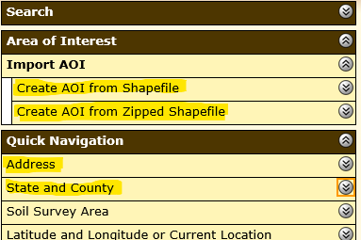
- Enter the address for the parcel (Option A), select “Colorado” and the county where the parcel is located (Option B), or import your singular or multi-part shapefiles (Option C). See next step for specific instructions.
Option A Option B Option C
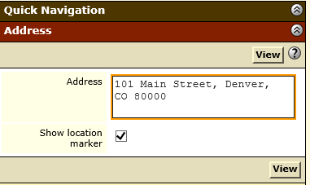 OR 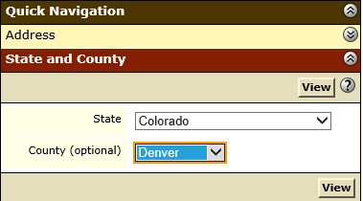 OR 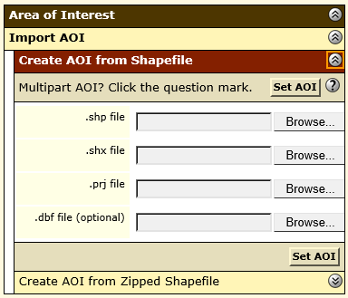
- Option A and B: After entering the parcel address or selecting the parcel’s county/state and selecting “View,” use the icons on the “Area of Interest Interactive Map” to zoom or pan to the parcel. Use the AOI (“Area of Interest”) buttons to draw the boundaries of the parcel using single clicks. Double click when finished drawing; the final polygon will appear with blue cross-hatching. Repeat this process for any additional polygons needed.
Option C: Open either “Create AOI from Shapefile” or “Create AOI from Zipped Shapefile” depending on your goal and shapefile data makeup. Select “Browse,” navigate to the location of your shapefiles, select the shapefiles as appropriate, and select “Open.” The file location should appear in the box next to “Browse.” Select the “Set AOI” button. Your parcel boundaries will appear in the “Area of Interest Interactive Map” in blue cross-hatching.
Note: Using any option, the boundaries must match all other maps provided in the application package. Any polygons created must be for the entire parcel offered area. If there are planned subdivisions or non-contiguous parcels, this process must be repeated for each area.
Custom Soils Resource Report Instructions (for basic soils information)
- Follow “General Access Instructions.”
- Select the “Soil Map” tab near the top of the page to view the soils map and soils table.
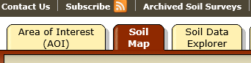
- You may see “Warning: Soil Map may not be valid at this scale” under the map. This is just for your information. Proceed with the next step.
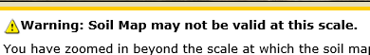
- Select “Add to Shopping Cart” near the top right of the page. A new window will pop up. Enter a subtitle that will properly identify the parcel. Select “OK.”
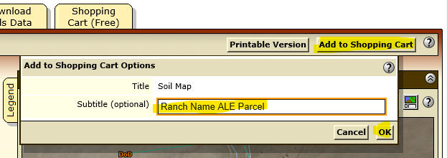
- Navigate to the “Shopping Cart (Free)” by selecting the last tab near the top of the page.

- Under “Report Properties,” select or enter a subtitle selection that will properly identify the parcel and review the other information.
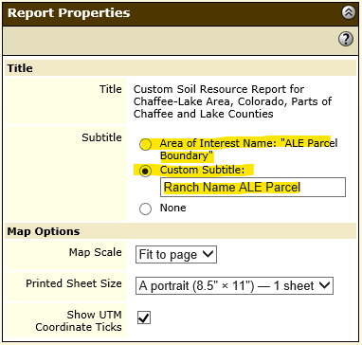
- Under “Table of Contents,” ensure all the “Soil Map” and all sub-groups are checked at a minimum. Note: Some fields automatically populate and cannot be removed.
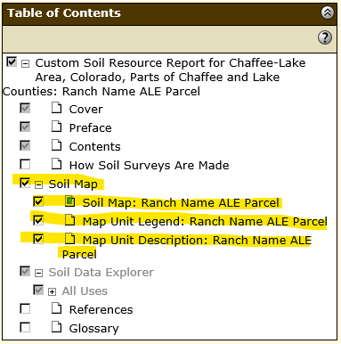
- Select “Check Out” near the top right of the page. A window will appear; select “Get Now” and then “OK.”
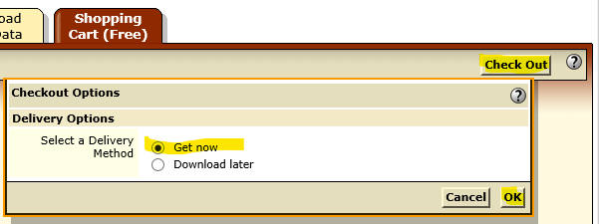
- A message box may appear at the bottom of the window indicating the report is downloading. A PDF of a Custom Soil Resource Report will pop up. (Note: If this does not occur, you may have to check your downloads or other location on your computer.) Save and/or print this report for the record.

Farmland Classification Instructions (a.k.a., “prime soils”)
- Follow “General Access Instructions.”
- Select the “Soil Data Explorer” tab near the top of the page. Then, select the “Suitabilities and Limitations for Use” sub-tab.
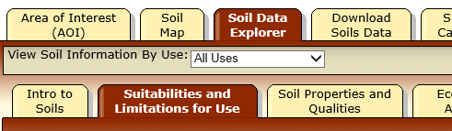
- On the left of the page, find “Land Classifications” in the list and select the two down arrows to expand. Once expanded, select the two down arrows next to “Farmland Classification” to expand.
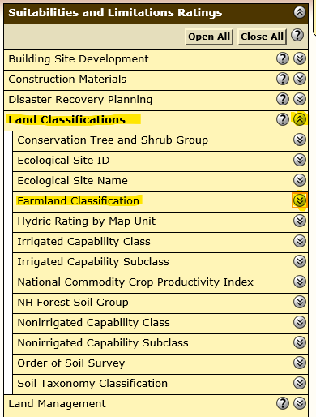
- Select either “View Rating” button in the expanded window. An interpretive soils map and table appears to the right. You may see “Warning: Soil Map may not be valid at this scale” under the map. This is just for your information. Proceed with the next step.
- Click on the “Printable Version” button located near the top right of the screen. A new window appears. Select or enter a subtitle selection that will properly identify the parcel and review the other information. Select the “View” button.
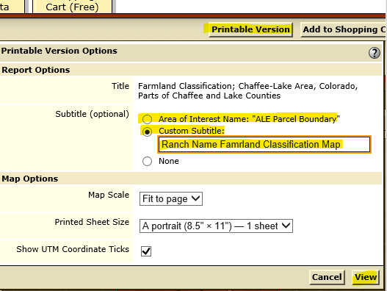
A message box may appear at the bottom of the window indicating the report is downloading. A PDF of a Custom Soil Resource Report will pop up. (Note: If this does not occur, you may have to check your downloads or other location on your computer.) Save and/or print this report for the record.

APPENDIX 3: NONPOINT SOURCE WATER POLLUTION WATERSHED OF PROTECTION

This map shows the Texas Nonpoint Source Water Protection Watersheds. If ACEP-ALE parcels fall within one of these watersheds and meet certain criteria, they may receive additional ranking points. Funded parcels that meet the criteria for this initiative will help NRCS reach its statutory goal of spending 10% of its overall funding on source water protection. Shapefiles can be provided upon request.
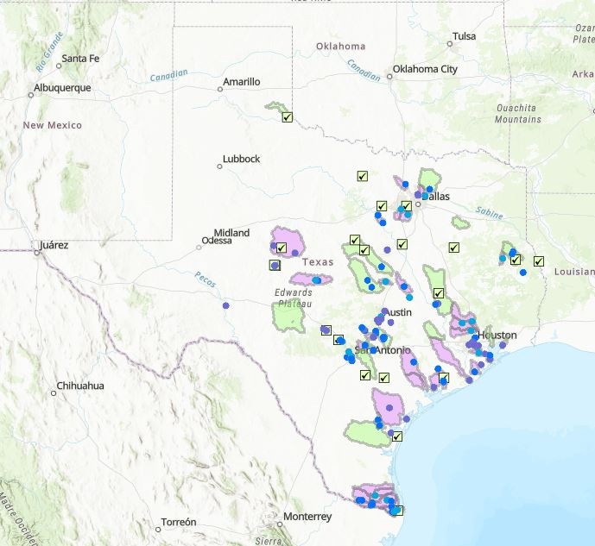

APPENDIX 4: COST SHARE MATCH REQUIREMENTS FOR 2018 FARM BILL ENROLLMENTS

General Information

There are two types of enrollments available under the ACEP-ALE: General and Grasslands of Special Significance (GSS). Each enrollment type has specific requirements for cost-share and matching funds. These requirements are based on the fair market value (FMV) of the easement as determined by an appraisal or other means of easement valuation and as accepted by the NRCS. The determination of FMV cannot not include any amounts for other costs for acquisition or management. The eligible entity must provide information on the estimated FMV and all contribution sources at the time of application. If funded and before closing, the eligible entity will provide a final listing of sources on the CPA-230E or CPA-230F, “Statement to Confirm Matching Funds” form and will provide supporting invoices, receipts, and other documentation as applicable.

Federal v. Non-Federal Share

Table 1. Federal and Non-Federal Share Requirements.
 | Federal Share (max. % of FMV) | Non-Federal Share (min. % of FMV)
General ALE Enrollment | 50% | 50%
ALE-GSS Enrollment | 75% | 25%†
†Estimation. The Non-Federal Share for GSS must be at least equivalent to the Federal share or satisfy the remainder of the easement FMV.

To be eligible for up to 75% Federal Share, the parcel must meet the established qualifications of GSS and the GSS option must be selected on the CPA-41A form. The GSS definition and other criteria can be found in the applicable section of this Questionnaire. There are no longer cash contribution waivers available for GSS or any other enrollment.

Non-Federal Share Requirements

The Non-Federal Share may be comprised of various sources. The allowable sources are listed below and should be considered in the order they appear (#1-4). No other sources will be considered.
- The eligible entity’s own cash resources for payment of easement compensation to the landowner or for a buy-protect-sell transaction, the amount of the fair market value of the ALE, less the amount of the Federal share, that is provided through the conveyance of the ALE by the eligible entity. The resources may in in-hand or committed. If these resources are less than 10% of the easement FMV, the eligible entity must attach to the CPA-41A specific evidence of funding or capacity available to manage, monitor, and enforce the easement. Eligible entities shall also review the requirement on the applicable CPA-1268 or SF-270 Supplement payment forms related to cash contributions less than 10% to ensure sufficient documentation can be provided at the time of payment.
- A landowner donation toward the easement value in the form of a charitable donation or qualified conservation contribution (section 170(h) of IRC of 1986). No other form of donation is acceptable. ACEP-ALE does not require the landowner to donate any part of the easement FMV.
- The procured costs paid by the eligible entity from sources other than the landowner (directly or indirectly) to a third-party for ONLY the items listed below. If not listed here, the procured cost is not acceptable for the Non-Federal Share. If the cost of any one of the items listed below is counted toward the Non-Federal Share, the report or service must meet the standards or requirement as identified in the ALE agreement or other NRCS-provided documentation.
  - Appraisal
  - Legal boundary survey of the easement area
  - Phase-I environmental site assessment that meets the requirement of 40 CFR Part 312
  - Title commitment or report
  - Title insurance
  - Baseline reports
  - Minerals assessments
  - Closing costs
- Up to 2% of the easement FMV toward stewardship and monitoring costs contributed by the eligible entity from sources other than the landowner (directly or indirectly). Any amount over 2% will not be counted.

Examples

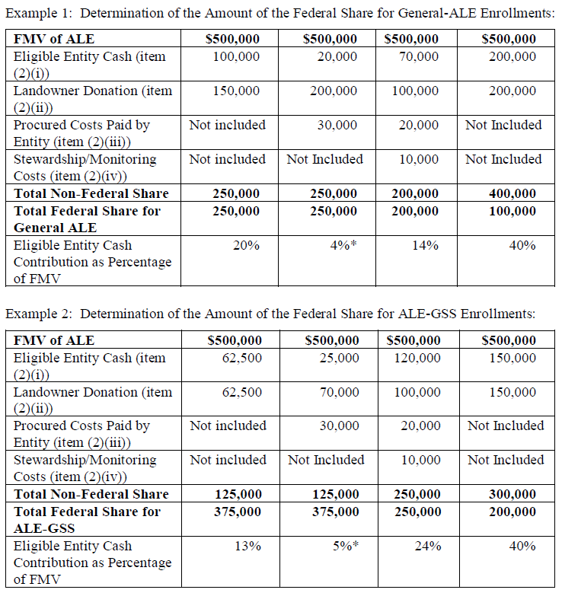
*See requirements in #1 of the “Non-Federal Share Requirements” section for cash contributions less than 10%.

- END -

