January 7, 2021

Starting time: 1:00 PM PDT/4:00 PM EDT

To join:
Call-in: 888-844-9904
Access Code: 2415774#

Participants

☐ Russ Almaraz – NRCS
☒ Matthew Ballmer – NRCS
☒ Jeff Bruggink - USFS
☐ Cory Cole - NRCS
☒ Martin Figueroa – NRCS
☒ Dave Kingsbury – NRCS
☒ Theresa Kunch – NRCS
☒ Jessica Lene’ – NRCS
☐ Parker Martyn - NPS
☒ Benjamin Moore – NRCS

☐ Alan Peck - BLM
☐ Betsy Schug – NRCS
☒ Tim Riebe – NRCS
☒ Josh Rose – FWS
☐ Matthew Tucker – NRCS
☐ Karen Vaughan - UWYO
☒ Aaron Wells – ABRI
☐ Guest:
☐ Guest:
☐ Guest:

ACTION ITEMS FROM PREVIOUS MEETING:
- Provide spreadsheet to team members for review. Provide recommendations to RDs (include Kingsbury if you wish to do so). (Spreadsheet provided this past July and before last TC on Dec. 3rd).
- RD’s to update spreadsheet based on feedback (need to follow up on this since holidays delayed progress on this; from last month, Kingsbury will pass updated spreadsheet on to Paul Reich).
- Possible presentations were identified – Cory Cole and Nathan Starman.
(Will provide update on this; AK staff have schedule conflict; Nathan awaiting information from NGDC (Ft. Worth))

MEETING AGENDA ITEMS:

- Compatible Team Updates (If participants are present) (None this meeting)
DSM Focus Team –
Training FT –
Fed Lands Liaison –
Other –

- IMFT Update (presentation delivered to NRCS SPSD Leadership on Nov. 3 and to the IMFT on December 3rd)
  - Review of short-term goals/plan
  - Review of long-term goals/plan
  - Interaction with other Focus Teams

- Development of Order 5 SSURGO (STATSGO2 conversion and development of Order 5 using correlated mapping and expert knowledge) – Update/new developments?
Two main contributors to this discussion:
Ben Moore (Dillon, MT SSO):
- Each of our offices (Dillon, Idaho Falls, Moscow) are working on individual USFS surveys in Idaho.
- These are primarily Order 3-4, with the order of mapping corresponding to management concerns and our staffing capabilities.
- These surveys are polygon products.
- Starting to use DSM techniques to bolster our operations, but do not have any agreements to publish a raster survey(s) at this time.
- Hope is that DSM abilities increase in the coming years to further help our work in more remote areas such as the Frank Church River of No Return Wilderness and other areas with limited access.
- For some of the work in the FCRONR in future years we will be coordinating/teaming up in some fashion to conduct the field work.
- For now, most of the staff time is being allocated towards areas with higher levels of management.
Tim Riebe (Wasilla, AK Regional Office):
- 3M+ acres for Kodiak Island (The Wasilla SSO is working on QC’ing the remaining Pedon and Site data and making necessary adjustments to incorrect classification in NASIS). This effort was estimated to take about 8 weeks. The project will then be ready for proper aggregation of similar soils and DSM analysis against raster stacks. Martin Figueroa is going to be conducting the DSM part. Parts of MLRAs 220 and 225.
- Glacier Bay QA is complete, the State Office is conducting final QA. The Final Correlation Document is signed by the Region and awaiting SSS and State Con signatures. The linework has gone through Spatial QA and is ready for the staging server. This project required updates to two adjoining published surveys. So Three projects were involved… AK692 Glacier Bay, AK693 Yakutat, and AK646 Chatham. Both spatial and tabular data were updated. Parts of MLRAs 222 and 220.
- Currently conducting data population (with QC/QA to follow, immediately) on Initial Mapping of South Kruzof Island (NOTCOM of AK646 Chatham Survey, Published) This is a 60,000 acre USFS project.
- Final Correlation Week is scheduled for February 15th for the Homer Soil Survey Office 1.5 million acre (AK630 Nulato Hills) project. Two weeks of wrap up after final correlation week are expected for finalization. The initial boundary area has been QAd and suggested adjustments to border were outlined for Homer Office staff to address. They are currently reviewing the spatial data following regional technical notes. 68 OSDs were created and they have been entered into the SC tool. The SSOL is running QC on the populated components and is following regional procedures for initial data population. The project adjoins one published survey area and several other initial SSAs. The AK654 Western Interior Rivers (published survey) is being updated where an exact join is required. The tabular and spatial data will be updated for that project. Parts of MLRAs 230, 240, 229, and 238.
- Sitka National Historical Park is scheduled for field work, the week of May 17th.
- 7 million Acre AK748 is scheduled for first field work (3 remote hitches in mountains of Arctic National Wildlife Refuge) June – August.
- STATSGO data elements are being adjusted to meet standards for STATSGO to SSURGO conversion for All NOTCOM (a proposed process that we will accomplish before the next refresh of NASIS).
- 14.3 million Acre MLRA 234 has all Rasters needed for DSM clipped to the MLRA boundary and edited to be used for Analysis and DSM if needed to compliment the STATSGO to SSURGO effort.
- 900,000 acre AK760 Willow Project Area in the National Petroleum Reserve Area is scheduled for field work with BLM in August. This is a traditional mapping project.
- 60,000 acre Update of Totchaket Area Alaska published project AK625 is scheduled for May 31st to June 25th.
- 6 million acre AK686 White Mountains Area Alaska is undergoing tabular and spatial QC and is scheduled to be turned over for QA at the end of the fiscal year. This project involves MLRA 231.
- 3 million acre AK659 North Copper River Area Alaska is undergoing mapunit development and QC of tabular and spatial. More field work will be conducted as this is an ongoing Order 2 and 3 project. Progressive posting will occur through the completion in 2025. This project involves published surveys AK612 Copper River, AK649 Gulkana River. Parts of MLRAs 227 and 228.
- 300,000 acre AK638 Cantwell Area is being QC’d currently and is scheduled for QA review by end of FY. This involves adjoining published survey area AK651 Denali National Park Area. Parts of MLRAs 223, 224.
We also have Backlogged projects Seward Alaska and Pilot Point Alaska that will be addressed after two of the above projects are completed.

Agenda items (continued):
- Assisting with the development of initial mapping project plans (see attached spreadsheet)
Can we integrate with PPT items?
Not necessarily only AK and Western US.
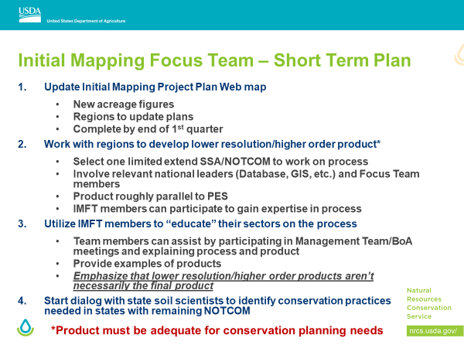

- Other business

ACTION ITEMS FROM THIS MEETING
1. Non-NRCS partners – for the next meeting, what are your expectations of the team and what do you see as your role (i.e. how can you assist/participate to help move forward)?
(Follow up question…what can non-NRCS’ers do to help you meet the 2026 deadline?)

NEXT MEETING DATE

February 4, 2020 – 1:00 PM PST/4:00 PM EDT (Proposed)

Skype Link:
.........................................................................................................................................
Join Skype Meeting
Trouble Joining? Try Skype Web App
Join by phone

Toll number: +1 636-352-2946,,325368133# (Dial-in Number) English (United States)

Find a local number

Conference ID: 325368133
Forgot your dial-in PIN? |Help

_{[!OC([1033])!]}
.........................................................................................................................................

