

IRRIGATION
WATER
MANAGEMENT
PLAN
CENTER PIVOT SYSTEM

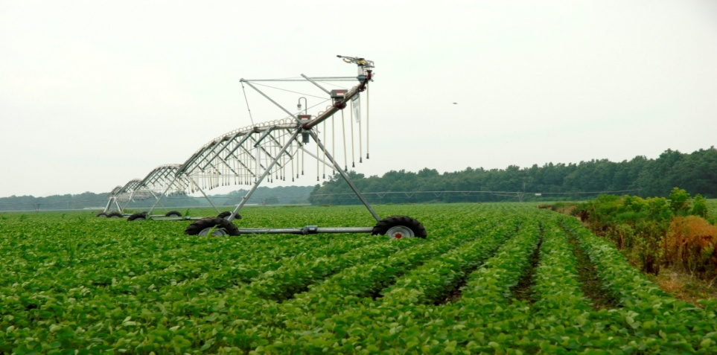

Owner/Operator
As the owner/operator of this Irrigation Water Management Plan, I certify that I, as the decision maker, have been involved in the planning process and agree to the items/practices listed in this document. I understand that I am responsible for the implementation of this IWM Plan and for keeping all the required records.

Signature: _________________________________________ Date:_________

Name: ____________________________________________

Farm Number/s: _______________________________

Tract Number/s: _______________________________

Consultant: ___________________________________
Section 1 – Definition and Requirements

What is Irrigation Water Management (IWM)?

IWM is simply defined as determining and controlling the volume, frequency, and application rate of irrigation water in a planned, efficient manner.

What are the benefits of proper Irrigation Water Management?

- Conserves water through efficient application and scheduling
- Improves crop yield and quality by managing according to crop needs
- Reduces runoff resulting in decreased soil erosion
- Decreases deep percolation and leachate contaminates into ground water
- Improves water quality (surface and subsurface)
- Saves energy through efficient pumping
- Reduces nutrient movement past root zone

What does a farmer need to do to implement IWM?

Irrigation Skills and Capabilities
The decision-maker must possess the following knowledge, skills, and capabilities of management coupled with a properly designed, efficient, and functioning irrigation system to reasonably achieve the purposes of irrigation water management.
- How to determine when and the amount of irrigation water that should be applied, based on the rate of water used by crops and on soil moisture monitoring;
- How to recognize and control runoff and erosion caused by irrigation;
- Knowledge of where the water goes after it is applied considering soil surface and subsurface conditions, soil intake rates and permeability, crop root zones, and available water holding capacity;
- How to identify system problems that reduce uniformity of water application;
- How to perform system maintenance to assure efficient operation;
- How to manage salinity and shallow water tables through water management;
- How to manage the operation of the irrigation system considering weather conditions that adversely impact irrigation efficiency and uniformity of application, such as high winds that diminish application uniformity.
- Maintain records including, but not limited to, rainfall, daily ET, soil moisture monitoring results, plant available water balance, and amount of irrigation water applied.

SECTION 2 - PLAN AND MAPS

SECTION 3 - OBJECTIVE OF PRODUCER AND CROPPING HISTORY

The producer’s objective is to manage soil moisture to promote desired crop response without causing erosion, runoff, and losses to deep percolation.

The irrigation system is designed to meet the peak ET of the grain crops in the rotation.

Crop History

The crop rotation follows a corn/barley/soybean rotation. The corn is planted in greater than 30% residue following planting. Following harvesting corn, a one pass conservation tillage tool is used to loosen and flatten corn stalks. Immediately following corn harvest, barley is drilled using a no-till drill. Double cropped soybeans are planted following the harvest of small grain.

Conservation Practices to reduce erosion and promote soil sustainability include 329 Residue and Tillage Management – Strip Till: 340 Cover crop: 328 Conservation Crop Rotation; 590 Nutrient Management; and 595 Integrated Pest Management.

Irrigation History

The field has been continually irrigated since 1995 with a center pivot irrigation system. A new system was installed in May of 2005.

SECTION 4 – SYSTEM INFORMATION

The irrigation system consists of a Hercules II, Zimmatic Center Pivot that covers 178.4 acres. The system includes a flow meter, pressure gage, and backflow preventer.

The system was installed on May 30, 2005 by Sussex Irrigation: The actual flow rate and pressure as determined by field measurements of the system under normal operating conditions are:

- The average flow rate is 1340 gallons per minute or approximately 7.5 gallons per minute per acre irrigated.
- Pumping plant operating pressure is 60 psi.
- System operating pressure is 50 psi when the end gun is operating. The end gun is supplemented with a booster pump.

Each year at the end of the cropping season, Sussex Irrigation drains and performs system maintenance.

The system was evaluated in the spring of 2009 by the University of Delaware with the results provided to the NRCS. The system evaluation is contained in Appendix A at the end of the IWM plan. When the system is operating at a 37% timer setting on-site actual test has determined it takes 24 hours for a full rotation. Flow rate is an average of 1340 gallons per minute. Typically at this setting, 0.38 inches of water (average irrigation water depth - area weighted) will be applied by the system. The system will deliver 1,937,593 gallons of water during an irrigation event over 178.4 acres.

Typically the producer applies water using a timer setting of 37%, with an estimated 24 hours to complete a full circle and applying 0.38 inches of water.

Timer Setting Chart supplied by Zimmatic (or as determined during the system evaluation shown in Appendix A) is as follows:

Irrigation depth/inches | Timer Setting | Full Circle Rotation
0.12 | 100% | 8.3 hours
0.20 | 62% | 13.3 hours
0.30 | 42% | 19.9 hours
0.40 | 31% | 26.5 hours
0.50 | 25% | 33.2 hours
0.60 | 18% | 39.8 hours
0.70 | 16% | 46.5 hours
0.80 | 16% | 53.1 hours
0.90 | 14% | 59.7 hours
1.00 | 12% | 66.4 hours

Irrigation water source, well yield, and water test results

Water source is a subsurface aquifer. Weber Well Drilling installed a 12 inch well 350 feet in depth, in April of 2005. Static water table is at 10 feet. The submersible pump is powered by an electric motor connected to a three phase system. Well capacity determined by Weber Well Drilling is 1500 gallons per minute. The pressure at the pumping station is 60 psi. The actual pumping rate as determined by flow measurement is 1,340 gpm.

Irrigation water must be tested for the following:

Suspended Solids
pH
Salt
Manganese ⁽¹⁾
Total Iron
Nitrate
Bacterial Population ⁽¹⁾

- These test required for Drip Systems only.

Soil Test

Provide soil test data from an approved soil testing lab.

Fertigation

In order to protect water quality when fertigating (applying 30% liquid nitrogen) a backflow prevention device was installed by Sussex Irrigation. A backflow prevention device is required to protect water supplies on systems used to apply fertilizer, chemicals, or liquid manure.

Irrigation Permits

(Provide water allocation permit, well permit number, and supporting data.)
SECTION 5 - PLANT AVAILABLE WATER DETERMINATION

Soil Data

Plant available water was determined by an on-site evaluation of soil textures in the soil profile and managed for a profile depth not to exceed 18 inches.

Table 1: Available Water Holding Capacity by Soil Texture

Textural Class | Available Water Capacity
 | Inches/Inches of Depth in Profile | Inches/Foot of Depth in Profile
Coarse Sand | 0.03 - 0.06 | 0.4 - 0.7
Sand | 0.06 - 0.08 | 0.7 – 0.9
Loamy Sand | 0.08 - 0.11 | 0.9 - 1.3
Sandy Loam | 0.10 - 0.16 | 1.2 - 1.9
Fine Sandy Loam | 0.14 - 0.18 | 1.7 – 2.2
Loam | 0.15 - 0.22 | 1.8 - 2.6
Silt Loam | 0.17 – 0.22 | 2.0 – 3.0
Clay Loam &  Silty Clay Loam | 0.17 – 0.22 | 2.0 – 2.6
Silty Clay  Clay | 0.15 – 0.20 | 1.8 – 2.4

Three soil borings were conducted in the central area of the center pivot, extending to the northeast direction of the system, mapped as a DoA and DoB (Downer Sandy Loam).
Actual field boring indicated:

Profile | Available Water
0-8 inches dark brown sandy loam | (8 inches X 0.13) = 1.04 inches
8-12 inches brown sandy loam | (4 inches X 0.11) = 0.44 inches
12-18 inches yellow brown sandy clay loam | (6 inches X 0.17) = 1.02 inches
 | Total available water = 2.50 inches

SECTION 6 – IRRIGATION SCHEDULING, SOIL MOISTURE and RECORDKEEPING

Irrigation Scheduling:

The Delaware Irrigation Scheduler (or KanSched or other irrigation scheduler) will be used to monitor Et, rainfall, irrigation events, and soil moisture. The Delaware Environmental Observing System (DEOS) system of weather stations will be the primary source for determining daily values of Et and rainfall depths. The DEOS rainfall data will be supplemented by rainfall depth data collected onsite using a rain gage.

Soil Moisture Monitoring:

The moisture content of the soil will be monitored within the irrigated fields using in ground measuring devices such as tensiometers, gypsum blocks/electrical resistance, and Watermark sensors (granular matrix sensors) or by use of portable measurement devices such as time domain reflectometry (TDR). Other mechanical methods may be used with prior approval. When using in-place measuring devices, such as tensiometers and gypsum blocks, a minimum of two devices per irrigation system shall be used. The water measuring devices will be located in the predominate soils within the field with one sensor placed at a depth of twelve (12) inches below the surface. The second sensor will be placed in the same location at a depth of eighteen inches (18). The soil moisture readings will be used to adjust the model where that capability exist in the model, such as KanSched, or to trigger irrigation events to maintain soil water capacity above the Maximum Allowable Depletion (MAD) value. Soil moisture gages should be inspected weekly. Soil moisture readings should also be collected and recorded weekly during the growing season and at the end of each significant rainfall event.

Soil moisture gages must be maintained in accordance with the instructions provided by the manufacturer.

Soil Moisture Chart When Using Tensiometers
(Based on Soil Texture)

Loamy Sand
Irrigation Range
Sandy Loam
Fine Sandy Loam
Silt Loam

The number of soil moisture monitoring devices planned for a field or farm is dependent upon the following criteria. However, a minimum of two soil moisture monitors (one at a depth of 12” the other at a depth of 18”) per irrigation system shall be used.

- Different soil types and topography within the irrigated acreage. For example; two different soil types, the higher ground is predominately a sandy soil and the bottom land soils are predominately loam or silt.

- Different crop types and/or growth stage within the irrigated field. For example; two different varieties of vegetables in the same irrigated field.

- Different crop varieties or diversity within the irrigated field. For example; two different varieties of corn in the same irrigated field.

Additional soil moisture gages may be warranted in these situations.

Recordkeeping:

- Written documentation of a Daily Irrigation Balance Sheet. This includes a report of the plant available water status, including all rainfall and irrigation amounts. Show documentation of MAD for crop grown when determining irrigation events;
- Each irrigation event must reference the mechanical or electrical soil moisture monitoring devices and measurements or readings used to monitor moisture depletion.

- Provide a written statement annually detailing the findings of a visual inspection performed during operation to determine that components are properly functioning, including but not limited to pressure gages, flow meter, and backflow preventer.

ADDITIONAL IWM COMPONENTS

BACKFLOW AND ANTI-SIPHON PREVENTION DEVICES: A chemigation valve, a backflow and an anti-siphon prevention device, is required to prevent any back flow into the water supply line or water source when pesticide, chemicals, and fertilizer is applied through the irrigation system. This prevents contamination of surface and ground water supplies. A chemigation valve includes a check valve, vacuum relief valve, low pressure drain valve, and chemical injection port is required on center pivot systems.

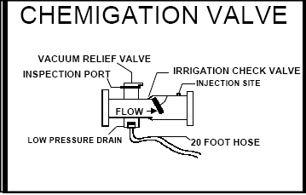
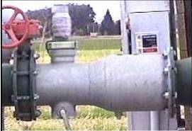

APPENDIX

Soils Map and Data

Feel and Appearance Method for Estimating the Available Moisture in the Soil

Irrigation System Evaluation

Soil Moisture Table Using Centibars

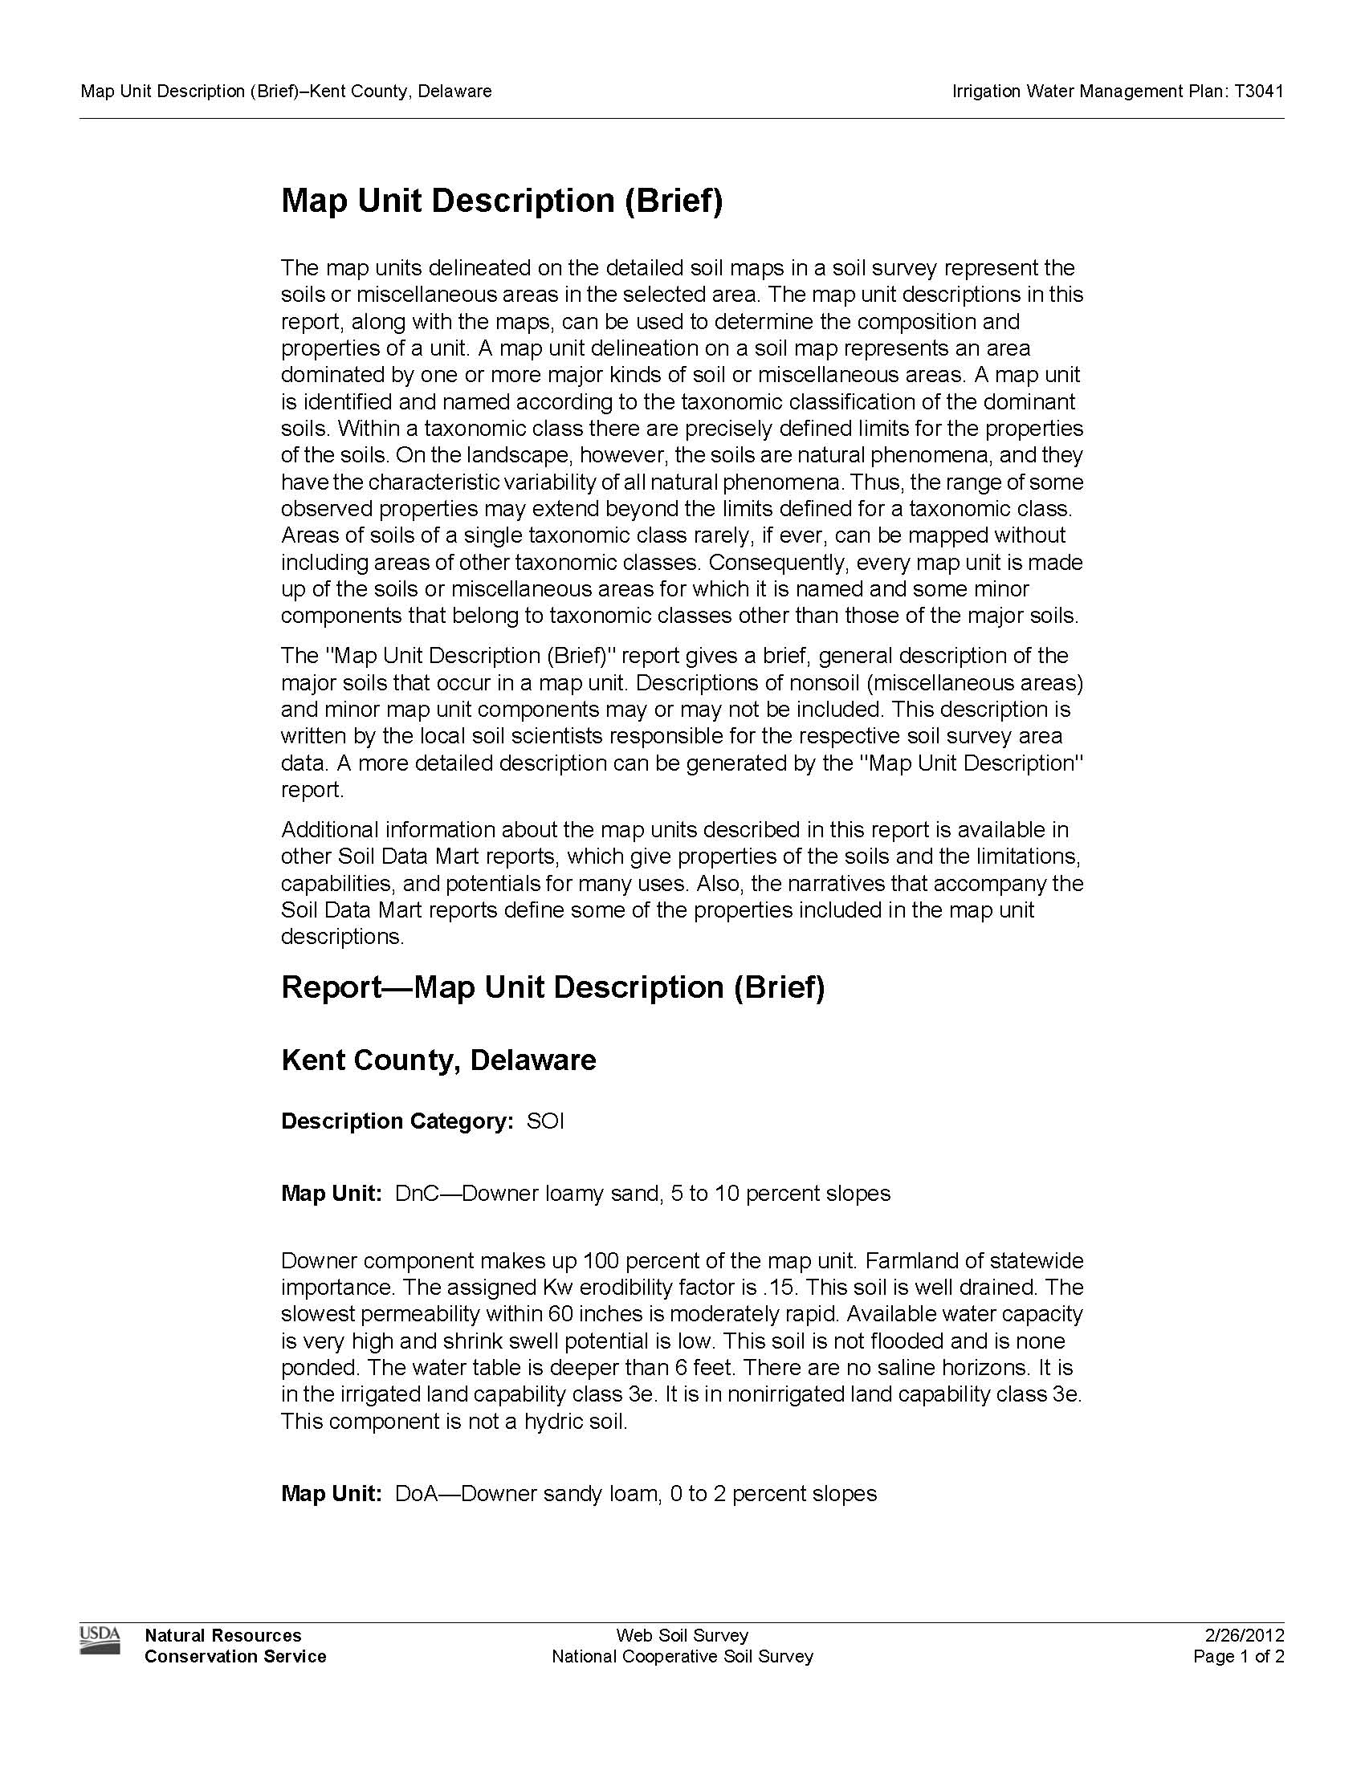
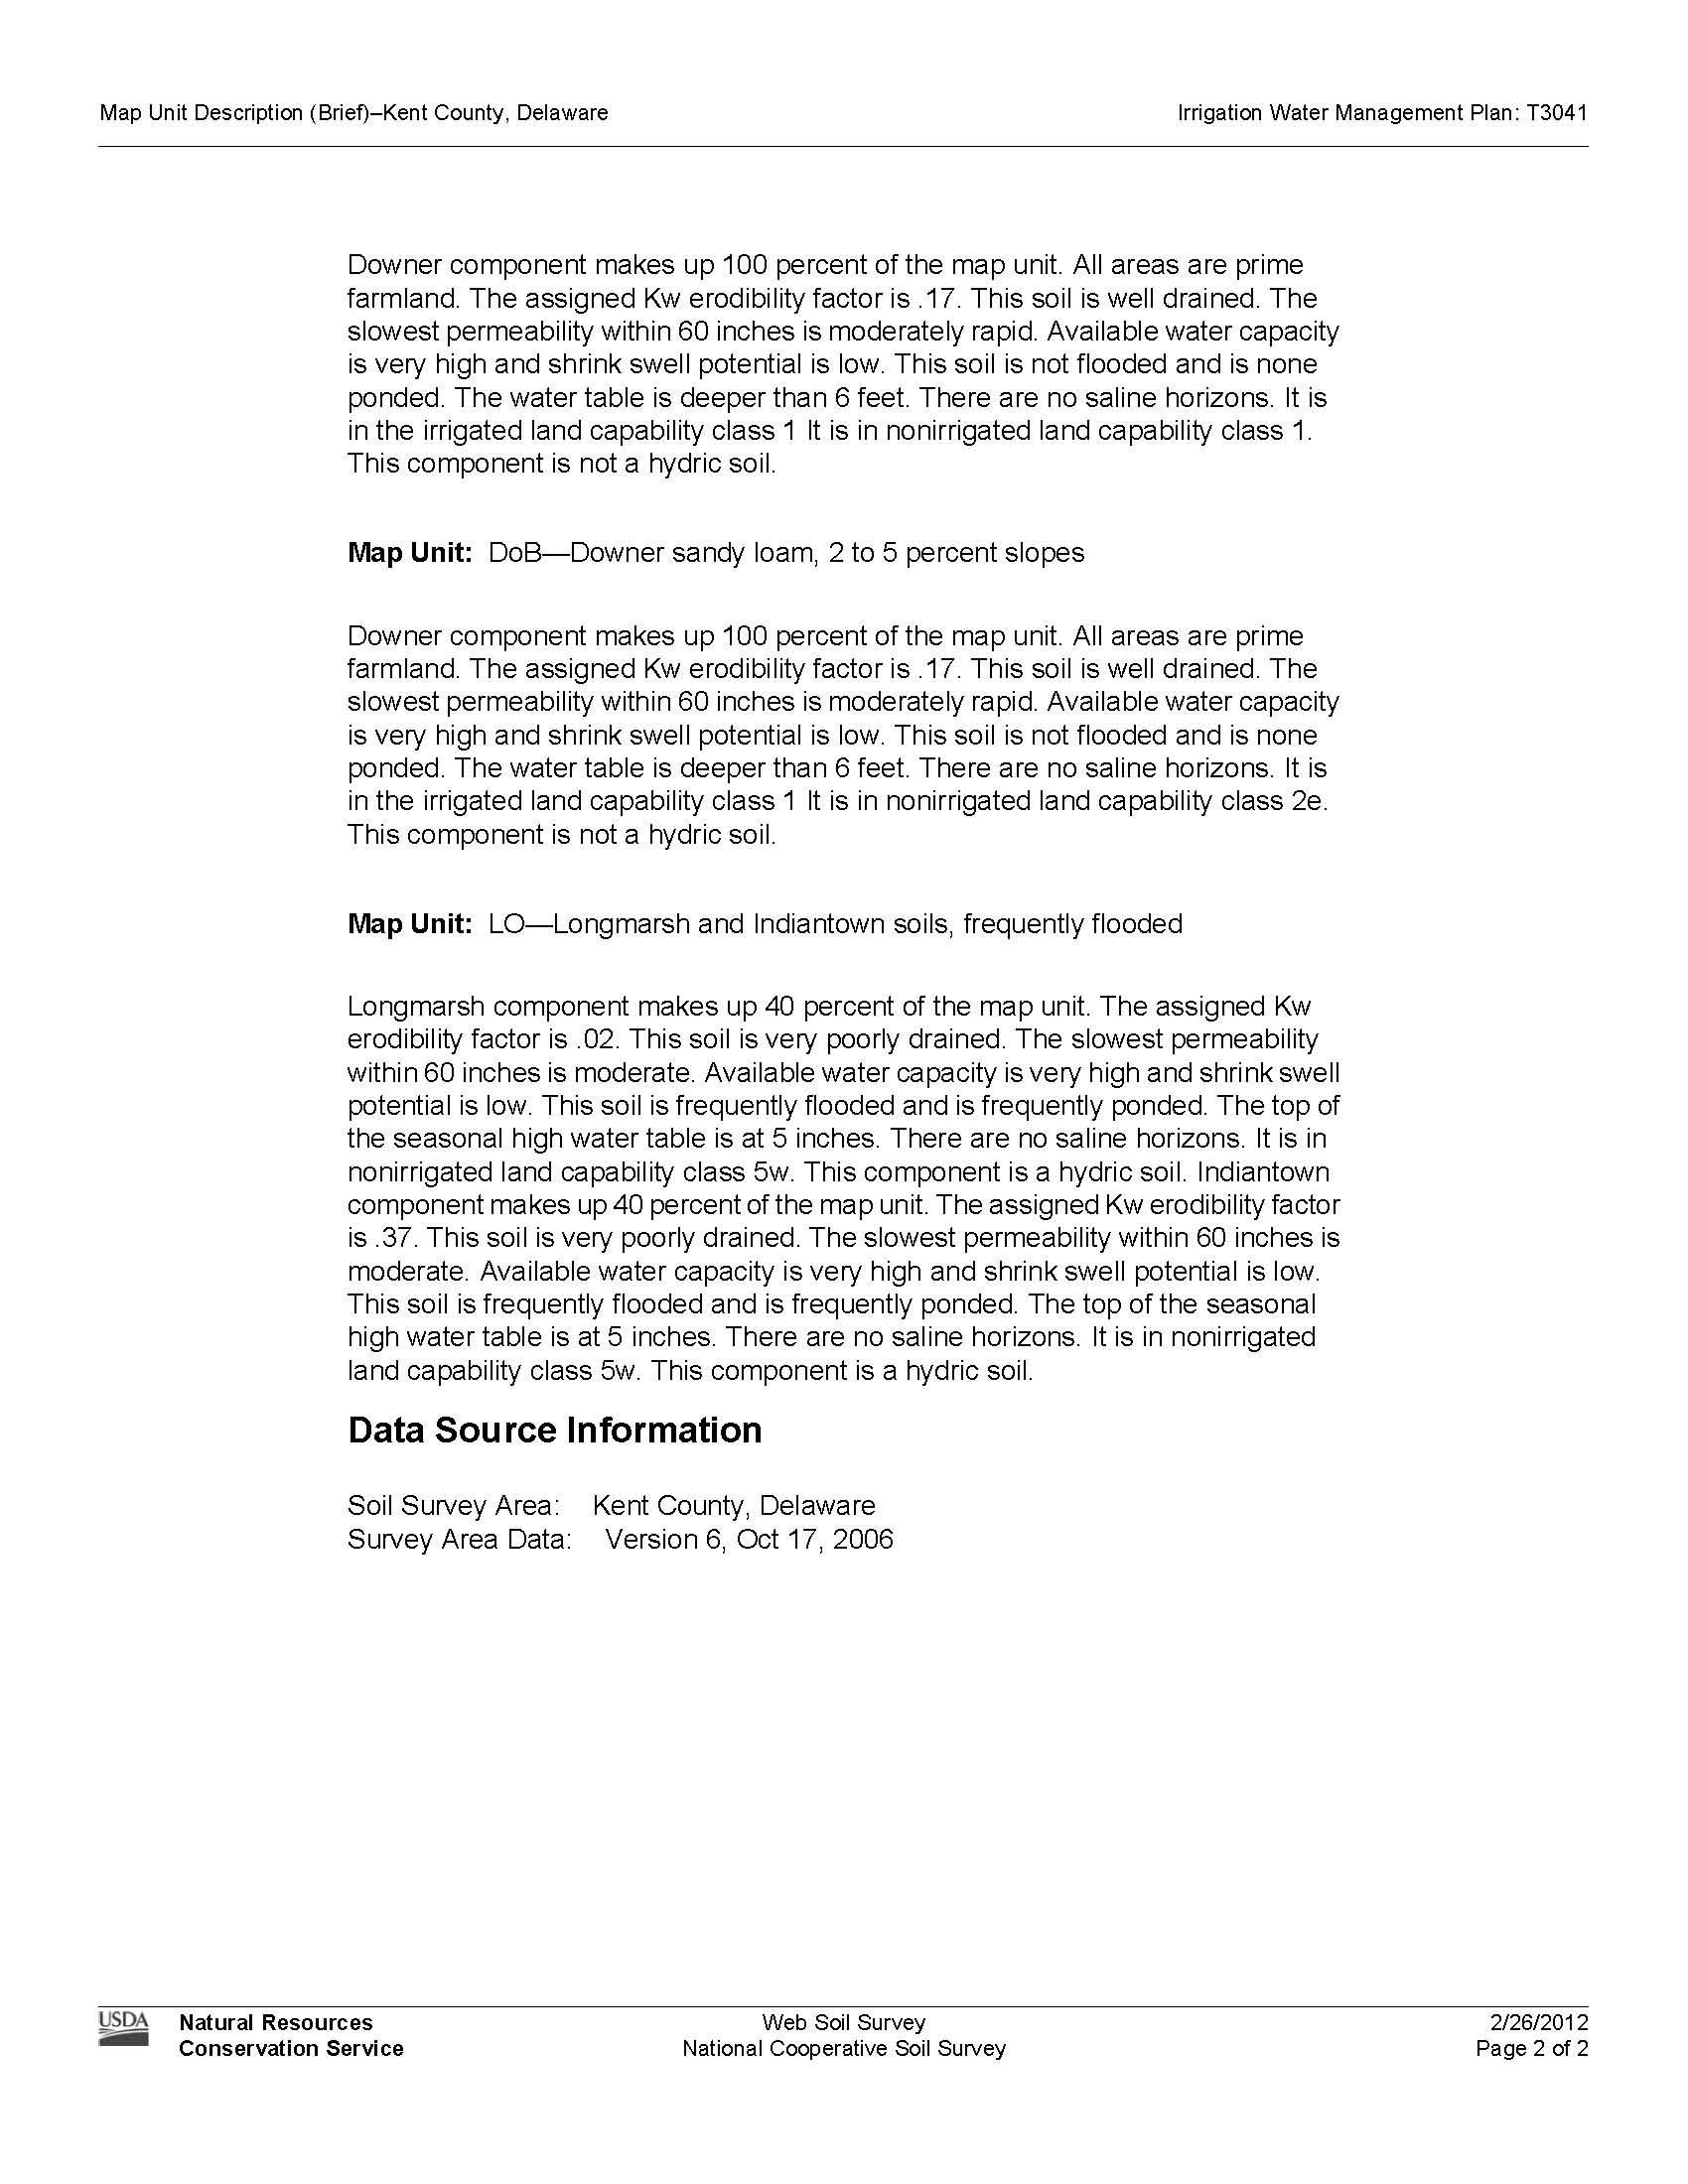
FEEL AND APPEARANCE METHOD FOR ESTIMATING THE
AVAILABLE MOISTURE IN THE SOIL
Available Moisture | Feel, Appearance, and Texture of Soil  AWC (In/Ft)
Available Moisture | Coarse textured soils | Moderately coarse textured soils | Medium textured soils | Fine & very fine textured soils
 | 0.5-1.25 | 1.25-1.75 | 1.5-2.3 | 1.6-2.5
0 - 25 % | Dry, loose, and single grained; flows through fingers | Dry and loose; flows through fingers | Powdery dry; in some places slightly crusted but breaks down easily into powder | Hard, baked, & cracked; has loose crumbs on surface in some places
25 - 50% | Appears to be dry; does not form a ball under pressure* | Appears to be dry; does not form a ball under pressure* | Somewhat crumbly but holds together under pressure | Somewhat pliable; balls under pressure*
50 - 75% | Appears to be dry; does not form a ball under pressure* | Balls under pressure but seldom holds together | Forms a ball under pressure; somewhat plastic; slicks slightly under pressure | Forms a ball; ribbons out between thumb & forefinger
75 - 100% | Sticks together slightly; may form a very weak ball under pressure | Form weak ball that breaks easily; does not slick | Forms ball; very pliable; slicks readily if relatively high in clay | Ribbons out between fingers easily; has a slick feeling
At Field Capacity | On squeezing, no free water appears on soil but wet outline of ball is left on hand | Same as for coarse textures soils at field capacity | Same as for coarse textured soils at field capacity | Same as for coarse textured soils at field capacity
Above Field Capacity | Free water appears when soil is bounced in hand | Free water is released with kneading | Free water can be squeezed out | Puddles; free water forms on surface

Research and Education Center
16483 County Seat Highway
Georgetown, Delaware 19947
Telephone: (302) 856-7303
Air temperature: 50°F
Wind speed: 3 mph
Timer: 31%
Pressure: 46 psi at pivot
Estimated full
circle: 22.94 hrs

2 lines of cans
5° apart
10 ft spacing

GPS at pivot
N00 00.000 W00 00.000
Irrigation system evaluation.

Grower Delaware Farmer
Farm/System 5 Tower Reinke
Date of evaluation October 28, 2011

The system was evaluated by laying out two radial lines of cans, 5° apart, starting from the first tower. Each can is 5 inches in diameter, and they were spaced 10 feet apart. Where possible, the system was evaluated with the end gun operating, with measurements made out to the end of the end-gun’s range. The system speed was measured by timing it over a measured distance.
A number of performance factors can be measured by such tests. These include the average depth of irrigation applied; whether the system is irrigating uniformly; and whether there are problems with the system, such as parts of it over or under-applying water.

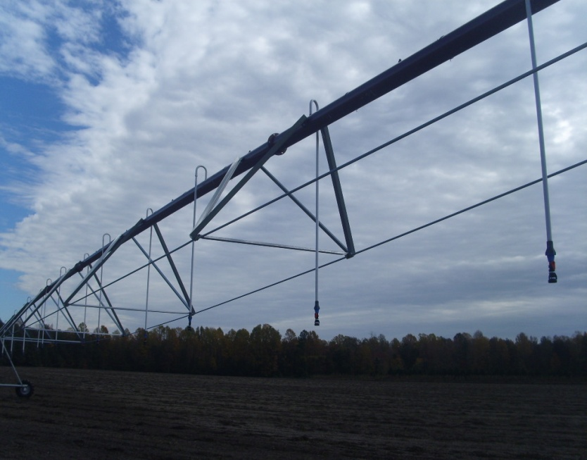
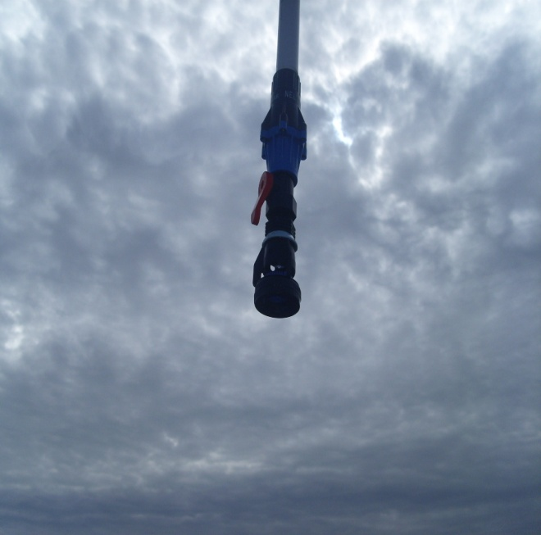

Results:

Overall Coefficient of Uniformity, CU, (area weighted): 88.2%
Line 1 CU: 88.1%
Line 2 CU: 89.3%
Average irrigation depth (area weighted): 0.38 inch
Flow Meter Readings GPM: 508 Pipe Thickness: .226
Average flowrate measured by can test: 501
Flowmeter versus measured percentage: 101%
Manufacturer’s predicted flowrate: 600

A chart of measured irrigation depth along the system is shown on the next page. Also included is a chart showing irrigation depth as it would vary with timer setting, based on the measured irrigation depth, along with the depth specified by the manufacturer.

Comments:
A typical CU for a center pivot that is operating well should be within the range of 85% to 92%. The measured CU of 88.2% is good. The drop in the end gun zone may be attributed to the end gun stops needing to be adjusted. There appears to be a leaking nozzle just before Tower 2 and at Tower 4. The measured irrigation rate was lower than the manufacturer’s chart predicted; please use the attached measured irrigation rate vs. timer setting chart for the future management of this system. Overall a very efficient system and this system should receive a grade of B+.

For questions or comments regarding this evaluation, contact Scott Wright (302) 856-2585 ext. 530 or sewright@udel.edu.

Irrigation amount measured in each can plotted against distance from the pivot point. The 5 can moving average represents the average readings from each can and the two closest cans on each side. 10% of the cans lie above and below the 10% Upper and Lower lines.

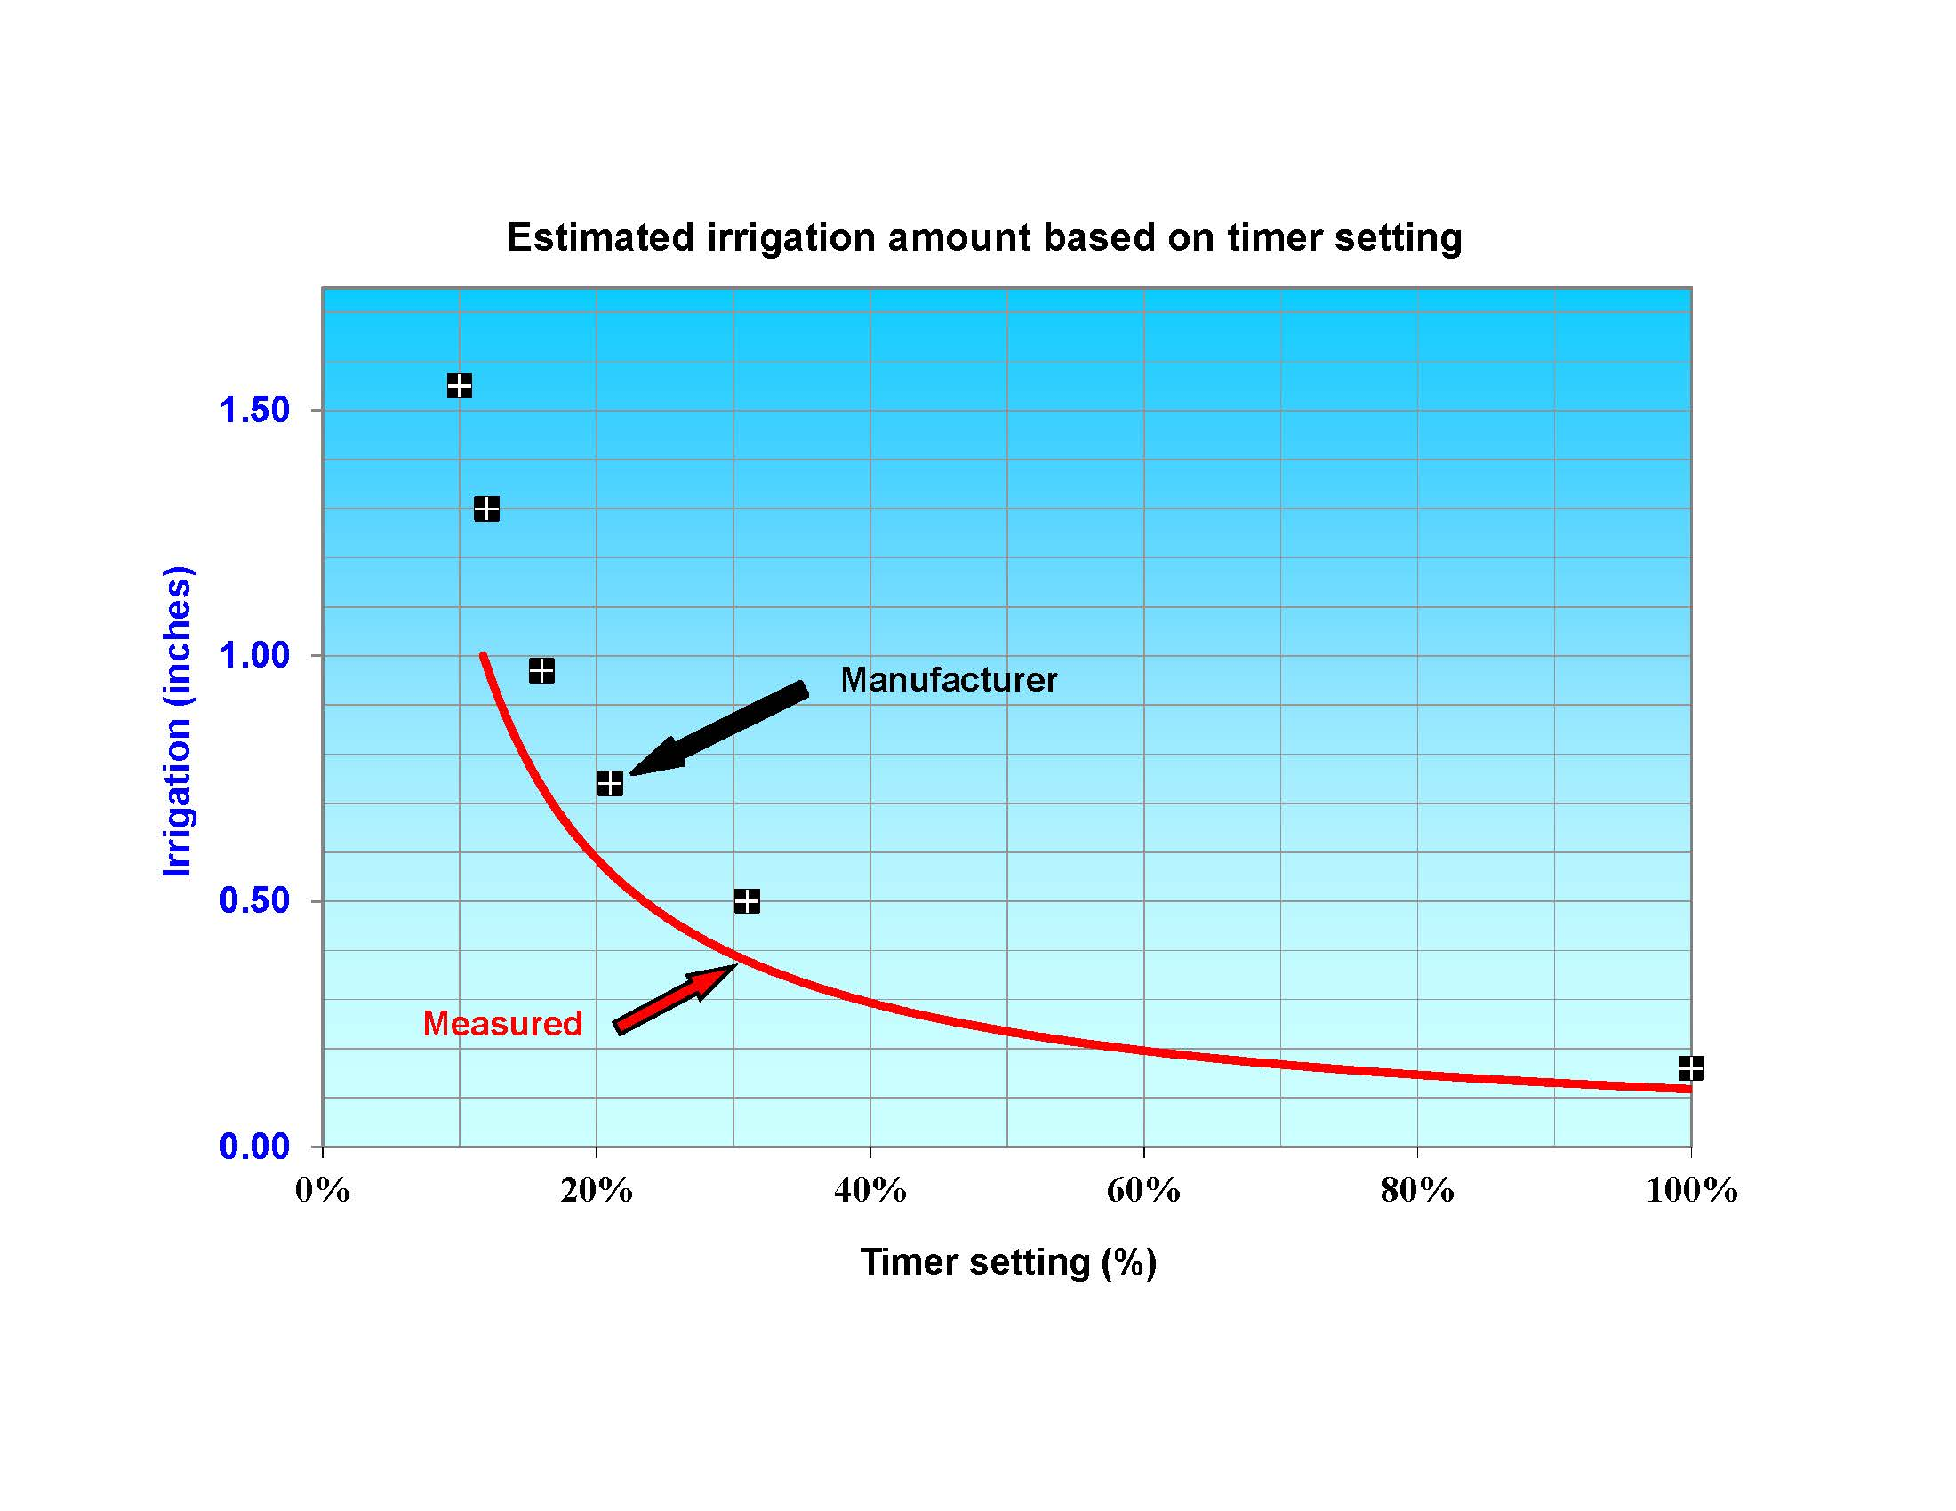
Irrigation amount as a function of timer setting, based on the irrigation amount measured in this test.

Explanation of terms.

Coefficient of Uniformity (CU)

This is a measure of how uniformly an irrigation system is able to apply water. An ideal system would have a CU of 100%, which means that every can would contain exactly the same amount of water after an irrigation. In practice, this never happens. Most cans will contain more or less water than the average. For example, if the average irrigation was 1.0 inches, and a single can contained 1.1 inches, the difference (the deviation) would be 0.1 inches. It is important to consider the deviation in comparison to the average. For example, a deviation of 0.1 inches represents 10% of the average irrigation of 1.0 inches. A deviation of 0.1 inches compared to an average irrigation of only 0.5 inches would be relatively larger (20%), and therefore more important. When measuring the deviation, it doesn’t matter whether the can contains more or less than the average irrigation. A can containing 0.8 inches would have a deviation of 0.2 inches, as would a can containing 1.2 inches. The CU is simply a measure of the average deviation compared to the average irrigation. The higher the number, the lower the average deviation compared with the average irrigation. For a center-pivot, the situation is complicated by the fact that the further from the pivot point the more area is covered by the system. So, a deviation of 20% along the outer part of a pivot is more important than a deviation of 20% close to the pivot point, because the area covered is larger. To account for this when dealing with a center-pivot, “weighted” averages are used that account for the increased coverage area the larger the distance from the pivot point.

