Engineering Field Handbook Chapter 2: Estimating Runoff and Peak Discharges
Delaware EFH-2 Supplement Number 001

Introduction / Background
This Supplement to EFH-2 concerns use of rainfall data developed by the National Oceanic and Atmospheric Administration Atlas 14 (NOAA 14) and rainfall distributions based on the NOAA 14 data. These rainfall data and rainfall distributions will replace rainfall data from Weather Bureau Technical Paper 40 (TP-40) and the standard NRCS rainfall distributions Type II and Type III. This Supplement contains maps, data, and technical procedures for the state of Delaware.
This supplement will be implemented by replacing the state/county rainfall database (county.DE) and rainfall distribution types (type.rf) used with the EFH-2 computer program.
The EFH-2 computer program User Guide contains information, guidance, and examples concerning runoff curve number, average watershed slope, watershed length, input/output operations, and limitations. This supplement includes information related to rainfall data and rainfall distribution for use with the EFH-2 computer program in the state of Delaware. Additional technical information is available from the NOAA 14 web site http://hdsc.nws.noaa.gov/hdsc/pfds/ and NRCS technical directives such as National Engineering Handbook Part 630 – Hydrology, Chapter 4, Storm Rainfall Depth and Distribution.
The Delmarva Dimensionless Unit Hydrograph (DMV) is used in much of Delaware and on the eastern shore of the state of Maryland, between the Chesapeake Bay and the Atlantic Ocean. When computing peak discharges in Kent and Sussex Counties, the DMV should always be used. When computing peak discharges in New Castle County, the DMV may be used in the southern portion of the county, within the Atlantic Coastal Plain Province. In northern New Castle County, within the Piedmont Province, the DMV should not be used. In this area, the Standard Dimensionless Unit Hydrograph is appropriate, and is already preset with the NOAA Region C rainfall distribution. For the purpose of simplicity, the C & D Canal is often used (while recognized this is not the geological divide) as the boundary for use of the DMV. It is recognized, however, that this is a transition area, and the DMV may or may not be appropriate immediately north or south of the canal, depending on the location of the watershed. It is recommended that a professional engineer determine which unit hydrograph to use in the transition area.

Rainfall Data
NOAA completed Volume 2 of Atlas 14 precipitation-frequency analysis in 2004. This is the first comprehensive precipitation-frequency analysis for the Ohio Valley and neighboring states since TP-40 was completed in 1961. Data are available for specific locations from an interactive web site (http://hdsc.nws.noaa.gov/hdsc/pfds/ ). Alternatively, data for representative locations in Delaware are included in a rainfall database county.DE for use with the EFH-2 computer program. The data contained in the database are included in Appendix 1 of this Supplement.

Rainfall Distributions
Four rainfall distributions have been developed for the Ohio Valley and neighboring states (DC, DE, IL, IN, KY, MD, NC, NJ, OH, PA, SC, TN, VA, and WV). These were developed based on the NOAA 14 data. Two of these extend into Delaware. The following map (next page) of the state of Delaware shows where to use the two distributions.

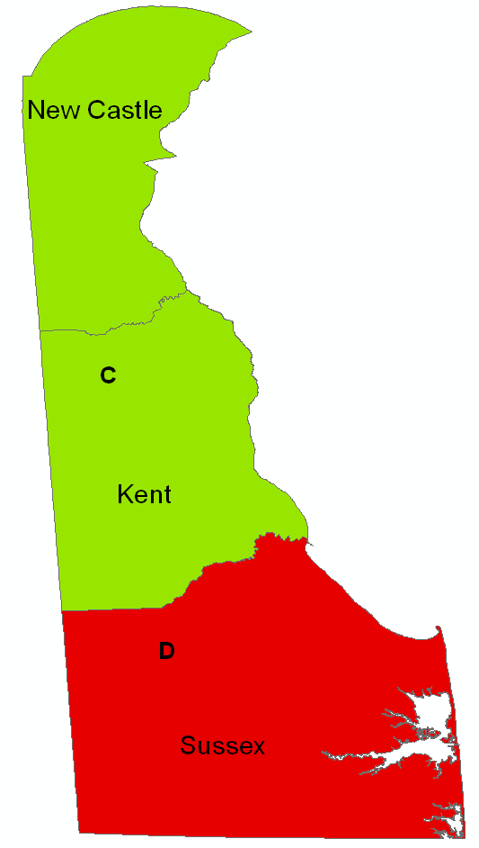
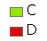
Delaware Regional Rainfall Distributions
The EFH-2 computer program uses equations to relate unit peak discharge (cubic feet per second per inch of runoff per square mile of drainage area) to time of concentration in hours. The equations and coefficients for the two NOAA 14 rainfall distributions are included in Appendix 2. Plots of the two rainfall distributions are included in Appendix 3.

Example Application of the EFH-2 Computer Program in Delaware
For this example, we select a small watershed in Kent County. The drainage area is 25 acres, the curve number is 82, length is 1200 feet, and average watershed slope is 0.5 percent. From the rainfall distribution map above, the rainfall distribution region is “C”.
Open the EFH-2 computer program and open the Basic Data tab. Enter State: DE and use the pull-down menu to select Kent County (Kent_ NOAA14). The “NOAA14” designation indicates that the rainfall table is referenced to NOAA Atlas 14, and includes the most recent rainfall data.
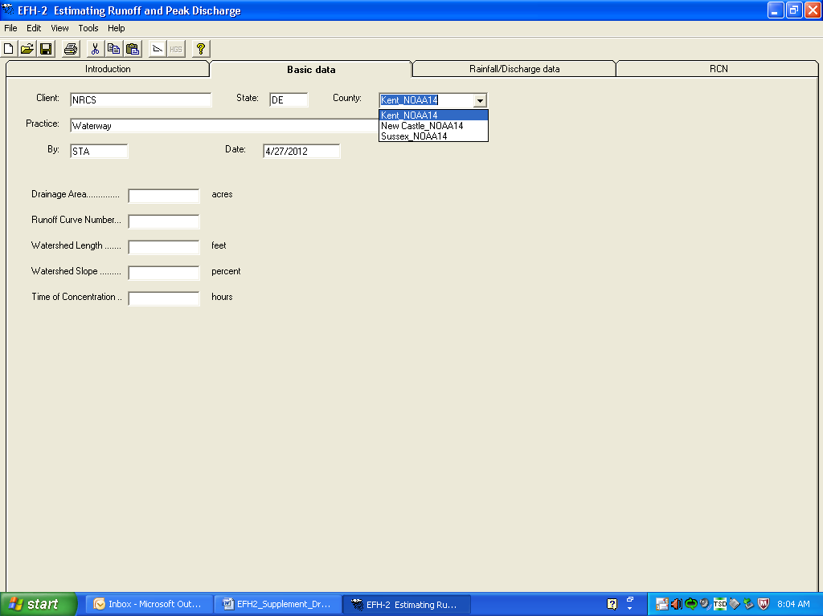

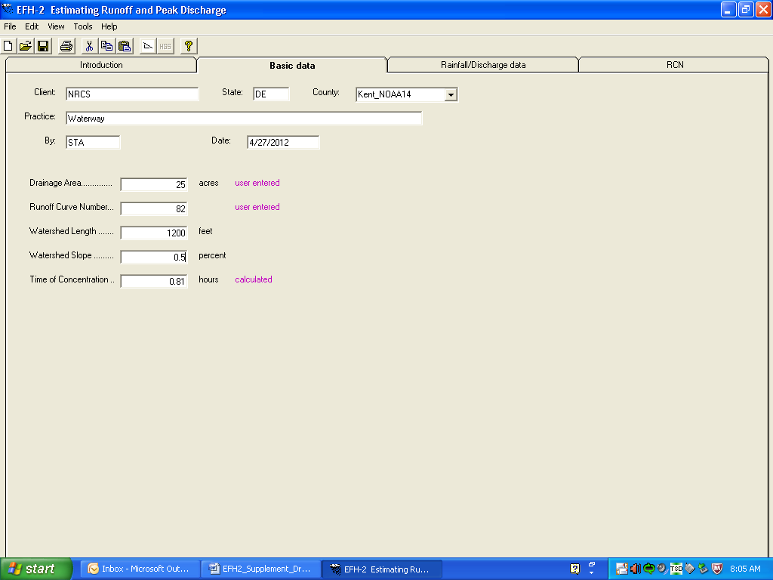

Enter the remaining data on this window. The Drainage Area and Runoff Curve Number could alternatively have been entered by opening the RCN tab (far right side of Basic data window). Open the Rainfall/Discharge data tab.
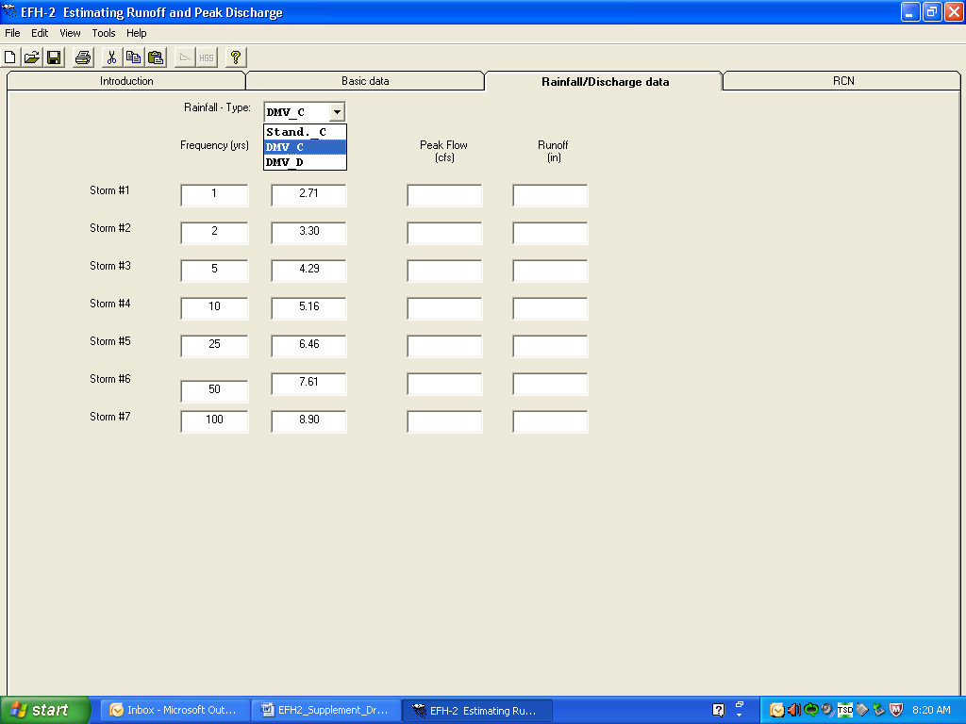

The rainfall data for Kent County have automatically been entered. Use the Rainfall Type: pull-down menu to select DMV_C. For locations in Kent or Sussex Counties, DMV_C or DMV_D should be selected, respectively, from the pull-down menu, based on the appropriate rainfall distribution for the project site (see the rainfall distribution map, above).
Note: Always use the DMV Unit Hydrograph when computing peak discharges in Kent and Sussex Counties. Use Standard _C, for northern New Castle County. Use Standard_C or DMV_C for southern New Castle County, depending on the watershed conditions.
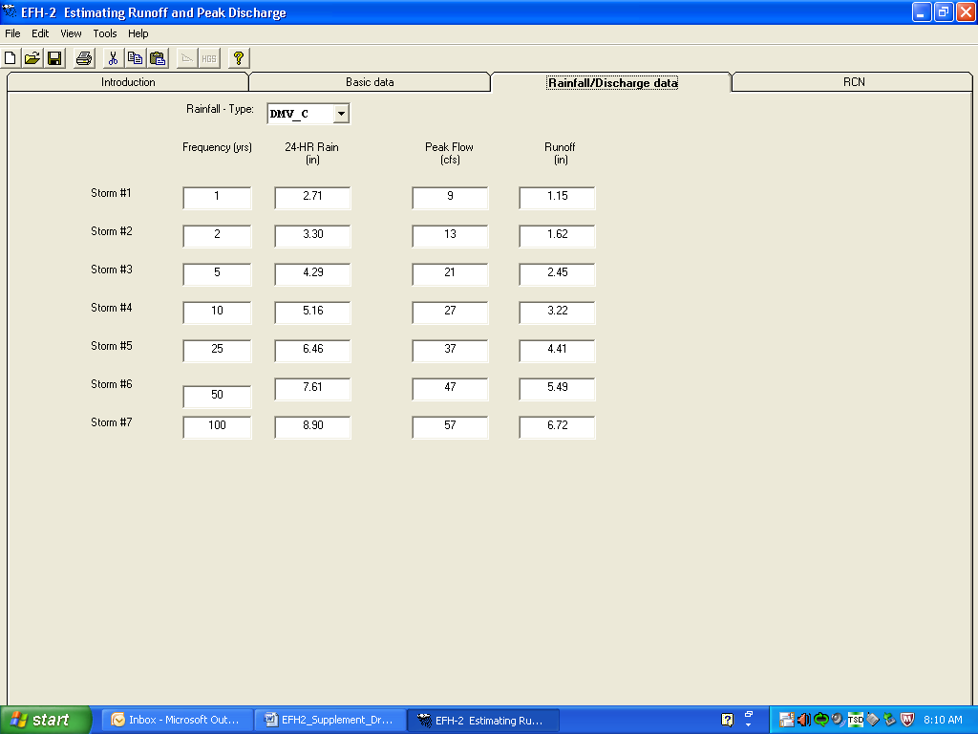

The peak discharges and runoff volumes have been calculated.

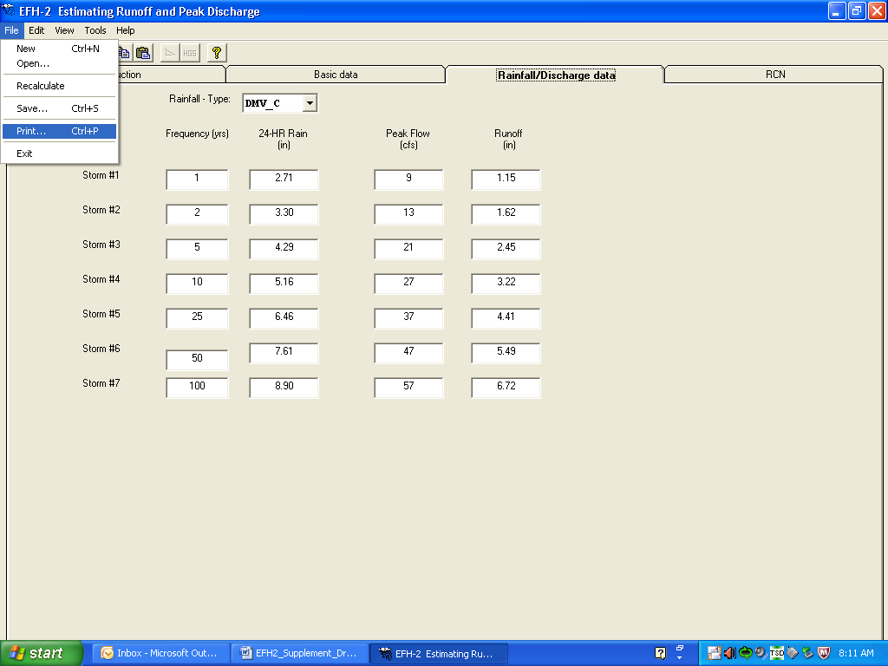

To complete the project, click File and Save. Print output if desired. Close EFH-2.

Appendix 1. County rainfall database (county.DE) Notes: Rainfall distribution for each county and zone are shown with the county name (Region C or D). The 24-hour rainfall duration values are in units of inches.
County/Zone | 1-year | 2-year | 5-year | 10-year | 25-year | 50-year | 100-year
New Castle NOAA-C | 2.64 | 3.20 | 4.09 | 4.85 | 5.99 | 6.97 | 8.05
Kent NOAA-C | 2.71 | 3.30 | 4.29 | 5.16 | 6.46 | 7.61 | 8.90
Sussex NOAA-D | 2.81 | 3.42 | 4.44 | 5.33 | 6.68 | 7.87 | 9.20

Representative points for Delaware counties included in rainfall database are shown below.
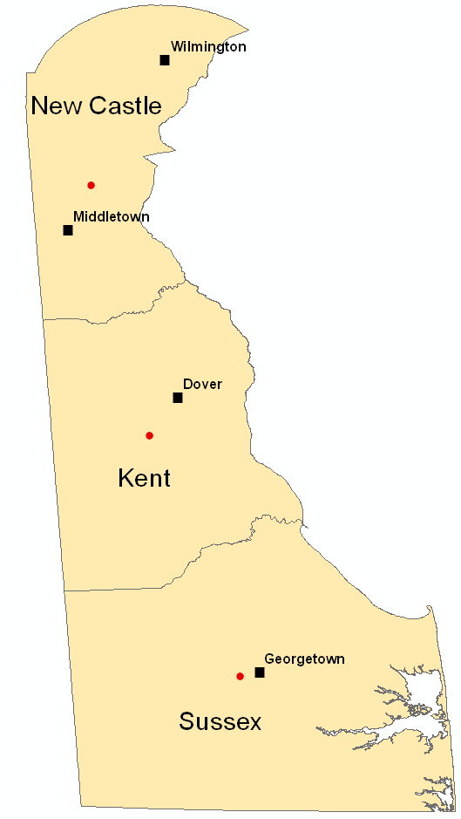
The latitude and longitude of these points are included in the following table. These points were selected because they are approximately located in the center of the county, and most representative of the county rainfall.
COUNTY | Rainfall Distribution | Latitude | Longitude
New Castle Co. | C | 39.5280 | -75.6762
Kent Co. | C | 39.0977 | -75.5750
Sussex Co. | D | 38.6840 | -75.4192

The table above includes Latitude and Longitude for representative points for each county which are in the rainfall database. Longitude is in decimal degrees west and is a negative number. Longitude is in decimal degrees north.

Appendix 2. Rainfall distribution database (type.rf)
Peak discharge results of EFH-2 are derived from results of WinTR-20 runs. To simplify the estimation of peak discharge, WinTR-20 was run for times of concentration of 0.1 to 10.0 hours and Ia/P ratios of 0.1, 0.25, 0.3, 0.4 and 0.5. Ia is initial abstraction in units of inches. Initial abstraction includes all losses before runoff begins (interception, depression storage, early storm infiltration, etc). P is the storm rainfall with units of inches.
Ia = 0.2 * ((1000 / CN) – 10) Eq. 1
where CN = NRCS runoff curve number.
Equations to relate time of concentration to unit peak discharge were then developed based on the WinTR-20 peak discharges. The equation used to compute the unit peak discharge (q) for the EFH-2 computer program is:
q = 10 ^ (Coeff_1 + Coeff_2 * LOG(Tc) + Coeff_3 * (LOG(Tc))^2) Eq. 2
The coefficients to be used with each rainfall distribution are tabulated below. For example, the equation applicable to the Region C rainfall distribution of northern Delaware and Ia/P ratio of 0.1 is:
q = 10 ^ (2.4928 – 0.585 * LOG(Tc) – 0.137 * (LOG(Tc))^2) Eq. 3
For a time of concentration of 0.58 hours and Ia/P ratio of 0.1, the unit peak discharge is q = 420.69 cfs / inch / sq mile.
For a drainage area of 100 acres (0.156 square miles) and runoff of 2.42 inches (rainfall is 4.15 inches, CN is 83, and Ia is 0.41 inch), the peak discharge, Q, is:
Q = 420.69 * 0.156 * 2.42 = 159 cfs Eq. 4

The peak discharge equation coefficients for each rainfall distribution are shown below.

Ia/P Coeff_1 Coeff_2 Coeff_3
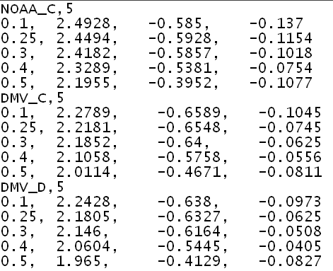

Appendix 3. Plots of the Ohio Valley and neighboring states rainfall distributions.
The following plots show the distribution of rainfall for the 24-hour design storm. They represent the accumulated rainfall during the 24-hour storm duration on a non-dimensional basis. The maximum accumulated rainfall in the plot is 1.0 which represents the total storm 24-hour rainfall.

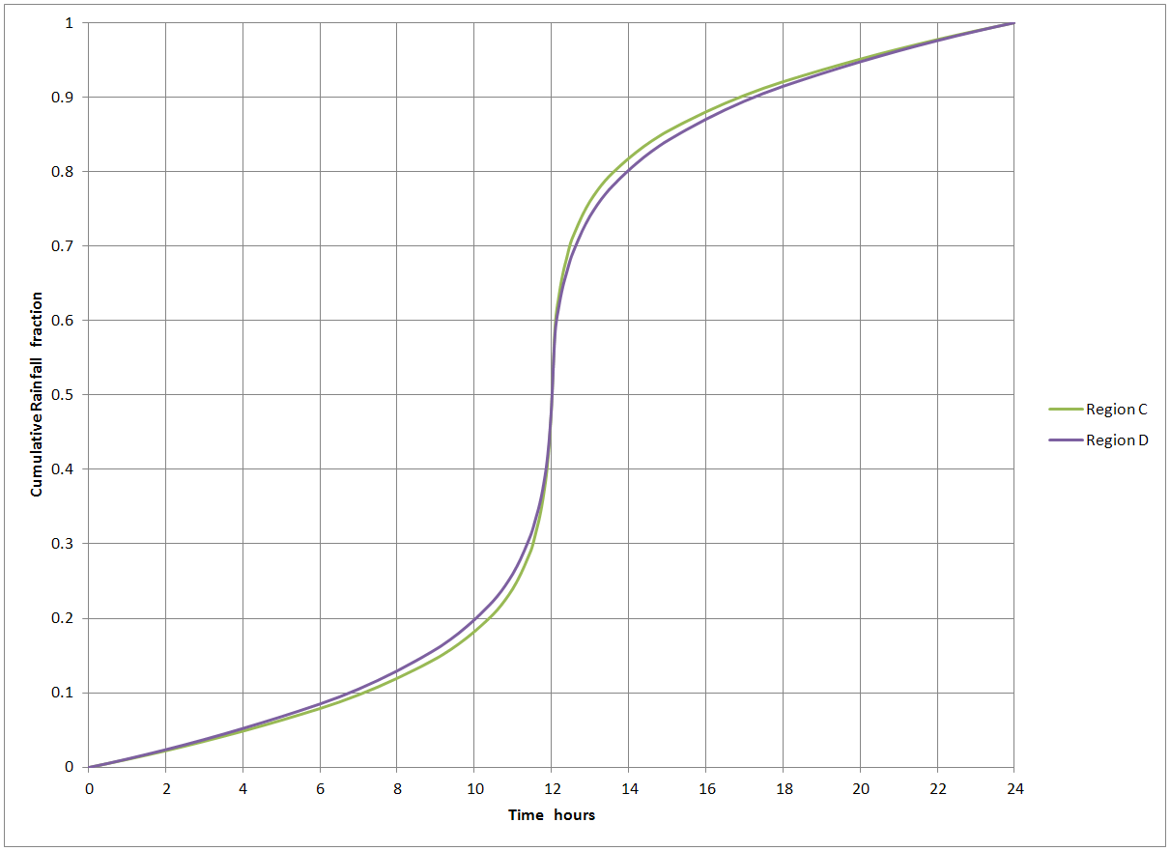

These rainfall distributions are represented in WinTR-20 in tabular format at a time interval of 0.1 hour.

