
Excel Forms for
Ecological Site Information
February 2016

Table of Contents
Introduction to Excel-based ESI Forms 4
Data Entry Methods 5
Degree of Detail 5
ESI Methodologies 5
How To Use The Forms 6
ESI Excel-based Form Names 6
Quality Control: Error Check Macro 7
Error Check Macro: Keyboard Shortcut 7
ESI Form: The Prime Directive 8
Good Habits with ESI Forms 8
ESI Form: Main Capabilities 11
Copy/Paste or Moving Cells: Use Extreme Care 11
Cell Comment Indicators 11
Types of Data Entry Fields 11
Numeric Fields 11
Nonnumeric Fields 12
Unusual Behavior in Data Entry Fields 13
Blacked Out Fields 13
Fields That Turn Red 14
Lowercase Switches to Uppercase 14
Predefined Cursor Path (PCP) 14
Auto-Populated Fields (APF) 15
Plot Layout and Size 16
Required Fields 17
National Plant Symbol (NPS) Fields 18
Data Validation 18
1) Checking a field’s value against allowable values. 18
2) Using the Error Check button. 18
3) Using the NASIS import error check. 19
Importing the Data into NASIS 19
Overwriting Data In NASIS 20
Choice List Code Meaning 20
Printing Legal Size Forms 20
Worksheets in the ESI Excel-basedForms 22
Front Worksheet 22
FrontDES Worksheet 23
WordList Worksheet 24
Change History Worksheet 25
Data Element Map Worksheet 26
Nondiscrimination Statement 28

Table of Figures
Figure 1.—Error Check Complete. 7
Figure 2.—Error Report. 8
Figure 3.—User Site Id. 9
Figure 4.—User Project Id. 10
Figure 5.—Long Note Field. 12
Figure 6.—Limited Text-Length Field (Short Note Field). 12
Figure 7.—Choice Field. 13
Figure 8.—Choice Field: Choice List. 13
Figure 9.—Dependent Choice Fields. 13
Figure 10.—No Blacked Out Fields. 14
Figure 11.—Blacked Out Fields. 14
Figure 12.—Predefined Cursor Path. 15
Figure 13.—Un-Blacked-Out Auto-Populated Fields. 16
Figure 14.—Blacked-Out Auto-Populated Fields 16
Figure 15.—Required and/or Suggested Fields 17
Figure 16.—Choice List Codes. 20
Figure 17.—Page Setup: Print Legal Size. 21
Figure 18.—Excel-Based ESI Form Worksheet Names. 22
Figure 19.—Front Worksheet. 22
Figure 20.—FrontDES Worksheet. 23
Figure 21.—WordList Worksheet. 24
Figure 22.—Change History. 25
Figure 23.—Data Element Map (DEM) Worksheet. 26

Introduction to Excel-based ESI Forms
An Excel-based form that can be used to record data that can then be imported into a corporate database. The Excel-based forms are available to assist in entering Ecological Site Inventory information (ESI) into the National Soil Information System (NASIS).
The methods used to enter ESI into NASIS are based on the philosophy and methods used to enter pedon description data into NASIS. Basically, the philosophy is to use the NASIS application or import existing data in some other way. For pedon description data, you can use the MS-Access database application “Pedon PC” or you can use the various MS-Excel based 232 forms.
If you are responsible for collecting ESI data, however, you only have two viable methods to get your data into NASIS. You can either use the NASIS application interface or use an approved Excel-based ESI form. At present, there is no application comparable to Pedon PC for importing ESI data into NASIS.
Deciding which data-entry method to use is somewhat dependent on the amount of detailed data you need to enter into NASIS. A complicating factor in this decision is the methodology used to collect the ESI data. The ESI database structure, i.e. tables and columns, is based on the various methodologies used to collect the data. Most of these methodologies have a paper-based form that has been used over the years to collect the data. Some of the columns or attributes being collected, however, exist on more than one of the ESI methodology forms. As a result, some attributes with the same name but representing different methodologies and are therefore stored in different database tables. It is important for you to know exactly which of the duplicate columns to use, based on the data collection method used.
Most of the ESI data collection methodologies have a corresponding Excel-based ESI data collection form. The data fields on each form are mapped to specific tables and columns in the database. If you try to enter ESI data directly into NASIS, there is a high probability of getting confused over which table a specific data field is to be stored in.
To help you avoid such confusion, Excel-based ESI forms have been built that import the data into the correct tables and columns in NASIS. These forms are based on the data collection method as expressed in existing, nationally sanctioned paper forms. Not all of the potential data collection methodologies, however, have widely used forms. As a result, not all of the methodologies have a dedicated Excel-based ESI form. If you are using the Daubenmire method, the nested frequency method, or another of the other methods without a widely used form, you will have to enter the data directly via the NASIS interface. This means you will need an in-depth knowledge of the methodology used, the data fields used, and their corresponding NASIS database tables and columns.
It is important to understand that the Excel-based ESI forms contain fewer attributes, expressed as data entry fields, than if the NASIS interface was used. At this time, there are some data fields on some forms that are not yet imported into NASIS. Also, the forms may contain data that is imported into NASIS more than once. These fields should be identified on the individual forms along with instructions on how to enter that data into NASIS using the NASIS interface. Hopefully, over time, as the NASIS import becomes more powerful and the ESI forms become more refined there will be fewer and fewer of these kinds of data fields.

Data Entry Methods
This document is designed to help you enter ESI data using one of the nationally approved Excel-based forms.
Once the data is in the form the data is imported into NASIS using the spreadsheet import icon.

Degree of Detail
The number of detailed attributes you wish to enter into NASIS can be categorized as low, medium, or high.
The number of data entry fields used in one of the Excel-based form is fewer than are available for use when the NASIS interface is used directly. Each form is tailored to a specific ESI data collection methodology, for example, Basal Gap Canopy Gap, Line Point Intercept, Fixed Radius Forest Plot, and Double Sampling Plant Production, etc. The data collected with a ESI form depends entirely on the ESI methodology used. The data from these Excel workbooks can be imported into NASIS by clicking on the spreadsheet icon in while in NASIS.
If you need to record the highest level of detail into NASIS, you must enter the data using the native NASIS interface as the data entry tool.
At this time, there is no tool for collecting a moderate level of detail. Some thought has been given to basing such a tool on the ARS DIMA Access database. This tool could be used to collect more detailed data than is available through an Excel-based form but less detail than is available through the NASIS interface. Building such a tool would be wholly dependent upon additional funding for new software development.

ESI Methodologies
There are two groups of forms for vegetation inventory: The ESI Group for ESI field staff and the CDSI Group for NRCS field office resource planners doing onsite resource inventories.
The ESI Group of forms includes the following methodologies:
- Basal Gap Canopy Gap
- Belt Transect
- Crop Tree Tally
- Dry Weight Rank/Comparative Yield
- Forest Plot
- Line Point Intercept
- Line Point Intercept with Height
- Ocular Estimate
- Pasture Condition Index
- Plant Production (double sampling, weight unit, and harvest)
The CDSI Group contains the same forms, except for the Forest Plot form. In place of the Forest Plot form, the CDSI Group includes:
- Fixed Radius Plot
- Variable Radius Plot
- Zig Zag Plot

How To Use The Forms
This section describes, in general, how to use an Excel-based ESI form. Each form has its own little idiosyncrasies that will be addressed later in the document. Those forms with known ‘issues’ will have a ‘Known Issues’ button at the top of the form, but outside of the print area. This button will take you to a section of the Front worksheet where the issues are listed and discussed, as needed. The main difference between the ESI and CDSI groups is that the forms of the CDSI group have some additional fields that deal with parcel identification that is not relevant to ESI forms and, at any rate is not imported into NASIS. Other than that small difference, the two groups are the same. There will not, therefore, be a separate discussion of the CDSI forms.
The set of Excel-based ESI forms has been posted to the USDA ESI Specialists Forum community in USDA Connect and to the NASIS downloads webpage. The file name of each form includes a version number and date. For the sake of brevity and clarity, the version number, date, and file extension (.xlsm) are left off the names in the following list:

ESI Excel-based Form Names
ESI – Basal Gap Canopy Gap
ESI – Belt Transect
ESI – Crop Tree Tally
ESI – Forest Plot Jun 2012 style
ESI – Line Point Intercept
ESI – Line Point Intercept with Height
ESI – Ocular Estimate
ESI – Pasture Condition Index
ESI – Plant Production
ESI – Range-Pasture DWR-CY
There is one overriding rule to always keep in mind. DO NOT modify any of the worksheets in an Excel-based ESI the form (i.e. workbook) in any way other than to input values in the data entry fields, which are located on the worksheet named Front. Unauthorized modifications of any of the five worksheets that make up the form is likely cause the following problems:
- Incorporated error checks and consistency checks may fail,
- Incorrect or bad data may be introduced into NASIS, and
- Importation of the form into NASIS may fail.
If you modify the form or any of the other worksheets, you do so at your own risk. There is no guarantee that modified forms will import data correctly (or import at all for that matter).
If you have suggestions for improving a form or if you find errors in either the form or the import into NASIS, please contact the Soils Hotline by email at soilshotline@lin.usda.gov or by phone at (402) 437-5379 or (402) 437-5378.

Quality Control: Error Check Macro
After entering the necessary data it is time to do some Quality Control. Click on the green button labeled “Error Check” to run the “Error Check” macro.
The Error Check macro makes many checks that are for downright errors, such as a pH of 15. Some of the checks are for inconsistences, such as a State field in User Site Id that is different from the State field in the Ecological Site Id.

Error Check Macro: Keyboard Shortcut
If you only have one of the form open, then you can use the hot key combination Ctrl-Shift-E to invoke the macro connected to the Error Check green button. You can use this hot key combination from any point on the form. This is particularly useful with long forms where the Error Check button scrolls off the top of the screen.
When the Error Check macro is finished, it displays a message box (fig. 1) listing the number of errors found. Click the OK button to display the error log file, which you can use to find the errors. Not every entry listed as an “error” is always a true error, some entries are FYI-type messages concerning inconsistencies. An inconsistency error is differentiated from a FATAL ERROR with the label of WARNING ERROR.
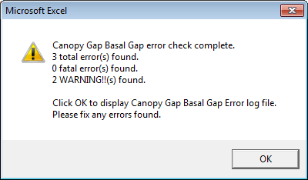
Figure 1.—Error Check Complete.
Clicking the OK button displays the error log as a Notepad document (fig. 2).
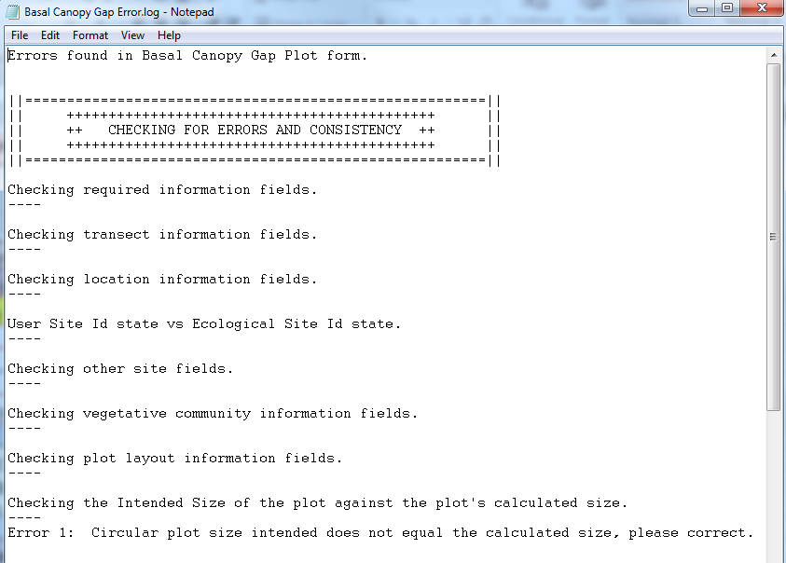
Figure 2.—Error Report.
This file can be found in the C:\Temp directory/folder on your computer.
After fixing the errors, you should then run the Error Check routine again.
NOTE: The font, Courier / size 12, seems to be a good font to use. The reports are designed to be displayed in Courier 12 pt.

ESI Form: The Prime Directive
The prime directive that CAN NOT be deviated from when using ESI forms is this:
“There MUST be a User_Site_Id already in the NASIS database before importing an ESI form.” This requirement is a result of the design of the database. ESI data is always linked to an existing Site record.

Good Habits with ESI Forms
Acquiring the following five habits when working with ESI Forms will benefit you.
- Ensure a User_Site_Id exists
If the ESI data being imported is not associated with an existing User_Site_Id, then you must create a Site record using the standard User_Site_Id format. This format can be seen in the form being imported. See figure 3.

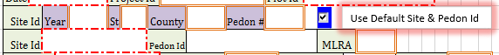
Figure 3.—User Site Id.
If you are importing ESI data that has associated soils data, then you will need to use the User_Site_Id assigned to it prior to importing any ESI forms.

While most newly collected data will be using the User_Site_Id’s default format there are likely to be some existing data on paper forms that uses a different User_Site_Id format. It is strongly suggested that all User_Site_Ids follow the standard format of the, four digit calendar year, two character alphabetic state abbreviation, three digit FIPS County code, and the three or rarely four digit (with leading zeros to pad the length to three or four) number assigned to the pedon for that year, state, and county. Such as, 2014MI031066.

When entering newly collected data into NASIS the user should always use the standard User_Site_Id format. All ESI forms contain the same fields as shown in figure 3 for Year, St, County, and Pedon #. The user will enter the required pieces and as long as the blue box is checked, the User_Site_Id and User_Pedon_Id will be auto-populated with the four concatenated fields.

If, for some reason, the User_Site_Id isn’t going to have the standard format, the user will need to put the cursor on the blue box and left click the mouse and the check mark with be removed. Now, the user will still be strongly urged to enter the four digit year, two character alphabetic abbreviation for the state, and the three digit county FIPS code. The Pedon # is optional. After removing the check mark you will need to enter the User_Site_Id field and enter a free form value.

If there is an entry in the User_Pedon_Id field, the value will be imported into NASIS as the attribute named associated_user_pedon_id in the Vegetation_Plot table. It is described as: The value recorded in the User Pedon ID column of the Pedon table for the pedon description collected from a vegetation plot. So, in order to link the vegetation plot id to an existing pedon record in NASIS you will need to input the value in this field or go into NASIS after the data is imported and enter the appropriate User_Pedon_Id into the associated_user_pedon_id field in the Vegetation_Plot table.

- Use Project_Id
If the ESI data being imported is part of an established Project, you will need to ensure that a Project record exists with a User_Project_Id and Project_Name in the Project table. See figure 4.

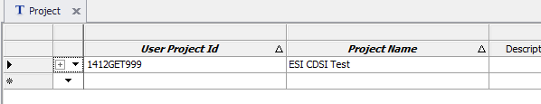
Figure 4.—User Project Id.
If you want to append ESI data to an existing Project and an existing Site record, you must go into the NASIS Site_Observation table prior to importing the ESI data. Set the Project Id by selecting it from the drop down choice list in the User Project Id field.

- Check Out Site records
Confirm that the necessary records in the NASIS database have been checked out and that you have rights to edit them. Work with the Soil Data Quality Specialist at your Soil Survey Regional Office to ensure that you have the necessary rights to add and edit data.

- Refresh Your Local Database
When you first login to NASIS, remember to refresh your local database before adding or editing data. One reason to do this is so that your database has the most current import scripts.

- Upload and Check In Data
At the end of the day, upload any records you altered and check them into the National database.
Once these habits have been established, you will find importing goes much smoother and faster.
Keep in mind that if the site or pedon data imported or entered by the soils personnel included vegetation information, then there will be two Vegetation_Plot records for each User_Site_Id. One record will have Plot_Plant_Inventory data (from the site or pedon data entered), and the other will have all the rest of the plant data that came from the ESI import. This is legal, it just looks a little strange.

ESI Form: Main Capabilities

Copy/Paste or Moving Cells: Use Extreme Care
Excel has many methods to make data entry faster and less tedious. One is the Copy/Paste method. In this method, the user highlights one or more cells, either in the same row or the same column, using one of the many copy methods. The user will then place the cursor into the cell where the data is to be copied to, i.e. pasted. The user can then use one of the many methods to paste what was just copied into the new location. It is important to understand that after copying one or more cells, the paste should only be done in the same relative location as it was copied from. The user should exercise extreme care when copying and pasting a large selection of cells to ensure that the paste operation is done to the same type of cells as were copied. If the user is going to copy a large selection of cells, it would be wise to save the file before doing the operation.
Sometimes the user might enter data into one cell and later realize the data should have been entered into the same column, but a different row. To rectify this error, it may be tempting to simply move the cell(s) involved. DO NOT give in to this temptation. Moving cells around WILL damage the integrity of the form and may cause the import to fail. In addition, this action may render the form unable to be imported and unfixable. Meaning, you will have to transcribe the original data to a blank form, again. Finding an error of this type, even given the information from the NASIS error message, may be very difficult if not impossible.

Cell Comment Indicators
Red triangles displayed in the upper right corner of the cell indicates that there is a comment associated with the cell. See Appendix A to learn how to hide these cell comment indicators.

Types of Data Entry Fields
There are two types of data entry fields on the ESI forms: numeric and nonnumeric (text). Almost each data entry field also has one or more data validations tied to it.

Numeric Fields
The most common type of data entry field is numeric. These fields are formatted to be an integer or float-data types. Most float-data type fields allow either one or two numbers to the right of the decimal point. The two exceptions are the latitude and longitude fields. They each allow up to seven numbers to the right of the decimal point.
The most common data validation for this type of field is a check to ensure a value is within a defined range. For example, the validation for pH is that the value in this float field, which has a precision of one, must be between 1.0 and 13.0, inclusive.
Other common data validations involve comparing the data entered using one or more of the following checks: the value is greater than, less than, greater than or equal to, or less than or equal to a given value.
The Elevation field has an unusual type of data validation for a numeric field. This is a “look up” validation. The allowable range for Elevation depends on the value in the State field. The forms are programmed such that when a specific State is entered, the allowable range for Elevation changes. The changes are based on the maximum and minimum elevations found in the State as determined by United States Geological Survey. If you enter a value that is outside the range in elevation for the selected State, an error message will be displayed. You will not be allowed to leave the Elevation field until either the value is corrected or deleted.

Nonnumeric Fields
There are three primary types of nonnumeric (a.k.a. text) data entry fields. These fields are for long notes, short text strings, or choices lists.
The first type is the long note field. In this type of field, you can enter any type of note of just about any length. All of the long note fields on the form can be quickly identified because they have more than one row. For example, see the Observations and Comments field in figure 5. There are no validations for the long note fields.
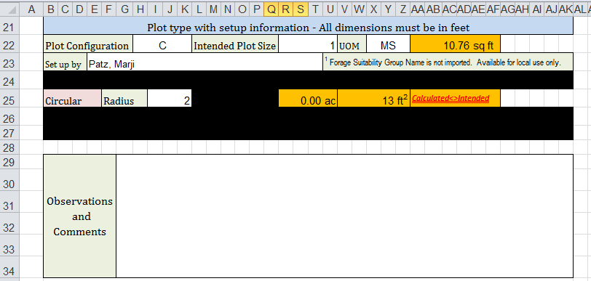
Figure 5.—Long Note Field.
The second type of text field is the short notes field. These fields are typically only one row, and you may or may not be able to type past the right end of the field. These fields typically have a data validation for the number of characters entered. If you type more than the allowable number of characters, you will get an error when trying to leave the field. The Collector field in figure 6 is an example of a short note field.
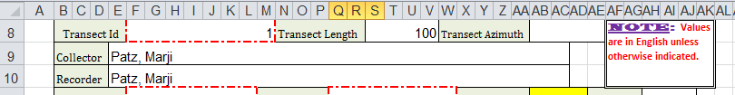
Figure 6.—Limited Text-Length Field (Short Note Field).
The third type of text field is a choice list field that uses codes instead of typed out values. These codes are short, usually two to five characters. When the cursor is in one of these fields, a downward pointing triangle is displayed on the right side of the field (fig. 7).
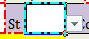
Figure 7.—Choice Field.
When you click on the downward pointing triangle, a list of up to eight choices appears. Lists that have more than eight choices are displayed with a vertical scroll bar for viewing the additional choices (fig. 8). The font size and number of choices displayed cannot be controlled by either the user or the creator of the form.
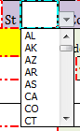
Figure 8.—Choice Field: Choice List.
In a few choice-list fields, the choices available depend on the value in a previous field. This is known as a dependent-choice list. In figure 9 for example, the County field is a dependent-choice list because the choices available depend on the value entered into the State field.

Figure 9.—Dependent Choice Fields.
Note: Some of the choice fields have numeric looking codes but are really text fields.

Unusual Behavior in Data Entry Fields
You may encounter three types of unusual behavior. These are blacked-out fields, fields that turn red, and text that changes from lowercase to uppercase.

Blacked Out Fields
On most of the forms, you will encounter fields that may be blacked out depending on the value of another field. This behavior is mainly encountered in the Plot Type section. Figure 10 displays this section with all fields visible.
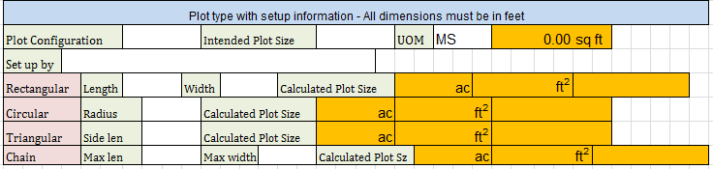
Figure 10.—No Blacked Out Fields.
When a Plot Configuration is selected in the first field in this section, the dimension rows for all other plot configurations are blacked out. Figure 11 displays this section with the irrelevant fields blacked out.
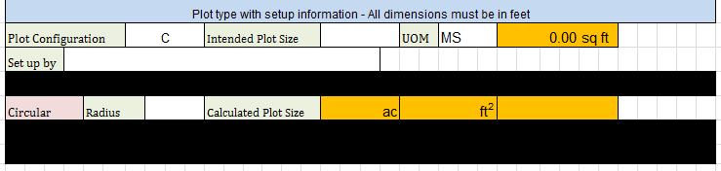
Figure 11.—Blacked Out Fields.

Fields That Turn Red
In currently very few instances, the characters entered in a field may turn red or the field may turn red. This can occur if an error is detected where there is more than one set of related data fields. For example, it can occur in some fields if you enter values into a low value field and a value in the upper value field and the upper value is smaller than the lower value. In this example, the upper value field would turn red. This color indicates an error was detected. Currently, this type of validation is available for very few fields. Future versions of the ESI forms may include more such cases.

Lowercase Switches to Uppercase
In most of the non-note text fields, you can enter the text in either uppercase or lowercase. When the cursor leaves the field, the entered text is redisplayed in uppercase. This change, although perhaps unexpected, is not an error.

Predefined Cursor Path (PCP)
To speed up data entry when the form or file is opened for the first time, the Tab key is programmed to move your selection from field to field, skipping intervening labels or skipping to the next row in the form. This capability is known as the Predefined Cursor Path (PCP). In figure 12, fields in blue are in the PCP and the cursor is in the first field (“Date”).
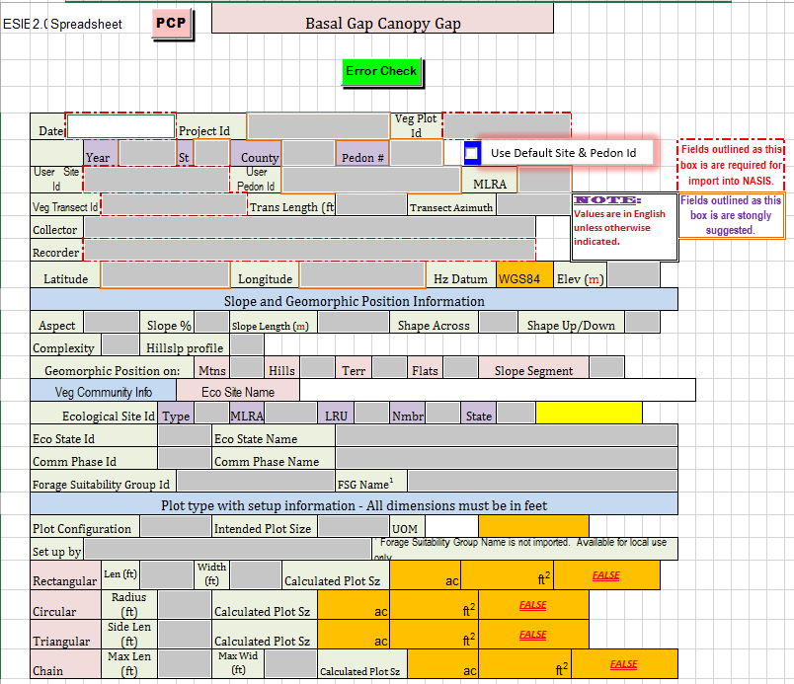
Figure 12.—Predefined Cursor Path.
This capability is limited to non-repeating fields in the top portion of the form (the Site section). When you open a blank form, e.g., one that was downloaded from the ESI Specialists Forum Files section, the PCP function is enabled. If you don’t see the blue fields, PCP has been disabled. To re-enable it, click on the pink button labeled “PCP” near the top of the form to the left of the title.
The Tab key moves the cursor forward to the next field. Shift-Tab moves the cursor to the previous field.

Auto-Populated Fields (APF)
Figure 12 has some orange-shaded fields. These fields are auto-populated based on the values found in other fields on the form. Some auto-populated fields are yellow-shaded. Do not type in either orange or yellow shaded fields. The orange-shaded fields are used for quality assurance purposes and are not imported into NASIS. Yellow-shaded fields are determined by values in other fields and are imported into NASIS.

Plot Layout and Size
The plot layout and size are in the Plot Type section of the form (fig. 13).
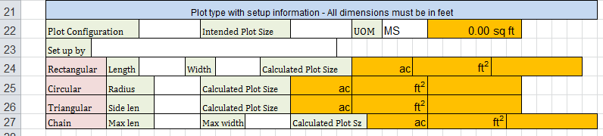
Figure 13.—Un-Blacked-Out Auto-Populated Fields.
Plot configuration can be either rectangular, circular, triangular, or chain type. Once you enter a Plot Configuration, only the row matching the selected plot configuration will be shown. The other three will be blacked out (fig. 14).
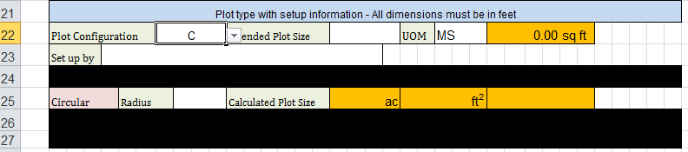
Figure 14.—Blacked-Out Auto-Populated Fields
Also seen in the Plot Type section are some orange fields. These compare the Intended Plot Size, as entered by you, to the Calculated Plot Size. They use the values entered into the dimension field(s) of the corresponding Plot Configuration.
You enter values for the Intended Plot Size and the corresponding Unit of Measure (UoM). The Intended Plot Size is then displayed in square feet, no matter which UoM is selected for the Intended Plot Size field value.
You then enter the dimension(s) of the selected Plot Configuration in feet or a decimal portion thereof. The dimension value(s) and shape of the plot are used to compute the area of the plot, which is then displayed in both acres and square feet.
The last field of each Plot Configuration dimensions row (which will be row 24 through 27, depending on the form being used), will commonly display the message ”calculated <> intended.” This message is displayed when the computed size, in square feet, doesn’t match the ‘Intended Plot Size’, as entered by you and converted to square feet. This error message is displayed most of the time because the Intended Plot Size (typically in square meters) is converted to square feet, and this value is rarely equal—to two decimal places—to the user-entered Intended Plot Size value. By comparing the Intended Plot Size to the computed size on the appropriate Plot Configuration row, you can determine if the measurements are within an acceptable error range. The message will be displayed when there is a difference between the ‘Intended Plot Size’ and the calculated plot size. It will not indicate if the calculated size is either smaller than or greater than ‘Intended Plot Size’.
The intention of this feature is to warn the user when the calculated plot size is different from the Intended Plot Size. This check is part of the data-integrity process. It is intended to prevent the importation of a plot size that is different from the intended size that the protocol is based on. At this time, the Intended Plot Size and the calculated plot size must be exact to avoid the warning message. You will need to use your judgment to determine if the calculated size is close enough to the intended size to be acceptable. The values in orange fields are not imported into NASIS.
In other sections of a form there may be fields that are highlighted in yellow. These fields are also auto-populated based on already entered data. Do not enter data into either and orange or yellow shaded field.

Required Fields
Several fields in the first part of the form are either required or strongly suggested fields, as shown in figure 15.
Required data entry fields have thick dash dot red in color borders. 
These fields are required and the import into NASIS will fail if they are null or empty.
There are several other strongly suggested to have fields and they have a thick double lines orange colored boarder. 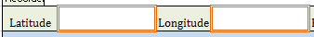 While the import into NASIS won’t fail if any of these fields are null or empty, they may be ‘required’ by policy and/or common sense.
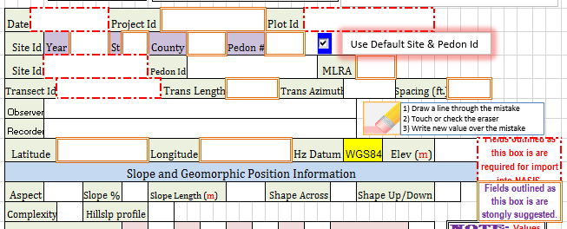
Figure 15.—Required and/or Suggested Fields

National Plant Symbol (NPS) Fields
Any data entered in these fields is checked against the list of approved National Plant Symbols as maintained by USDA PLANTS. This check is done when the Error Check button is clicked and the Error Check macro runs.

Data Validation
Three general types of validation are employed in the ESI forms to help ensure that incorrect data does not get imported into NASIS.

1) Checking a field’s value against allowable values.
These validations include:
- Making sure that the data type entered into a field matches the data type defined for the field. For example, a numeric field will not accept a text entry.
- Checking a number value against the allowable range for the value. For example, a percent field may have limits of 0 and 100, inclusive.
- Using choice lists to require a correct value or to automatically check an entered value against a list of allowable choices. This method allows for the use of codes or short character strings in place of typing out a whole, potentially long value for a field. (Such manually entered values are subject to fumble-fingered typing and misspelling.)
This type of validation is automatically enforced. The value you enter into a field is checked when you try to leave the field. If the value fails validation, you are notified and, in most cases, are not allowed to leave the field until the validation is passed.

2) Using the Error Check button.
- Unlike the data validation errors discussed in item 1 above, this data validation does not run automatically. You must click on the green Error Check button at the top of the form to run this set of data validations.
- Clicking this button invokes a macro that checks for errors that would cause the NASIS import to fail. An example of this type of error is having a pH of 15 when the range is 1 to 13, inclusive.
- The Error Check validation also makes some consistency checks. These checks are for entries that would not necessarily cause the import into NASIS to fail but may be considered errors in context with data entered into other fields. Some examples are:
  - Checking to ensure that the latitude and longitude are within the contiguous 48 States if the State field identifies it should be.
  - Checking to ensure that the height to the bottom of a canopy is smaller than the height to the top of the canopy.
  - Comparing the location associated with the User_Site_Id to the location associated with the Ecological Site Id. This type of consistency check may not report a real error or even a real inconsistency, but the error check macro is written to be careful.
- Some consistency checks are common for all ESI forms. Others are specific to the sampling methodology used by the form.

3) Using the NASIS import error check.
- A third type of error check is done when Excel-based forms are imported into NASIS.
- NASIS performs a final error check when the data is being imported.
  - NASIS employs more sophisticated error checks than is possible with Excel.
- The Excel forms run some data-consistency checks that may or may not be available in NASIS.
  - These consistency checks are performed automatically when the Error Check button is used.
- In NASIS, consistency checks must be written and then manually run against NASIS records.
  - In NASIS, these checks are also known as Validations.

Importing the Data into NASIS
Each of the methods of identifying errors reduces the number of errors that can cause the import to fail. This means that, overall, the data will be imported faster if all of the data validation checks are used.
In general, the steps taken to import Excel workbooks are:
- Click on the Spreadsheet icon on the NASIS main menu.
- Select one or more ESI forms to import during the same import session.
- NASIS looks for import script errors for each form before importing the form.
- NASIS analyzes each workbook for data errors.
- At the first error NASIS finds, the import process quits.
- NASIS reports the first error found.
Note that any error stops the entire process. For example, if you select 10 Excel workbooks (forms) for one import session and NASIS finds invalid data in the tenth workbook, the entire import session is aborted and the database is rolled back to its beginning state. None of the data is imported into NASIS.
Also, note that the Excel files are imported and processed in the order in which they were selected in step 2.
Depending upon the ESI methodology, i.e. form, successfully importing a workbook can take quite a bit of time. Needing to redo the import process can reduce productivity significantly and can cause you frustration.
The bottom line is this: Importing is not necessarily a quick process. So, the more errors that can be found prior to an import session, the higher the productivity and the lower the frustration level.

Overwriting Data In NASIS
When the ESI form is imported, any data in fields that are shared with a soils Site record will not be imported into the database. The import does not write over existing data. For example, if the soils record shows an elevation of 652 meters and the ESI form shows an elevation of 256, the 652 will not be overwritten. If the data in the form is correct, you will need to go into NASIS and edit the field after the import is completed. If the field in the database is empty and the ESI form has a value in that field, then the value will be imported.
It is important to understand that you will not be notified if the data being imported is different from the data currently in the database.

Choice List Code Meaning
What do all the codes mean? When you are filling out a form in the field, you are likely to often need the Field Book to find a list of allowable codes and their meanings. This is time consuming and frustrating.
To alleviate the time-consuming task of looking up codes in another document, the forms now display most of the choice lists, including the codes and their meanings. In most cases, the choice lists are printed on the page of the form in which they are used. Choice lists that have a large number of choices are not printed. Sample choice list codes are shown in figure 16.
Slope Shape
C concave
V convex
L linear
Slope Complexity
S simple
C complex
Hillslope Position
BS backslope
FS footslope
SH shoulder
SU summit
TS toeslope
Geomorphic Component Mtns
MT mountaintop
MF mountainflank
UT mountainflank, upper third
CT mountainflank, center third
LT mountainflank, lower third
MB mountainbase
FF free face
Geomorphic Component Hills
IF interfluve
HS head slope
NS nose slope
SS side slope
BS base slope
CT crest
FF free face
Geomorphic Component Terr
RI riser
TR tread
Geomorphic Component Flats
DP dip
RI rise
TF talf
Slope Segment
LT lower third
MT middle third
UT upper third
Plot Configuration
C circular
CH chain
R rectangular
T triangular
Gaps Between
G annual grasses
F annual forbs
O other
P perennial plants
S shrubs

Figure 16.—Choice List Codes.

Printing Legal Size Forms
Many ESI forms are designed with large data-entry fields. This design is intended to make writing in them easier when you are not at your desk. In order to have enough paper real estate to be useable, many of the forms are designed to be printed on ledger size paper (11 by 17 inches). Unfortunately, standard clipboards are 8.5 by 11 inches, which is too small for ledger size paper. Many of the forms have data entry fields that are very hard to use if the form is printed on 8.5 by 11 inch paper.
As a compromise, a process was developed that allows the original ledger size to be printed in legal size (8.5 x 14 inches). It has been our experience that folks who have neat penmanship and who use reasonable care can use the forms on legal size paper.
ESI forms that have a default size of 11 by 17 inches (ledger size) display onscreen instructions for printing at legal size when the form is opened in Excel. These instructions are reproduced below.
The default page size for this form is ledger, or 11 by 17 inches. To print legal size:
1) On the Page Layout ribbon, click on the small icon in the lower right corner of the Page Setup section. This will display the Page Setup dialog, as shown in figure 17.
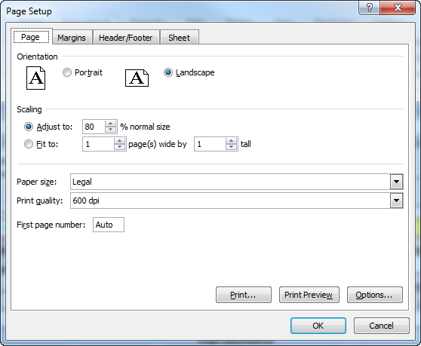
Figure 17.—Page Setup: Print Legal Size.
2) On the Page Tab, in the scaling section check the “Adjust to:” radio button and enter 80; and then select legal in the Paper Size field.

Worksheets in the ESI Excel-basedForms
There are five worksheets in each unused ESI form. They are, from left to right:
- Front
- FrontDES
- WordList
- Change History
- Data Element Map
Figure 18.—Excel-Based ESI Form Worksheet Names.

Front Worksheet
The Front worksheet looks like (and is) a form for data entry.
Figure 19.—Front Worksheet.

FrontDES Worksheet
The FrontDES worksheet extracts the data from the Front worksheet and arranges it into columns and rows, i.e. cells, which are read during the NASIS import process.
Any editing of this worksheet is likely to cause the NASIS import to fail.
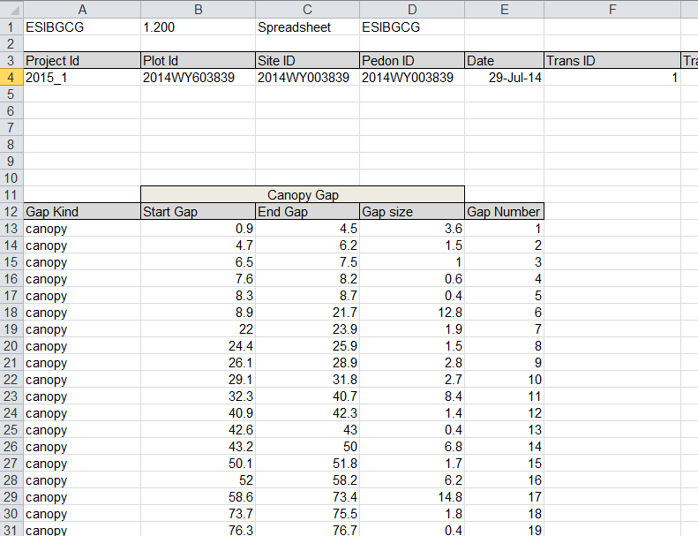
Figure 20.—FrontDES Worksheet.

WordList Worksheet
The WordList worksheet contains the codes and descriptions that are used as choice lists on the Front worksheet. The codes and descriptions are arranged as shown in Figure 21.
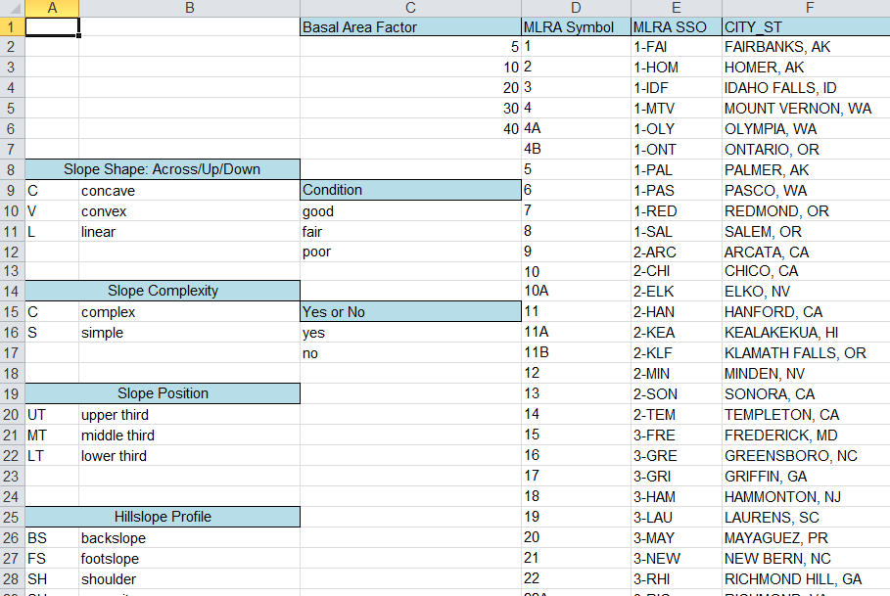
Figure 21.—WordList Worksheet.
Each choice-list data-entry field in Front is linked to the appropriate range of codes and descriptions in WordList. This worksheet is also accessed by FrontDES to display the description of the code used on Front. Since NASIS does not store codes the uncoded values on FrontDES are what is imported into NASIS.

Change History Worksheet
The Change History worksheet is mostly self-explanatory. It is a place where changes to the form are recorded.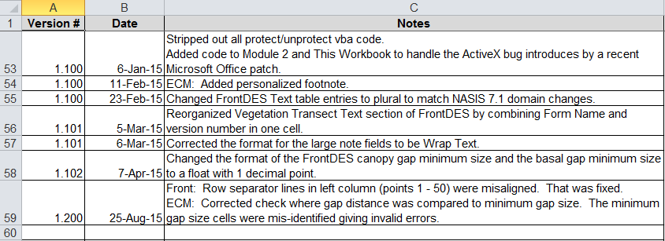
Figure 22.—Change History.
Sometimes, a change is significant enough to justify a change in version number. During development of a form, the version is typically 1.000. This number won’t change until after the form is deployed. Following deployment of the form, any change to the worksheet causes a change in the version number. Depending on the magnitude of the change, the version number could increment by as little as .001 (e.g., 1.001 to 1.002) to as much as a whole number (e.g., 1.002 to 2.000). The decision about to what level to increment the version number is not always logical or explainable. That doesn’t matter as long as cell B1 on FrontDES is the same as the import script version, the import will proceed. If the version numbers differ, then NASIS will display an appropriately worded error message.

Data Element Map Worksheet
The Data Element Map (DEM) worksheet records the relationship between the field on the FrontDES worksheet and the location, i.e. the table and column of the location of the data in NASIS.
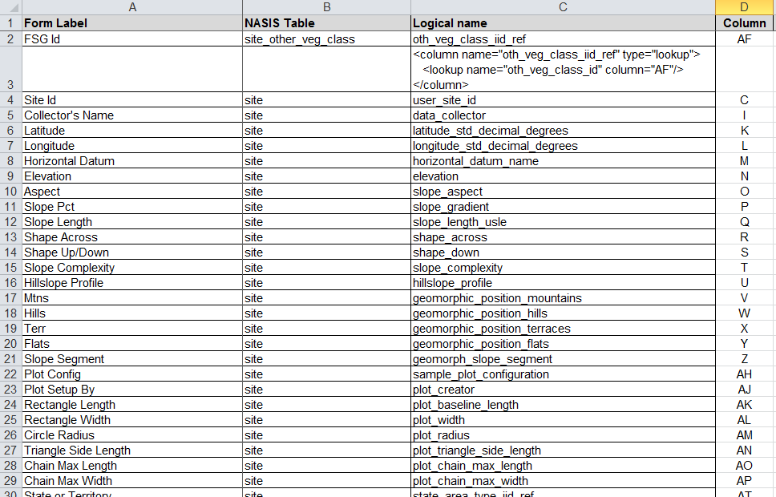
Figure 23.—Data Element Map (DEM) Worksheet.
Originally, the DEM worksheet was designed to aid the developer in writing the NASIS import script. Recently, however, the DEM has taken on a more prominent role by users of the various ESI forms. It is used in a couple of different ways by field users of the forms.
- The DEM worksheet helps educate users as to the storage location of specific data in NASIS; i.e., it helps you to understand the NASIS database structure (also known as the data model).
- This knowledge helps those users who are writing reports and queries determine where in NASIS a specific data element is located.
One of the best uses for the DEM worksheet is to help generate reports that can be used to write ecological site descriptions. The first three columns of the DEM worksheet relate the data entry fields on the Front worksheet to the tables and columns in NASIS. Once you know where the data is stored, you can create an almost unlimited number of reports as resources for creating ecological site descriptions.
As inferred above, the last column in the DEM does not refer to the column on the Front worksheet where the data attribute is located. This column actually relates to the column on the FrontDES worksheet where the transformed data is located. This column has a couple of different uses.
Originally, it was used by the developers as they wrote NASIS import scripts. The scripts use the column to locate specific data in the form so the data can be read and imported correctly into NASIS.
This column is also useful when there is an error during the import. If an import fails, NASIS will display an error message to the Status Message area in the NASIS interface. The amount of information in the error message varies, but normally the message will list the column and row of the cell being read that has caused the import to fail.
It is important to realize that the column and row NASIS displays relates to the FrontDES worksheet. The user should NEVER edit a cell on the FrontDES worksheet.
It is a common misconception that the row and column described in the error message received when importing the workbook into NASIS relates to the Front worksheet. The message really relates to the FrontDES worksheet.
To use the error message to find the error on the Front worksheet, you need to use the FrontDES worksheet. First, find the cell address given in the error message. Next, go to the FrontDES worksheet and put the cursor on the cell address. Then, interpret the formula in that cell to determine where the error is on the Front worksheet.

Nondiscrimination Statement
In accordance with Federal civil rights law and U.S. Department of Agriculture (USDA) civil rights regulations and policies, the USDA, its Agencies, offices, and employees, and institutions participating in or administering USDA programs are prohibited from discriminating based on race, color, national origin, religion, sex, gender identity (including gender expression), sexual orientation, disability, age, marital status, family/parental status, income derived from a public assistance program, political beliefs, or reprisal or retaliation for prior civil rights activity, in any program or activity conducted or funded by USDA (not all bases apply to all programs). Remedies and complaint filing deadlines vary by program or incident.
Persons with disabilities who require alternative means of communication for program information (e.g., Braille, large print, audiotape, American Sign Language, etc.) should contact the responsible Agency or USDA’s TARGET Center at (202) 720-2600 (voice and TTY) or contact USDA through the Federal Relay Service at (800) 877-8339. Additionally, program information may be made available in languages other than English.
To file a program discrimination complaint, complete the USDA Program Discrimination Complaint Form, AD-3027, found online at http://www.ascr.usda.gov/ complaint_filing_cust.html and at any USDA office or write a letter addressed to USDA and provide in the letter all of the information requested in the form. To request a copy of the complaint form, call (866) 632-9992. Submit your completed form or letter to USDA by:
(1) mail: U.S. Department of Agriculture
Office of the Assistant Secretary for Civil Rights
1400 Independence Avenue, SW
Washington, D.C. 20250-9410;
(2) fax: (202) 690-7442; or
(3) email: program.intake@usda.gov.
USDA is an equal opportunity provider, employer, and lender.

